Answers
Task 1: Manufacturing compromises
Manufacturing costs should be roughly one quarter of the retail price. This enables the manufacturer to make a small profit margin on items sold to wholesalers, who will make a small margin before they distribute the goods to retail outlets, who will then add their profit margin before they are sold to consumers.
A new Bluetooth speaker sells for £100.
- Referring to the components in the table, calculate the maximum cost of manufacture per unit. £25.

- Using the table below, decide on how the cost of manufacturing the individual components will impact the total cost to produce the new speaker.

Make sure that you do not overspend on the manufacturing costs for the components for each unit.
 | Low quality |  | Medium quality |  | High quality
Housing material | Polymer | £2 | Aluminium | £5 | Carbon fibre | £9
Bluetooth class | Class 3  (1m range) | £3 | Class 2  (10m range) | £4 | Class 1  (100m range) | £6
Resistance | Dust proof | £1 | Splash proof | £4 | Water proof | £6
Battery power | 430 mAh  4 hours play | £5 | 4,000 mAh  10 hours play | £6 | 10,000 mAh  15 hours play | £7
Speaker type | 1 x 40mm mono woofer | £3 | 2 x 35mm stereo woofers | £7 | 2 x 63 mm stereo woofers | £8

Answers will vary, but a practical compromise might be as indicated in red. Students should understand that compromises need to be made in manufacture in order to meet acceptable end-user expectations.
Allow errors in the calculation of the maximum cost carried forward from part (a).
Task 2: Case study: New screen technology
Read the following extract from a press release from the University of Sussex:

Sussex physicists have breakthrough on brittle smartphone screens
Professor Alan Dalton and his team have developed a new way to make smartphone touch screens that are cheaper, less brittle, and more environmentally friendly. On top of that, the new approach also promises devices that use less energy, are more responsive, and do not tarnish in the air.
The problem has been that indium tin oxide, which is currently used to make smartphone screens, is brittle and expensive. The primary constituent, indium, is also a rare metal and is ecologically damaging to extract. Silver, which has been shown to be the best alternative to indium tin oxide, is also expensive. The breakthrough from physicists at the University of Sussex has been to combine silver nanowires with graphene – a two-dimensional carbon material. The new hybrid material matches the performance of the existing technologies at a fraction of the cost.
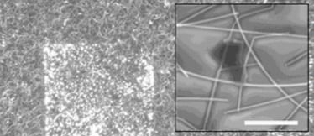
The graphene is embedded with tiny silver nanofibers
Professor Dalton, from the School of Mathematical and Physical Sciences at the University of Sussex, says:
“While silver nanowires have been used in touch screens before, no one has tried to combine them with graphene. What’s exciting about what we’re doing is the way we put the graphene layer down. We float the graphene particles on the surface of water, then pick them up with a rubber stamp, a bit like a potato stamp, and lay it on top of the silver nanowire film in whatever pattern we like.”
“And this breakthrough technique is inherently scalable. It would be relatively simple to combine silver nanowires and graphene in this way on a large scale using spraying machines and patterned rollers. This means that brittle mobile phone screens might soon be a thing of the past.”
“The addition of graphene to the silver nanowire network also increases its ability to conduct electricity by around a factor of ten thousand. This means we can use a fraction of the amount of silver to get the same, or better, performance. As a result, screens will be more responsive and use less power.”
Dr Matthew Large, lead researcher on the project within the School of Mathematical and Physical Sciences at the University of Sussex, says:
“Although silver is also a rare metal, like indium, the amount we need to coat a given area is very small when combined with graphene. Since graphene is produced from natural graphite – which is relatively abundant - the cost for making a touch sensor drops dramatically."
University of Sussex 13 December 2017
(a) State the two main materials that are combined to make the new glass screen.
Silver and graphene.
(b) How might manufacturing and development timescales of devices using the new technology be affected?
The manufacturing process outlined by Professor Alan Dalton is ‘relatively simple’ which would reduce the complexity and timescales involved in their manufacture compared to existing techniques. The abundance of the raw graphite material may also reduce lead times to improve production time.
Development time is likely to require much longer to perfect this technique as it may only have been tested in a laboratory rather than in an industrial setting.
(c) Explain how consumer budgets are likely to be affected by the new technology.
The technology relies on more abundant material (graphite) which is likely to bring material costs down and as a result, may be reflected in the consumer prices.
The process of combining graphene with silver is also described as being possible ‘at a fraction of the cost’ of existing methods for the same function.
The number of broken, cracked or fractured screens should be reduced dramatically, saving costly repairs for the consumer. There should also be a reduction in the amount of cases where repairs by unauthorised shops invalidates warranties and guarantees.
(d) The Office for National Statistics estimate that smartphone usage amongst the UK population is roughly as shown below.
Justify which age group is most likely to benefit from a stronger screen.
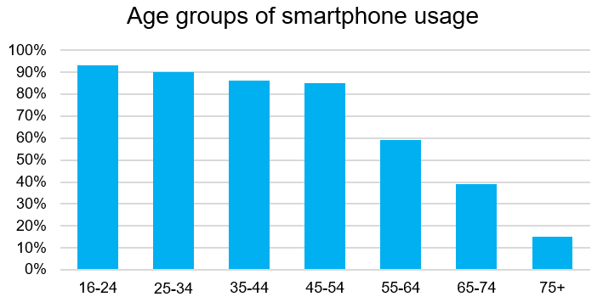
Users under the age of 55 are most likely to benefit given that they have the largest usage rate proportionately for the demographic. However, elderly or very young users are more likely to drop a phone owing to decreased grip strength, arthritis or physically smaller hands.
(e) Explain how the manufacturing capability could be adapted for other products.
Once the processes of manufacturing the silver nanowires using large scale spraying machines and patterned rollers is perfected, the process could benefit the manufacture of other touch-screen technology such as laptops, tablets and mp3 players.

