Answers

State one factor in the decision to adopt new or emerging technologies in the manufacture of a new product. [1]
Award only 1 mark for a correct response.
Budget; timescale; who the product is for; the cost / type of the materials being used; manufacturing capabilities.

Irreversible thermochromic pigments change colour when specific temperatures are reached and cannot revert to their original colour state.
These pigments are increasingly being used in product labelling where the temperature stability of the product during transportation and distribution is critical.
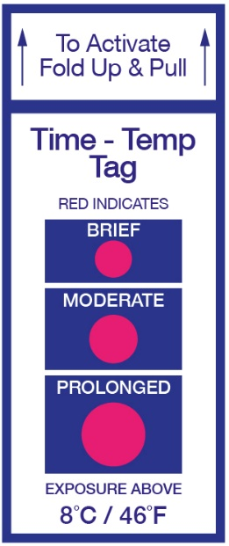
Some medicines and food products (such as raw meats) require constant chilling. They cannot be exposed to temperatures above 8°C.
An alternative to thermochromic labels is the use of digital thermometers. The table below factors for consideration in using either of these methods to monitor temperature.
Factor | Thermochromic labels | Digital thermometer
Unit cost | 1.5p per unit | £90
Quality control speed | Quick visual check | Slower digital reading

Analyse the data provided.
(a) Calculate the number of stickers that would need to be used in order for the cost of stickers to equal the cost of the thermometer. Show your working out in your answer. [2]
Award 1 mark for the working out and the second mark for the correct answer.
£90 / 100 = 9,000p. 9000p / 1.5p = 6000 stickers.
(b) Discuss the issues manufacturers face in deciding whether to adopt this
labelling technology for the shipping of their products. [6]
Indicative content:
- Labels with smart technology would increase the allocated budgets and costs of distribution per unit; but these costs may be minor compared to the cost of a potential disaster as a result of unmonitored / unnoticed temperature increases.
- The costs of a digital thermometer would soon be outweighed by cumulative costs of thermochromic labels, but the slower speed of quality control checking may have additional labour costs associated with it.
- The timescale to manufacture the products / labels is unlikely to increase significantly but may require some additional processes in order to correctly label boxes prior to shipping at source, and to examine labels at the destination as part of quality control.
- Other manufacturers may be using the technology, which may create an obligation to do the same. Customers may feel more secure using a sticker than trusting someone to manually check the temperature as data could be tampered with when being recorded and stored. Companies may gain a competitive advantage by adopting the sticker technology first to alleviate customer anxiety.
- A thermometer is likely only to be able to monitor the overall temperature of a storage facility or haulage vehicle, even if measurements are constantly taken over time. Stickers on each individual product will be able to accurately identify uneven fluctuations in temperature affecting some products and not others.
Level | Marks | Descriptor
 | 0 | Nothing worthy of credit.
1 | 1 – 2 | One or two brief valid points or one point with some explanation. Answer shows limited understanding of the issues with no coherent argument. Analysis only rather than evaluation. No conclusions drawn.
2 | 3 – 4 | Response shows some good understanding of the issues surrounding the selection of methods demonstrating a range of points with some analysis/evaluation. Argument may lack some coherency and conclusions drawn may be unsubstantiated.
3 | 5 – 6 | Response shows excellent understanding of the issues surrounding the selection of methods.  A fully coherent, balanced and logical argument based on sound reasoning.  An appreciation of the interconnection between factors and the effect they have on the decision to use either method.

Miniaturised, lightweight components connected using conductive thread are becoming available to provide electrical power through garment fibres.
State one suitable group of users that these materials may be aimed at. [1]
Award only 1 mark for a correct response. Answers may include:
The elderly / babies and infants / (winter) sports people; to provide built-in heating elements.
Youth; to provide communications built in to outerwear.
[Total 10 marks]

