Answers
Task 1
- (a) Match the labels to the correct part of the diagram:
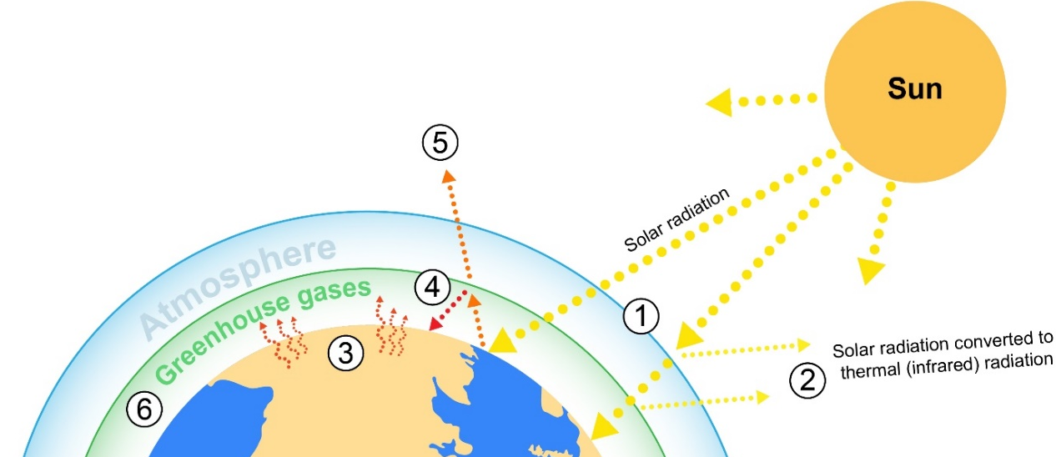
2 | Some solar radiation is reflected away before it passes through to Earth
4 | Infrared thermal radiation is reflected away from the Earth but bounces back
6 | Greenhouse gases block infrared radiation from escaping and the thermal energy is reflected to Earth to warm the planet for a second time, causing global warming
1 | Incoming solar radiation from the sun penetrates the Earth’s atmosphere
5 | Infrared radiation is reflected away and escapes the Earth’s atmosphere and is released back into outer space
3 | Some solar radiation is absorbed into the surface of the Earth. This warming effect keeps the planet at a temperature that is suitable for living organisms

(b) If the Earth gets warmer what will happen to the ice caps in the North and South Pole? How could this affect low-lying land?
Higher temperatures will cause the polar ice caps to melt, causing sea levels to rise, leading to flooding in low-lying areas and coastal regions.
(c) How will the greenhouse effect, affect countries near the equator?
Higher temperatures will make equatorial regions uninhabitable causing more droughts and heatwaves. This increases desertification and reduces the ability for the land to retain moisture, hence leading to lower water tables and a scarcity of fresh water. Livestock and crops may no longer be able to be farmed in these regions which will displace communities.
(d) How might global warming affect people and wildlife?
More frequent extreme weather events such as hurricanes and flooding. Droughts and flooding will destroy habitats for wildlife leading to extinction of species and a reduction in biodiversity. Communities will be displaced as the land becomes uninhabitable.
Task 2
- Autonomous vehicles are going to be increasingly a part of everyday travel.
Sensors, clever software, GPS location technology and Wi-Fi connectivity within the vehicles enables them to maintain safe passage.
Accidents and unforeseen dangers however, are an inevitable part of any journey that these cars are likely to encounter.
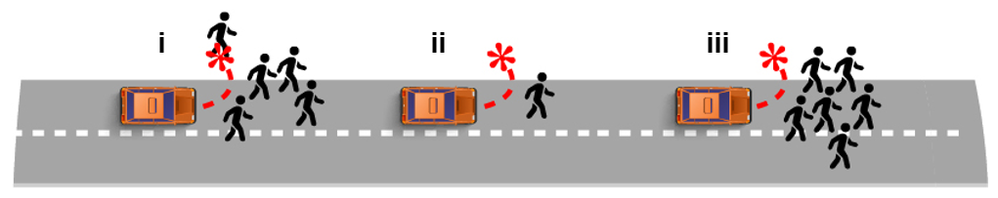
The following questions are about ethics in imaginary situations. Current sensors on vehicles cannot tell exactly who is near the vehicle, however in the future they may be able to tell an animal from a human and perhaps even one person from another.
(a) Discuss the ethics surrounding how the cars should be programmed to respond in different situations:
(i) Swerve to avoid a criminal gang, hitting a pedestrian on the pavement?
(ii) Swerve to avoid an elderly man, hitting the vehicle driver?
(iii) Swerve to avoid a group of children, hitting the vehicle driver?
(b) Who would be to blame for any accident? The driver? The manufacturer?
The programmer?
There are no answers for these question, but they should provoke some good debate on ethics surrounding new technologies.
(c) Discuss how communication might be affected with Wi-Fi connectivity in every vehicle.
The number of vehicles autonomous that could appear over the next decade or so will greatly increase the number of potential networking hotspots that together could form a mesh network. This could effectively make busy urban areas entirely Wi-Fi enabled.
Drivers may no longer have the same restrictions on the use of mobile technology whilst driving a vehicle. Currently the driver takes responsibility for full control of a vehicle.
GPS communication would constantly communicate with the vehicles, and with the aid of Wi-Fi access, could determine and potentially coordinate (if the destination of every vehicle is known before departure) a clear path for every vehicle on the road, greatly reducing traffic jams and journey times.
Accidents and natural disasters such as flooding could also be immediately relayed to all vehicles which could automatically move the journey path via higher ground or avoiding affected areas.

