Answers
Task 1
The list below gives several different lifestyle choices.
- Add a plus (+) or minus (-) beside each choice to show which one adds (+) to a carbon footprint and which lifestyle choice reduces (-) a carbon footprint
- Explain how each lifestyle choice might affect someone’s carbon footprint
Lifestyle choice | ± | Explanation
Taking long-haul flights | + | It takes a great deal of energy/fuel to get a plane into the air and keep it there. Emissions from air travel, especially long-haul flights contribute heavily to a carbon footprint.
Eating locally sourced food | - | Reducing the number of miles food travels means that the fuel needed to transport the food is reduced, thus reducing emissions from vehicles. Growing your own food is another way to reduce your carbon footprint.
Online shopping | ± | It could be argued that shopping online encourages consumerism: buying more products increases our carbon footprint due to the resources and energy used to manufacture and distribute the product. However, shopping online can reduce your footprint as consumers don’t have to drive to the shops, and products don’t have to be distributed to stores. Instead the goods are delivered by one vehicle to many consumers using very efficient routes directly from wholesalers or manufacturers.
Being vegetarian | - | Farming animals increases the number livestock. Livestock produce large amounts of methane (although this is not carbon, it is a gas which contributes to the greenhouse effect). Furthermore, the land, fuel and water used to farm these animals contributes to our carbon consumption.
Walking to the shops | - | Walking or cycling is preferable to taking the car / public transport as fuel consumption is reduced. However, shopping contributes to our consumer society and buying products increases your carbon footprint.
Installing solar panels | - | This reduces our reliance on fossil fuels. Sourcing fossil fuels causes issues such as scarring of landscape / deforestation / drilling at sea and potential oil leaks etc. Burning fossil fuels adds to the carbon in the atmosphere.
Using a tumble drier | + | Tumble driers use electricity which is usually derived from unsustainable sources (coal, oil and gas). Hanging your clothes on a washing line to dry does not contribute to carbon emissions.
Sharing a lift to school | - | If you share a lift to school you can reduce the amount of fuel used, powering one vehicle to complete a given journey as opposed to two or three.
Using Skype / Facetime | - | Video conferencing means that neither party need travel to physically meet, therefore fuel consumption is reduced.

Task 2 Life Cycle Assessment
Use the labelled diagram below to help you conduct a Life Cycle Assessment on a plastic supermarket shopping bag.
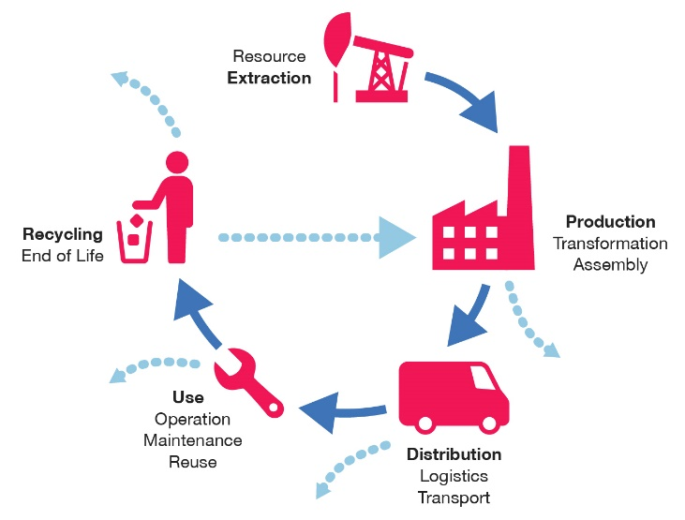
Extraction: Oil is extracted from the ground or seabed.
Production: Oil is processed to convert it to a polymer. The polymer is formed into a sheet / chips / film using heat. It is then processed to form a bag and then frequently printed using inks / dyes.
Distribution: Bags are sent worldwide to supermarkets and other retailers using road, rail and air – all of which causes pollution and uses more oil (fuel).
Use: Generally, only used once, although many are recycled in the form of rubbish bags. Either way they end up as landfill. Once damaged, they cannot be repaired.
End of life: Some supermarkets offer a recycling service. Some bags are made with recycled plastics or biodegradable polymers. Many bags are thrown away after a single use.
What could you do to improve the environmental impact of a shopping bag?
Answer may include:
Make bags from another, more sustainable resource other than oil. Paper / plant oil.
Make bags more durable so that they are reused more frequently.
Make it easier to recycle bags.
Use biodegradable polymers.
Explain how plastic bags might contribute to pollution in the air and water.
Oil distillation process produces pollutants. Transportation of bags to retailers creates pollution from exhaust and spent fuel. Bags frequently end up in the sea or other waterways.
Explain how this might impact global warming.
Production processes create CO₂.
What new material is being used to provide an alternative solution?
Biodegradable polymers.
Describe how the consumption of plastic bags is being reduced in the UK.
Charging for bags has reduced consumption (by 80% in the first year).

https://www.theguardian.com/lifeandstyle/2010/jul/18/vegetarianism-save-planet-environment

