Answers

The charts below show the percentage of emissions and the percentage population
by region.
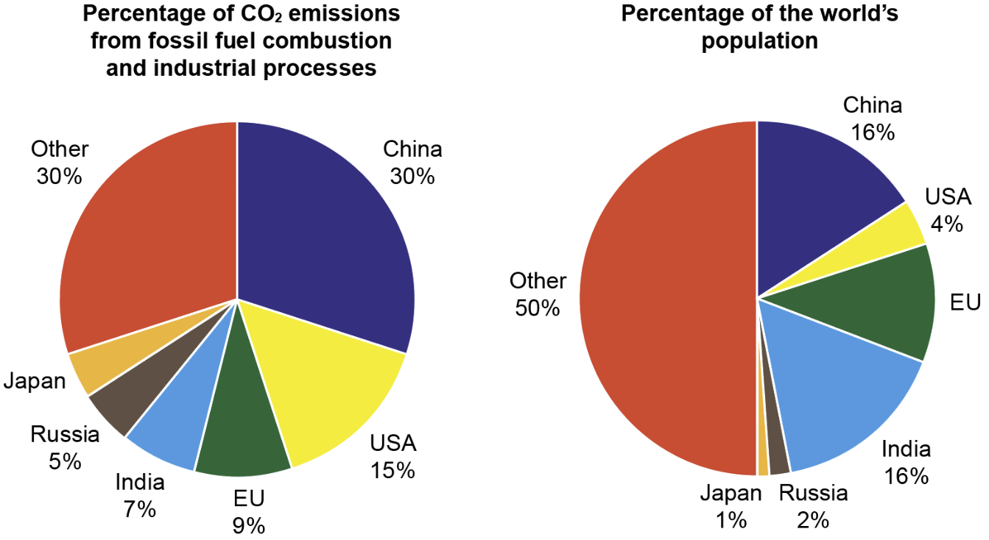
Source: https://www.epa.gov/ghgemissions/global-greenhouse-gas-emissions-data

Calculate the missing percentages.

Calculate the percentage of CO₂ emissions from Japan. 4% [1]

Calculate the percentage of the world population living in the EU. 11% [1]

  - India accounts for 16% of the global population, yet only 7% of carbon emissions. Describe how this compares to the data for the US. [2]
Award 1 mark for a correct description and a second mark for comparing the response.
The US is responsible for 15% of emissions even though only 4% of the global population live there (1). The average lifestyle in India produces much less carbon than that of the average US citizen in a lifetime (1).

  - Explain what this data might tell you about the average lifestyles and social
values of those living in India compared to those living in the United States. [3]
Award 1 mark for an explanation and up to 2 marks for justifying the response.
US lifestyles are more detrimental to the environment than those in India (1).
The US society is a consumerist society meaning that the economy and social values are linked to an individual’s purchasing power and possessions (1). Lower incomes in India reduces their ability to shop / travel etc., which reduces their carbon footprint (1).

- A cacao pod contains 40 seeds, each of which is separated, roasted, ground and added to other ingredients to become chocolate.
The pods are harvested and managed by farmers in small communities, who then sell them on to fair trade chocolate producers.



(a) Other than cacao, suggest one example of a fair trade product. [2]
Award 1 mark for each correct answer up to a maximum of 2 marks.
Answers include but not limited to: cotton, bananas, tea, coffee, flowers, gold and some beauty products.
(b) Explain one benefit for fair trade farmer of selling their produce through a
fair trade organisation [3]
Award 1 mark for an explanation and up to 2 marks for justifying the response.
They get a fair price for their produce (1) which means they are not being taken advantage of / get a fair return from their work (1) allowing them to invest / pay wages / improve their own / others living conditions / lives (1).

[Total 12 marks]

