Name: Class: Mark:

State one factor in the decision to adopt new or emerging technologies in the manufacture of a new product. [1]

Irreversible thermochromic pigments change colour when specific temperatures are reached and cannot revert to their original colour state.
These pigments are increasingly being used in product labelling where the temperature stability of the product during transportation and distribution is critical.
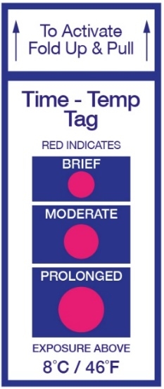
Some medicines and food products (such as raw meats) require constant chilling for them to remain effective or safe. They cannot be exposed to temperatures above 8°C.
An alternative to thermochromic labels is the use of digital thermometers. The table below factors for consideration in using either of these methods to monitor temperature.
Factor | Thermochromic labels | Digital thermometer
Unit cost | 1.5p per unit | £90
Quality control speed | Quick | Slow

Analyse the data provided.
(a) Calculate the number of stickers that would need to be used in order for the
cost of stickers to equal the cost of the thermometer. Show your working out in your answer. [2]

(b) Discuss the issues manufacturers face in deciding whether to adopt this
labelling technology for transporting goods. [6]

Miniaturised, lightweight components connected using conductive thread are becoming available to provide electrical power through garment fibres.
State one suitable group of users that these materials may be aimed at. [1]

[Total 10 marks]

