Name: Class: Mark:

Task 1
- (a) Match the labels to the correct part of the diagram:
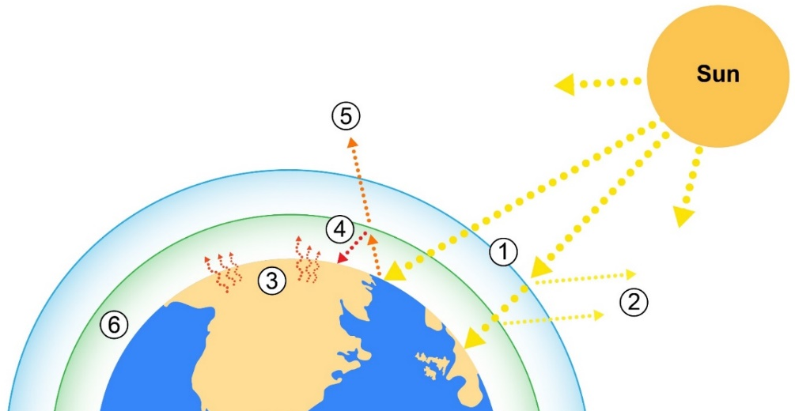

Some solar radiation is reflected away before it passes through to Earth

Infrared thermal radiation is reflected away from the Earth but bounces back

Greenhouse gases block infrared radiation from escaping and the thermal energy is reflected to Earth to warm the planet for a second time, causing global warming

Incoming solar radiation from the sun penetrates the Earth’s atmosphere

Infrared radiation is reflected away and escapes the Earth’s atmosphere and is released back into outer space

Some solar radiation is absorbed into the surface of the Earth. This warming effect keeps the planet at a temperature that is suitable for living organisms

(b) If the Earth gets warmer what will happen to the ice caps in the North and South Pole? How could this affect low-lying land?

(c) How will the greenhouse effect, affect countries near the equator?

(d) How might global warming affect people and wildlife?

Task 2
- Autonomous vehicles are going to be increasingly a part of everyday travel.
Sensors, clever software, GPS location technology and Wi-Fi connectivity within the vehicles enables them to maintain safe passage.
Accidents and unforeseen dangers however, are an inevitable part of any journey that these cars are likely to encounter.
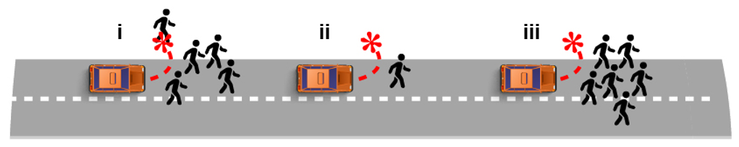
The following questions are about ethics in imaginary situation. Current sensors on vehicles cannot tell exactly who is near the vehicle, however in the future they may be able to tell an animal from a human and perhaps even one person from another.
(a) Discuss the ethics surrounding how the cars should be programmed to respond in different situations:
(i) Swerve to avoid a criminal gang, hitting a pedestrian on the pavement?
(ii) Swerve to avoid an elderly man, hitting the vehicle driver?
(iii) Swerve to avoid a group of children, hitting the vehicle driver?
(b) Who would be to blame for any accident? The driver? The manufacturer?
The programmer?

(c) Discuss how communication might be affected with Wi-Fi connectivity in every vehicle.

