Name: Class: Mark:

Task 1
The list below gives several different lifestyle choices.
- Add a plus (+) or minus (-) beside each choice to show which one adds (+) to a carbon footprint and which lifestyle choice reduces (-) a carbon footprint
- Explain how each lifestyle choice might affect someone’s carbon footprint
Lifestyle choice | ± | Explanation
Taking long-haul flights
Eating locally sourced food
Online shopping
Being vegetarian
Walking to the shops
Installing solar panels
Using a tumble drier
Sharing a lift to school
Using Skype / Facetime

Task 2 Life Cycle Assessment
Use the labelled diagram below to help you conduct a Life Cycle Assessment on a plastic supermarket shopping bag.
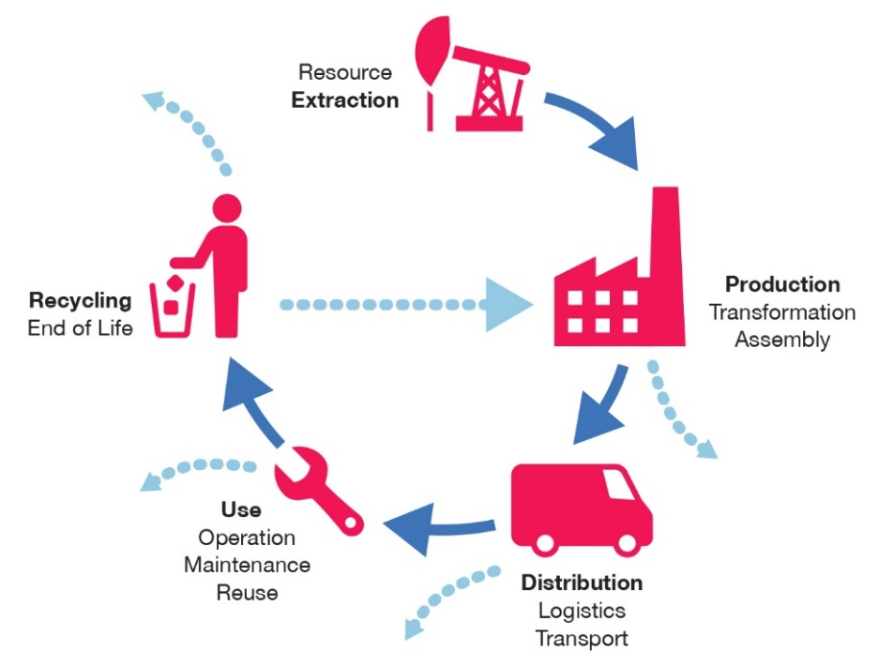
Extraction:

Production:

Distribution:

Use:

End of life:

What could you do to improve the environmental impact of a shopping bag?

Explain how plastic bags might contribute to pollution in the air and water.

Explain how this might impact global warming.

What new material is being used to provide an alternative solution?

Describe how the consumption of plastic bags is being reduced in the UK.

