Name: Class: Mark:

The charts below show the percentage of emissions and the percentage population
by region.
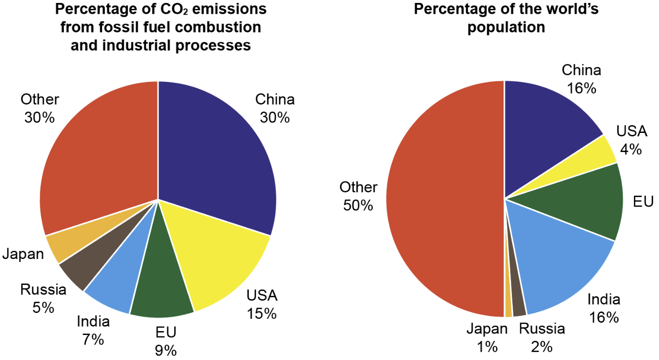
Source: https://www.epa.gov/ghgemissions/global-greenhouse-gas-emissions-data

Calculate the missing percentages.

Calculate the percentage of CO₂ emissions from Japan. [1]

Calculate the percentage of the world population living in the EU. [1]

  - India accounts for 16% of the global population, yet only 7% of carbon emissions. Describe how this compares to the data for the US. [2]

  - Explain what this data might tell you about the average lifestyles and social
values of those living in India compared to those living in the United States. [3]

- A cacao pod contains 40 seeds, each of which is separated, roasted, ground and added to other ingredients to become chocolate. The pods are harvested and managed by farmers in small communities, who then sell them on to fair trade chocolate producers.

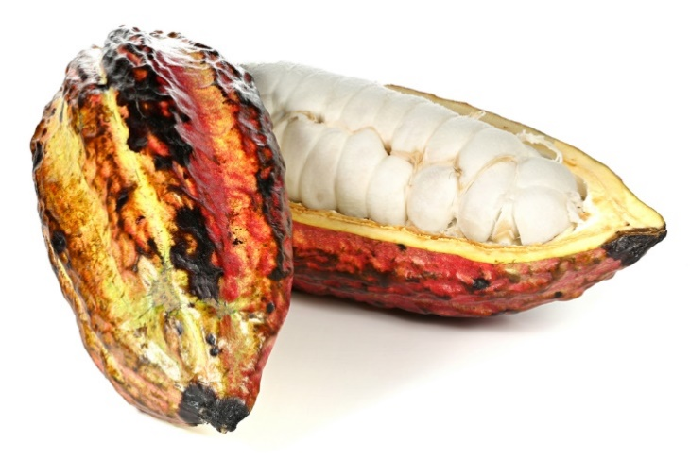

(a) Other than cacao, suggest two other examples of fair trade products. [2]

(b) Explain one benefit for fair trade farmer of selling their produce through a
fair trade organisation. [3]

[Total 12 marks]

