Name: Class: Mark:

1. Give three advantages to a manufacturer of using CNC machinery to produce a
range of timber-based products. [3]
Advantage 1:
Advantage 2:
Advantage 3:

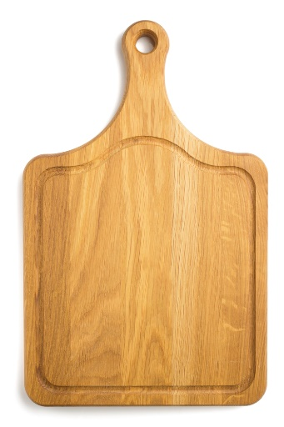
2. A mass-produced breadboard has been produced using a CNC router.
(a) Describe two factors that make the board suitable for CNC manufacture. [2]

(b) What quick and easy to use quality control measure could a manufacturer use
to ensure that the hole cut in the board is within a specific tolerance? [1]

3. Give two reasons why a manufacturer uses systems to ensure the accuracy
of their products. [2]

4. A company manufacturing children’s furniture wants to extend their range to include
high quality educational toys.
Name one suitable material that you would recommend manufacturing the toys from. [1]

5. State which one of the finishes below is not suitable for use on an external
window frame. [1]
⬨ Varnish
⬨ Wax
⬨ Paint
⬨ Stain
⬨ Wood preservative
6. When purchasing rough-sawn timber for outdoor use, you may opt to have
tantalised timber.
(a) Explain the process of tanalising. [3]

(b) State two advantages of tanalising timber. [2]

[Total 15 marks]

