Name: Class:

Task 1
Look at the two rocking horses below in figures 1 and 2.
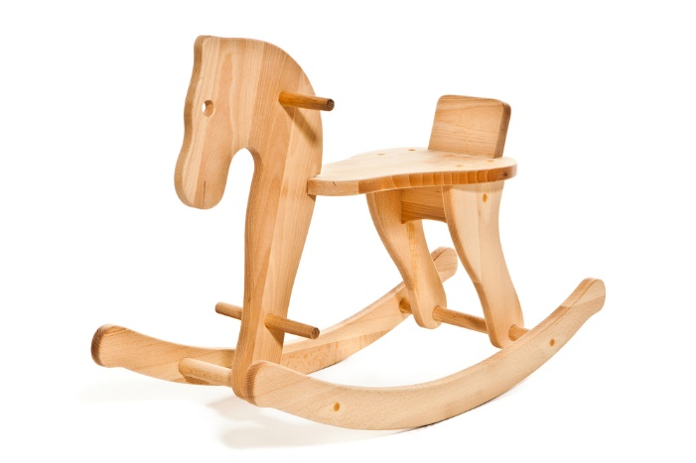 | 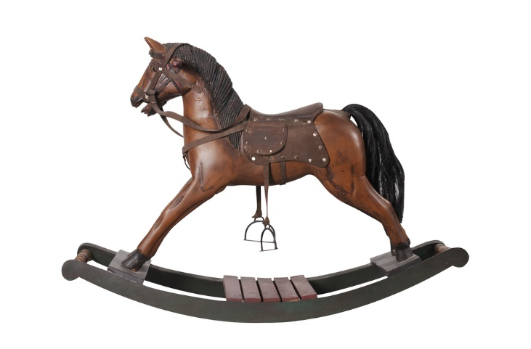
Figure 1 | Figure 2
Choose one scale of production appropriate to manufacture the rocking horse in Figure 1 and explain your choice.

Name one advantage of using plywood to manufacture the horse in Figure 1.

Choose one scale of production appropriate to manufacture the rocking horse in Figure 2 and explain your choice.

Name one advantage of using Jelutong wood to manufacture the horse in Figure 2.

Extension task
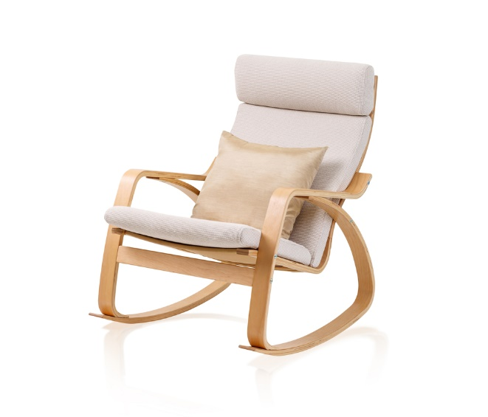
Figure 3
Look at the rocking chair in Figure 3. It is mass produced and supplied to the customer flat packed. Which aspect of the chair lends itself to sub assembly and why?

The chair is assembled using standard hex head bolts. The flat pack includes all fixings as well as an Allen key and pictorial instructions. What are the advantages to the manufacturer in supplying the furniture like this?

Task 2
The billiard table is made from natural timber.
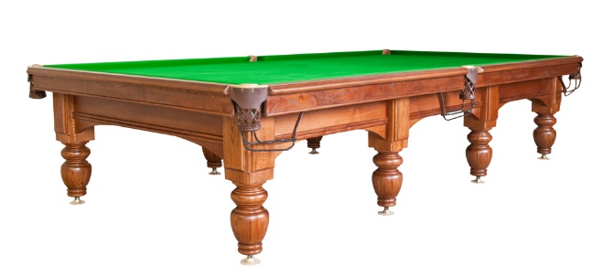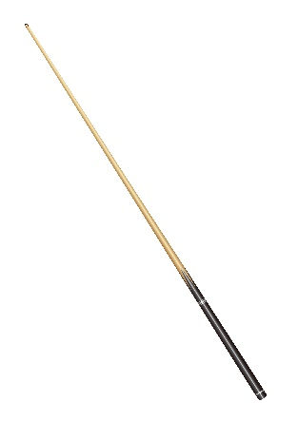
Suggest suitable commercial manufacturing techniques for finishing the detail on sides of the table, and for producing the legs and the cue.

Reason for choice:

What would be a suitable method of finishing and protecting the table?

Reason for choice:

Extension task
The wooden clock has been commercially made.

Why have bright colours been used for the numbers and hands on this clock?

What are the risks of using paint on a child's toy?

What can the manufacturer do to ensure the clock is safe?

