Name: Class: Mark:

A timber 'moulding' would be suitable for which one of the following applications? [1]
⬨ Reinforcing a wood joint
⬨ A skirting board
⬨ Shaping a steam bent plank
⬨ A kitchen worktop
2. What is the function of a surform? [1]
⬨ To route a groove in wood
⬨ To remove wood from rebates and recesses
⬨ To smooth a surface
⬨ For the fast removal of material

3. Study the picture of the hand-held disc sander shown below. [6]

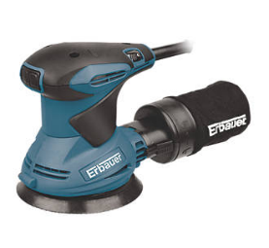

Complete the table below by identifying three additional hazards and state a precaution
for each one.

Examples have been given.
Hazard | Precaution
Clothing becoming ruined / contaminated  Long hair could get caught in the disc | Wear and apron or dust jacket  Ensure long hair is tied back

4. Name each of the following tools and describe a specific process where you would
use each tool. [4]
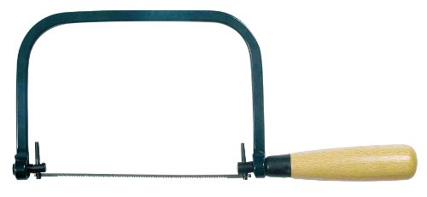

Name:

Process:

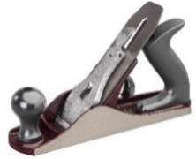

Name:

Process:

- State three advantages of having stock forms and sizes of timber readily available. [3]

[15 marks]

