Name: Class:

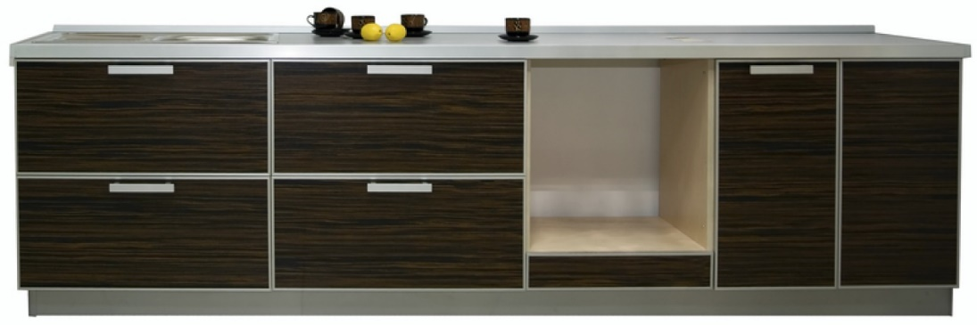
Task 1

Kitchen cabinet manufacturers frequently use standard components and knock down fittings to enable their cabinets to be assembled within customers’ homes.
Study at the image above:
What knock down fitting could you use to attach a worktop to the cabinet carcass?

Reason for choice

What type of hinge could you use to hang the doors on the cabinet carcass?

Reason for choice

What fixing would you use to connect a hinge to a cabinet door?

Reason for choice

Mathematics extension exercise
One unit carcass measuring 600mm wide and 560mm deep and 720mm high is to be cut and fabricated from a sheet of chipboard. Using the cutting specification below, show how the parts would fit efficiently onto a standard sheet 1220mm x 2440mm.

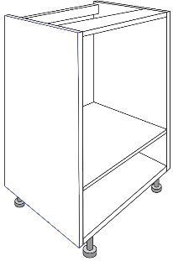

2 x 560mm x 500mm
2 x 720mm x 560mm
2 x 560mm x 100mm

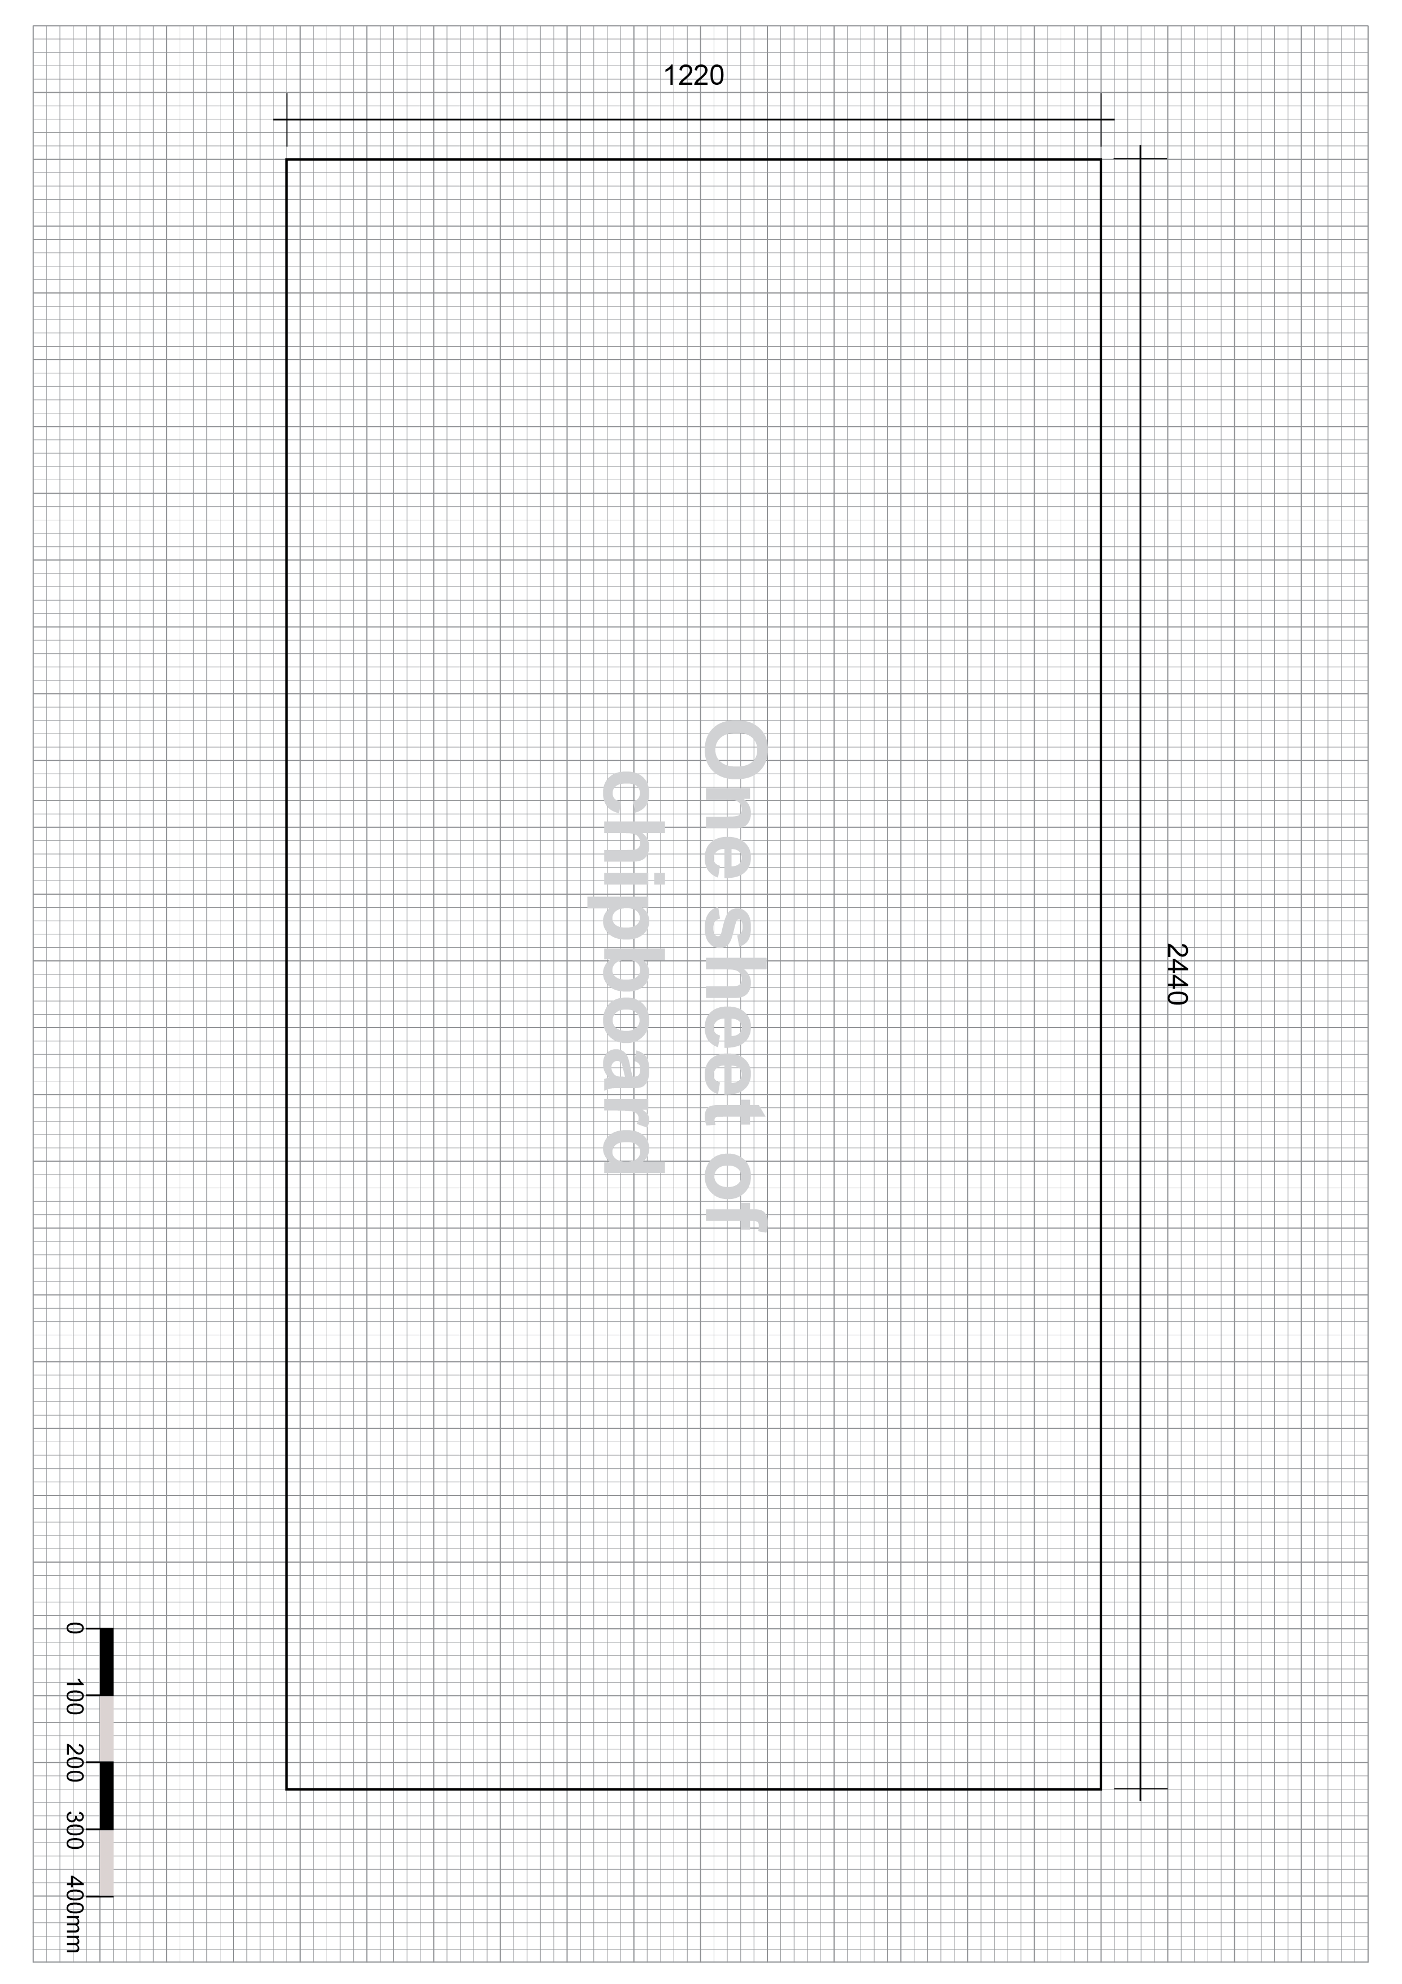
Calculate the area of waste material. (You can assume there is no allowance for kerf.)

Work out whether it theoretically possible to cut two carcases from the same piece of board?

Explain whether it is physically possible?

Task 2
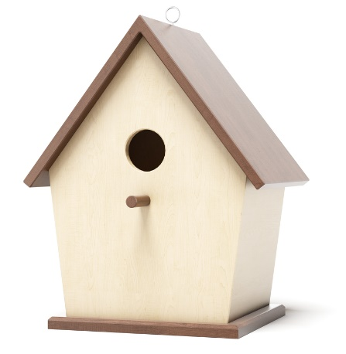
Look closely at the image above:
Point 1 - What type of joint has been used to join the two pieces that make the peak of the roof?

Reason for choice

Point 2 – The roof is screwed to the body of the box, what is the name of the first hole that is drilled through both pieces of wood to accommodate the screw?

What is the name of the second larger hole that is drilled through only the top piece
of wood?

What is the name of the drill bit that is used to make a third shallow hole that allows the screw head to be screwed in flush?

Point 3 - What type of drill bit would you use to create the entrance hole in the front of the bird box?

What type of sanding machine would help you sand the inside of the hole to ensure a smooth edge?

Task 3
Using annotated sketches, describe how you would laminate the wooden chair component pictured below.
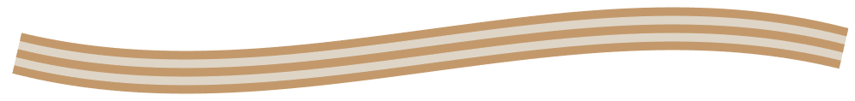

What are the advantages of laminated timber over single timber planks or boards?

