Name: Class:

Task 1
The two commercially produced benches below are very similar in design however the bench in figure 1 is made from the softwood, pine and the bench in figure 2 is made from
the hardwood, oak.
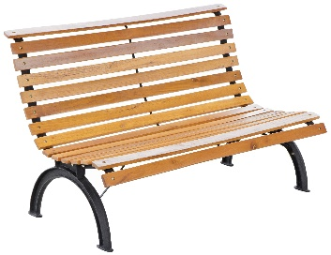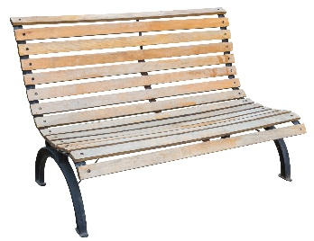
Figure 1 Figure 2
State two advantages of using pine to manufacture this bench.
Advantage 1:
Advantage 2:

Name one disadvantage of using pine.
Disadvantage:

List two advantages of using oak to manufacture this bench.
Advantage 1:
Advantage 2:

List one disadvantage of using oak.
Disadvantage:

How might genetic engineering be used to produce pine that is a preferable material for
the bench?

Task 2
Manufactured board is often used in the production of flat pack furniture.
Give two advantages and two disadvantages of using manufactured board instead of a natural timber.
Advantages | Disadvantages

Task 3
The disposable cutlery below is made from thermo-formed birch wood.
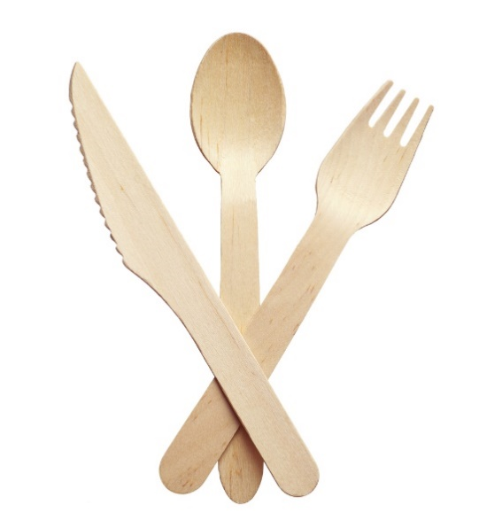
Suggest some advantages that disposable wooden cutlery may have over plastic cutlery based on the following responsible design criteria:
- Safety

- Fit for purpose

- Cultural or social differences

- Sustainability

Suggest possible disadvantages of the introduction of disposable wooden cutlery.

