Answers
Task 1
The two commercially produced benches below are very similar in design however the bench in figure 1 is made from the softwood, pine and the bench in figure 2 is made from
the hardwood, oak.
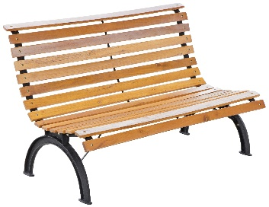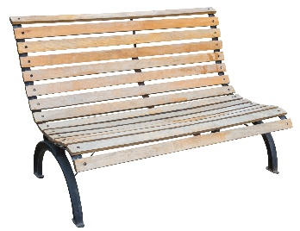
Figure 1 Figure 2
State two advantages of using pine to manufacture this bench.
Advantages: Low cost, readily available, easily stained or painted.
Name one disadvantage of using pine.
Disadvantages: Must be finished / tanalised to protect the timber, less robust than oak, not very water resistant and prone to rot.
List two advantages of using oak to manufacture this bench.
Advantages: Hard wearing / durable / tough, aesthetically pleasing, less prone to rotting, does not require a protective coating.
List one disadvantage of using oak.
Disadvantages: Expensive, some types prone to splitting along grain, fewer stock sizes available / stock sizes may be harder to obtain, hardwood can blunt tools more quickly.
How might genetic engineering be used to produce pine that is a preferable material for
the bench?
Trees can be engineered to grow straighter and with fewer small branches and thus fewer knots and faults. Trees can be made more resistant to disease / rotting / fungus / moisture.
Task 2
Manufactured board is often used in the production of flat pack furniture.
Give two advantages and two disadvantages of using manufactured board instead of a natural timber.
Advantages | Disadvantages
Low cost production  Choice of colours and finishes  Available in large format sheets  More stable than natural timber  Makes use of waste wood  Cheaper than natural timbers | Not as robust  Can chip and break easily  Easily damaged by moisture  Adhesives used are bad for the environment  Natural wood is perceived as higher value/quality by many consumers

Task 3
The disposable cutlery below is made from thermo-formed birch wood.
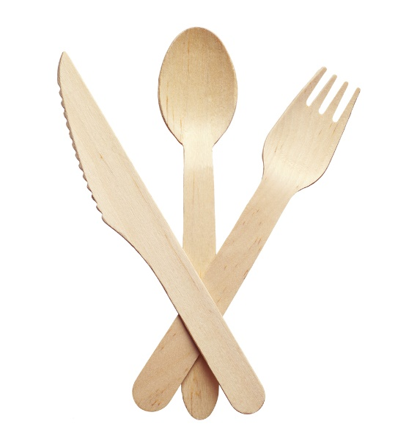
Suggest some advantages that disposable wooden cutlery may have over plastic cutlery based on the following responsible design criteria:
- Safety
Birch cutlery is free from toxic chemicals unlike plastics.
- Fit for purpose
Wooden cutlery is stronger and less likely to snap in use than single use plastics.

- Cultural or social differences
In some countries recycling is still not the norm and so biodegradable cutlery is more suitable. Some social and cultural groups are refusing single use plastics making these birch products an acceptable option.
- Sustainability
Birch is a renewable resource. Whilst plastic is recyclable, birch is biodegradable/compostable if put into landfill.
Suggest possible disadvantages of the introduction of disposable wooden cutlery.
Whilst mass produced and relatively inexpensive, it still costs more than plastic ‘disposable’ cutlery.
Anything that is branded ‘disposable’ encourages a ‘throw away’ mentality.
Wood is porous and so absorbs liquids making it less safe if it is used more than once.
Cheaply made wooden cutlery may not be finished carefully and may splinter or split.

