Answers
Task 1
Carbon is produced with every mile timber travels and with every process that it goes through. Describe how each stage of timber production from tree to end product adds to its overall carbon output.
Machinery burns fuel to plant trees; trees are thinned; others are cut down by logging machinery. Logs are stripped and loaded onto lorries; driven to saw mills; cut to size by machinery in the sawmill that uses electrical energy. Energy is also used in the kiln-drying process. It is sawn, planed and transported to builder’s merchants / manufacturer. Transported again to end-point. Converted by manufacturer / builder into end product by further machining.
Task 2
A European company that designs and manufactures wooden kit houses, like the one pictured, has asked you to source materials for the construction of similar houses in the UK.
All materials must be sustainably sourced and be either recyclable or made of
recycled materials.
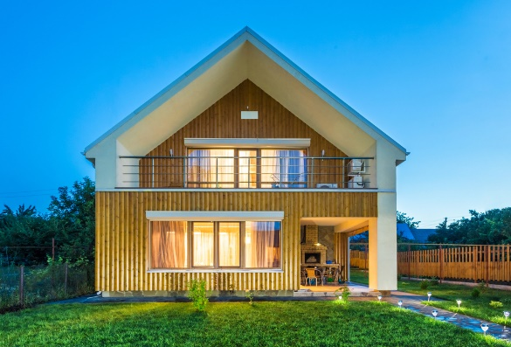
- Suggest a suitable material and its source for the external frame of the house and the window and door frames:
Material:
Solid timber, some students may identify a specific type – hardwood, softwood and
a few students may specify a species – cedar, pine, oak etc.

Reason for choice:
Available in long, standardised planks or beams, readily available, sustainable,
natural resistance to insect/fungal attack, durable (some may refer to finish or
protective qualities), aesthetically pleasing.

Source of material:
Sustainably managed forests in the UK, supplier must be PEFC or FSC accredited.

- Suggest a suitable timber-based material that could be used internally to form
the floors.
Material:
Manufactured board, some students will identify a specific board – veneer faced - plywood, chipboard, veneer faced MDF, OSB etc.
Reason for choice:
Students should show consideration of function i.e. the advantage of the available size of manufactured boards, cost, sustainability, durability, rigidity.

Manufacture of material:
Students should mention the source of materials, either – waste from the timber industry, recycled wood etc., and that veneers, chips, strands, particles etc. are glued together under compression, or sheets of timber veneers or blocks of low-grade timber from sustainably managed forests laminated together with adhesives.
- The company is also considering designing a garden storage shed for the house. Explain why you would not choose to make this out of chipboard or MDF?
Chipboard and MDF do not function well externally as they structurally degrade when subject to moisture ingress.

