Answers
A timber 'moulding' would be suitable for which one of the following applications? [1]
⬨ Reinforcing a wood joint
⬧ A skirting board
⬨ Shaping a steam bent plank
⬨ A kitchen worktop
2. What is the function of a surform? [1]
⬨ To route a groove in wood
⬨ To remove wood from rebates and recesses
⬨ To smooth a surface
⬧ For the fast removal of material

3. Study the picture of the hand-held disc sander shown below. [6]

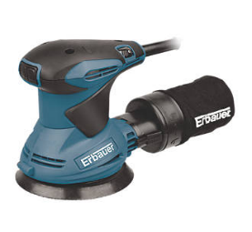

Complete the table below by identifying three additional hazards and state a precaution for each one.

Examples have been given.
Hazard | Precaution
Clothing becoming ruined / contaminated  Long hair could get caught in the disc | Wear and apron or dust jacket  Ensure long hair is tied back
Dust could enter your lungs  Dust could fill the workshop | Wear a dust mask / ensure extraction is connected to / near the equipment if available
Dust / flying debris could get into your eyes | Wear a face mask/visor
Trailing lead could be a trip hazard | Ensure it is signed / covered / clamped to avoid / reduce trip hazard
Danger to others close by | Only one person should be near the machine unless helping in which case full / same PPE should be used

Award 1 mark for each correctly identified hazard and 1 mark for each relevant precaution up to a maximum of 6 marks.
4. Name each of the following tools and describe a specific process where you would
use each tool. [4]
Award 1 mark for each correctly identified tool and up to 1 mark for a correct description of a specific process up to a maximum of 4 marks.
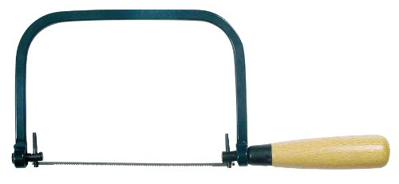

Name
Coping saw (1)

Process
When cutting a detailed shape in a piece of wood (1).
When cutting a curved shape in a piece of wood (1).
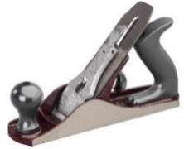
Name
Smoothing plane (1)

Process
Removes fine strips of wood / used to flatten an uneven edge or face / used along the grain of the wood / used to create an accurate 90-degree face side and edge / used to finish wood before final sanding (1).

- State three advantages of having stock forms and sizes of timber readily available. [3]

Award 1 mark for each correct point up to a maximum of 3 marks.
- Components are commonly manufactured to fit and work with stock forms
- Shapes, sizes and quantities are recognised by those who use timber products
- Ensures a cheaper supply of standard sized materials due to mass production
- Available immediately without the need to wait for bespoke materials
- The primary processing has already been completed
- Storage, transportation and handling can be easier since machinery has been manufactured to work more easily with stock sizes
- Processing machinery is commonly set up to work with standard sizes of materials
[15 marks]

