Answers
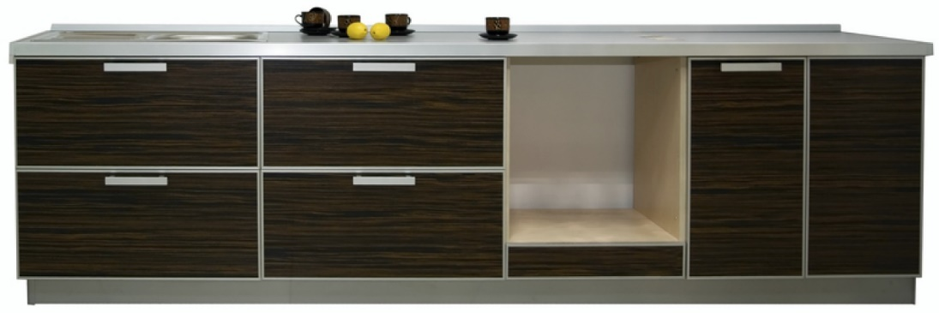
Task 1

Kitchen cabinet manufacturers frequently use standard components and knock down fittings to enable their cabinets to be assembled within customers’ homes.
Study at the image above:
What knock down fitting could you use to attach a worktop to the cabinet carcass?
KDF: Many names are used for the same component include modesty blocks / assembly joint / joining block / block fitting / connecting block / cam lock fitting
Reason for choice
Readily available, standardised sizes, relatively inexpensive, simple to fit, joint will not be visible from the outside, will hold worktop securely.
What type of hinge could you use to hang the doors on the cabinet carcass?
Hinge: Concealed hinge
Reason for choice
Readily available, standardised sizes, relatively inexpensive, standard jigs and drill bits available for fitting, highly adjustable, allows doors to open out beyond 90 degrees, once fitted doors can be removed easily for cleaning.
What fixing would you use to connect a hinge to a cabinet door?
Screw / countersunk screw / self-tapping screw
Reason for choice
Readily available, standardised sizes, relatively inexpensive, jigs available to assist fitting, joint will not be visible, load bearing, good shear strength, ensures a tight join between door and carcass.

Mathematics extension exercise
One unit carcass measuring 600mm wide and 560mm deep and 720mm high is to be cut and fabricated from a sheet of chipboard. Using the cutting specification below, show how the parts would fit efficiently onto a standard sheet 1220mm x 2440mm.

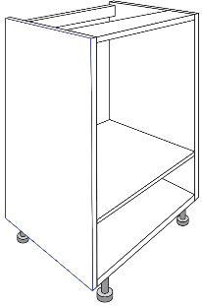

2 x 560mm x 500mm
2 x 720mm x 560mm
2 x 560mm x 100mm
Answers may vary.

Calculate the area of waste material. (You can assume there is no allowance for kerf.)
Area of standard sheet: 1220 x 2440 = 2,976,800.
Area of parts: 560 x 500 x 2 = 560,000
720 x 560 x 2 = 806,400
560 x 100 x 2 = 112,000
Total = 1,478,400

Area of waste = 2,976,800 – 1,478,400 = 1,498,400mm² or 1.4984 m². (Allow 1.5m².)
Work out whether it theoretically possible to cut two carcases from the same piece of board?
Yes, with a waste of 20,000mm² or 0.02m².
Explain whether it is physically possible?
Yes, but only assuming there is no kerf waste. See outlines on cutting diagram.

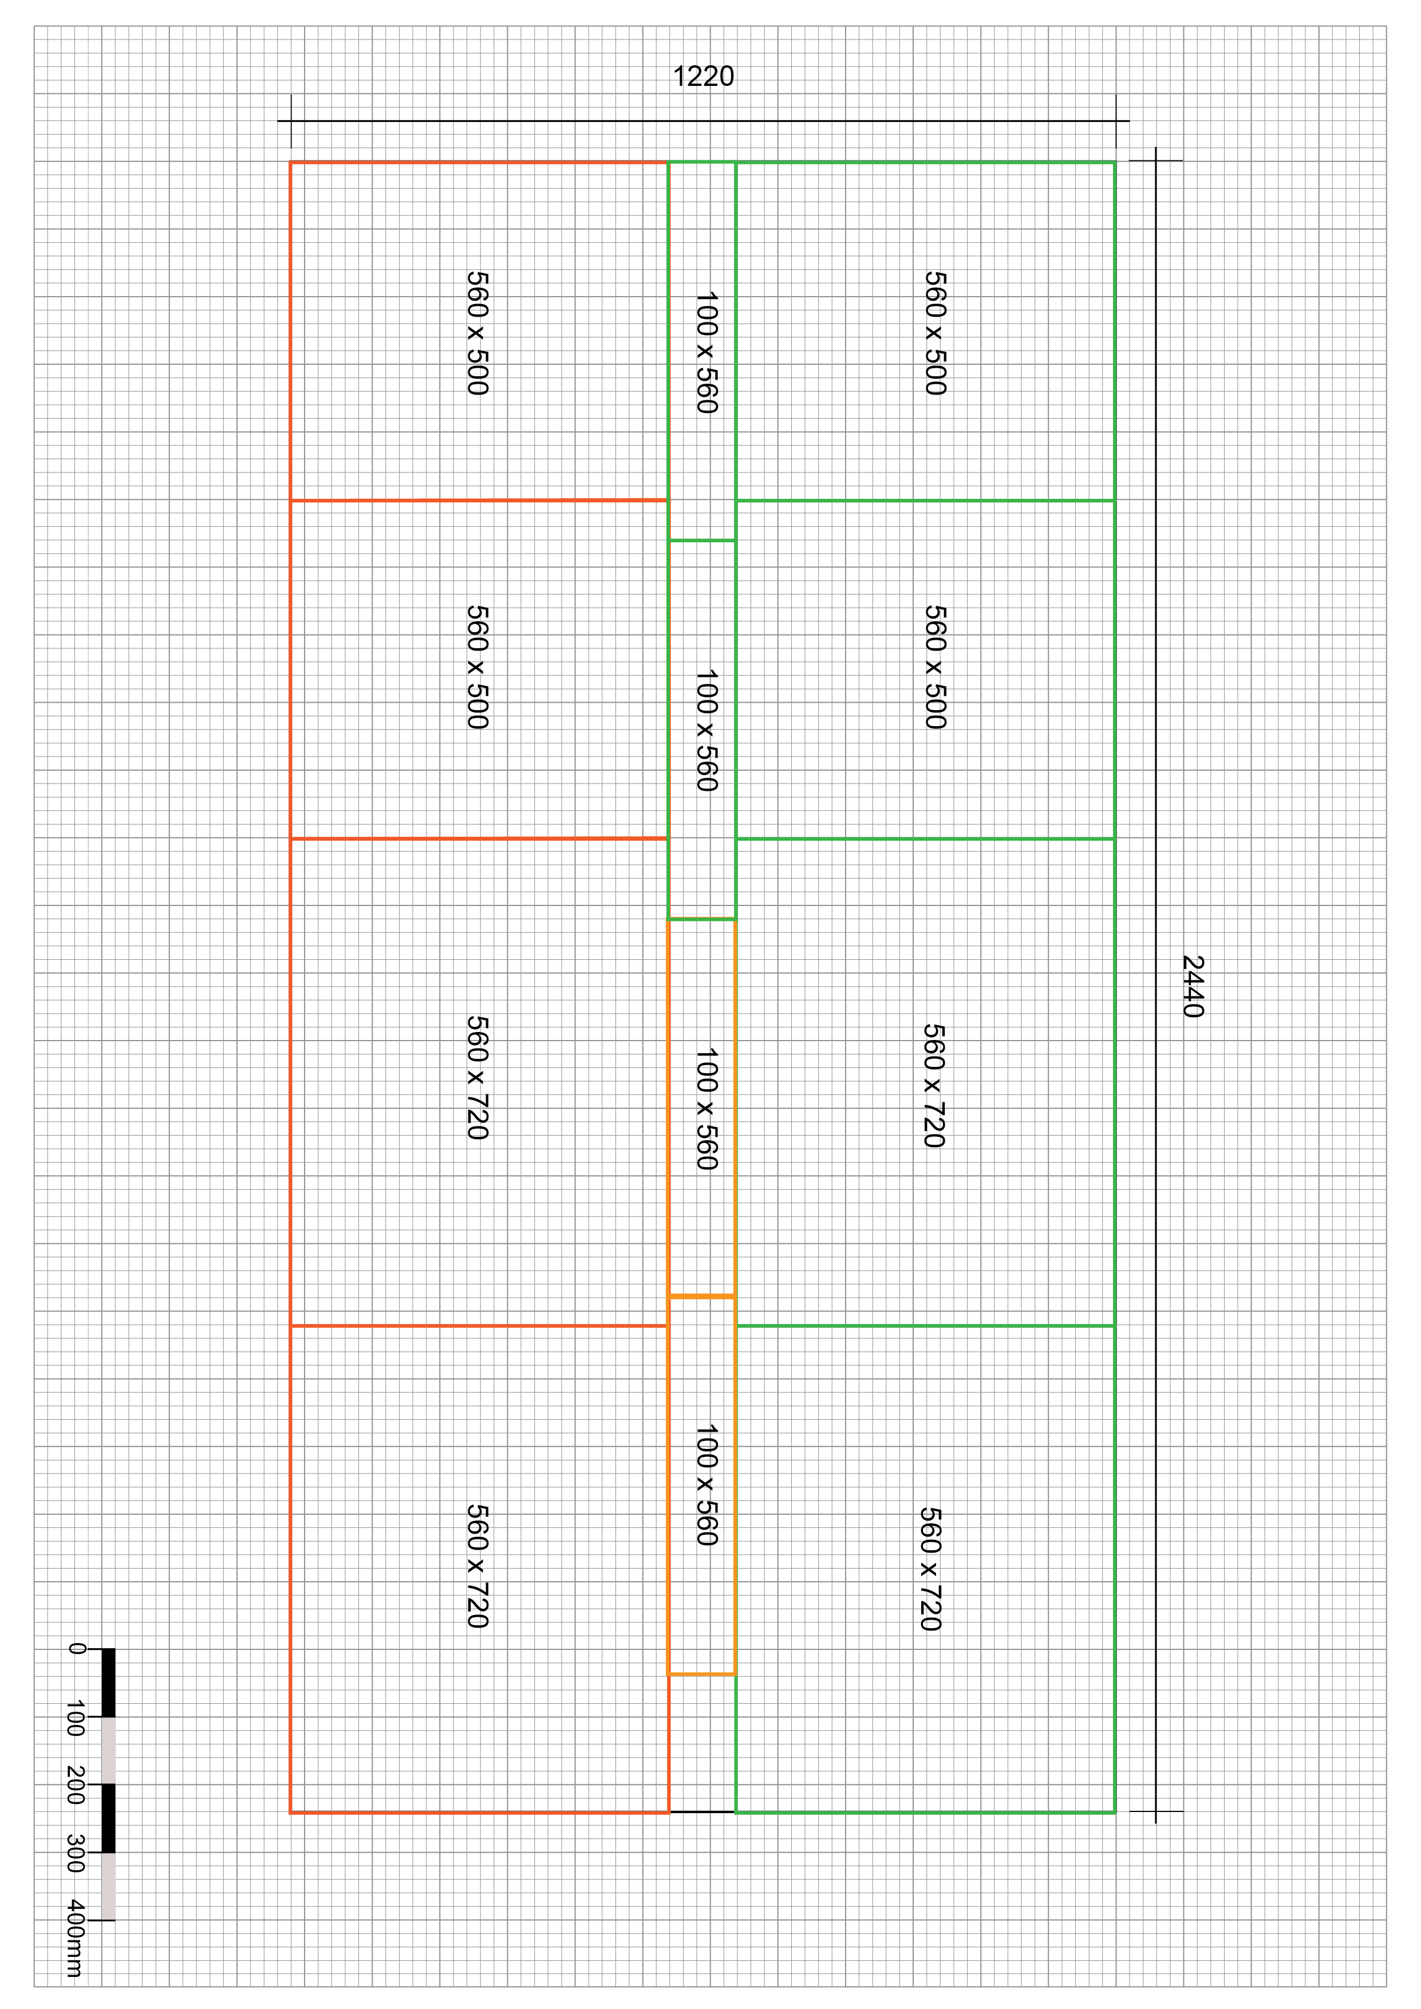
Task 2
1
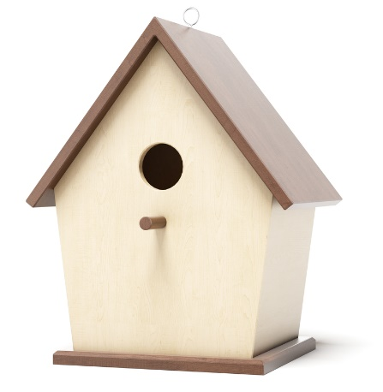
3
4
2
Look closely at the image above:
Point 1 - What type of joint has been used to join the two pieces that make the peak of the roof?
Mitre joint
Reason for choice
Attractive finish, suitable for angled joints, especially those not at 90 degrees.
Point 2 – The roof is screwed to the body of the box, what is the name of the first hole that is drilled through both pieces of wood to accommodate the screw?
Pilot hole
What is the name of the second larger hole that is drilled through only the top piece
of wood?
Clearance hole
What is the name of the drill bit that is used to make a third shallow hole that allows the screw head to be screwed in flush?
Countersink bit
Point 3 - What type of drill bit would you use to create the entrance hole in the front of the bird box?
Forstner bit, hole saw, flat bit
What type of sanding machine would help you sand the inside of the hole to ensure a smooth edge?
Bobbin sander

Task 3
Using annotated sketches, describe how you would laminate the wooden chair component pictured below.
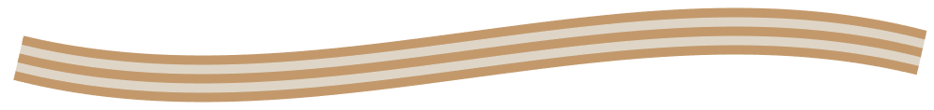
Two different methods for laminating wood using a jig/former and clamps or bag press / vacuum method.
Award credit for responses that include reference to:
- Preparing a two-part former or jig or
- Setting up a vacuum / bag press
- Cutting thin layers of material
- Gluing up layers using even coat of adhesive
- Laying glued laminate in/over the former or jig
- Clamping the former between sash cramps or
- Running the vacuum / bag press to pull the lamination over the mould
- Leaving in compression until dry
- Trimming the lamination to size

What are the advantages of laminated timber over single timber planks or boards?
Timber is less likely to split or crack.
Provides more even strength across the board in all directions.
No natural faults that could weaken the structure.
Increased protection from weather damage.
Laminated timber can make use of smaller pieces of timber, rather than one longer
/ larger piece.

