Answers

1. Give three advantages to a manufacturer of using CNC machinery to produce a
range of timber-based products. [3]
Award 1 mark for each correct advantage up to a maximum of 3 marks.
CAD software allows them to plan layouts (1), minimises waste (1), fast (1), efficient (1), accurate (1), consistent (1), doesn't require a skilled craftsman (1), cost effective after set-up costs are paid off (1), all/many processes can be completed in one go (1).

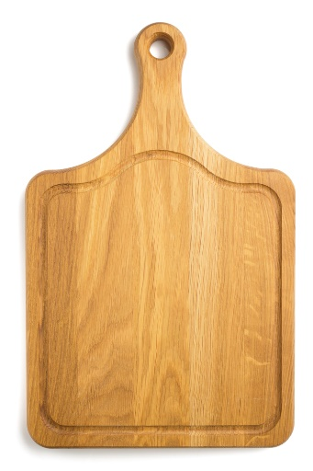
2. A mass-produced breadboard has been produced using a CNC router.
(a) Describe two factors that make the board suitable for CNC manufacture. [2]

Award 1 mark for each correct factor up to a maximum of 2 marks.
Identical shaped and sized products are produced in large batches (1), the board and the hole can be cut in one go (1), this can be repeated (1), CNC machine can change its tools to produce each hole, cut or groove (1), precision is required (1), CNC routers can run consistently and repetitively (1), shape can be nested easily (1).
(b) What quick and easy to use quality control measure could a manufacturer use
to ensure that the hole cut in the board is within a specific tolerance? [1]
A go/no go fixture / gauge.

3. Give two reasons why a manufacturer uses systems to ensure the accuracy
of their products. [2]
Award 1 mark for each correct reason up to a maximum of 2 marks.
To ensure consist high quality (1), to ensure parts fit / work / don’t break (1), fewer
faulty products (1), fewer returns (1), improves consumer satisfaction (1), saves
money (1), reduces waste (1), increases sales with greater reputation (1).
4. A company manufacturing children’s furniture wants to extend their range to include
high quality educational toys.
Name one suitable material that you would recommend manufacturing the toys from. [1]
Suitable material – Beech (1) or other suitable hardwood.

5. State which one of the finishes below is not suitable for use on an external
window frame. [1]
⬨ Varnish
⬧ Wax
⬨ Paint
⬨ Stain
⬨ Wood preservative
6. When purchasing rough-sawn timber for outdoor use, you may opt to have
tantalised timber.
(a) Explain the process of tanalising. [3]
Award 1 mark for each correct point up to a maximum of 3 marks.
Timber is immersed in a preservative (1); which is forced into the wood (1); under
high pressure (1).
(b) State two advantages of tanalising timber. [2]
Award 1 mark for each correct point up to a maximum of 2 marks.
Helps delay the rotting process (1); protects against insect / fungal attack (1), no need
or finishing by customer/ saves time (1).

[Total 15 marks]

