Answers
Task 1
Look at the two rocking horses below in figures 1 and 2.
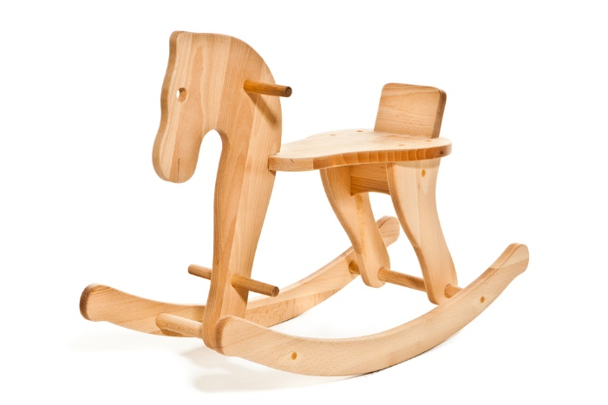 | 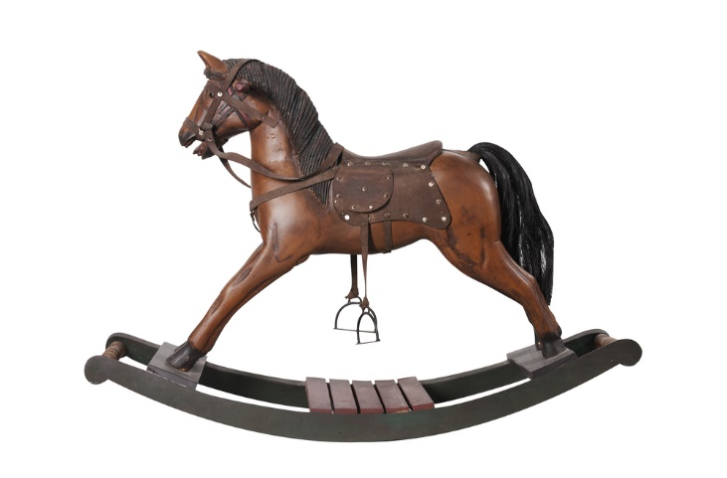
Figure 1 | Figure 2
Choose one scale of production appropriate to manufacture the rocking horse in Figure 1 and explain your choice.
Batch production: Simple product made up of several component parts which can be produced and repeated using jigs and template or CAD/CAM e.g. router / laser cutter.
Name one advantage of using plywood to manufacture the horse in Figure 1.
Advantages: Relatively inexpensive, available in large sheets (no need for joining planks / suited to CAM) consistent finish, stable material, easily finished.
Choose one scale of production appropriate to manufacture the rocking horse in Figure 2 and explain your choice.
One off or bespoke production: The design is detailed and requires specialist skilled hand manufacturing techniques such as carving and joint making. Manufacture will take time and materials will be costly.
Name one advantage of using Jelutong wood to manufacture the horse in Figure 2.
Advantages: Easy to carve and shape, takes paint/varnish well.

Extension task
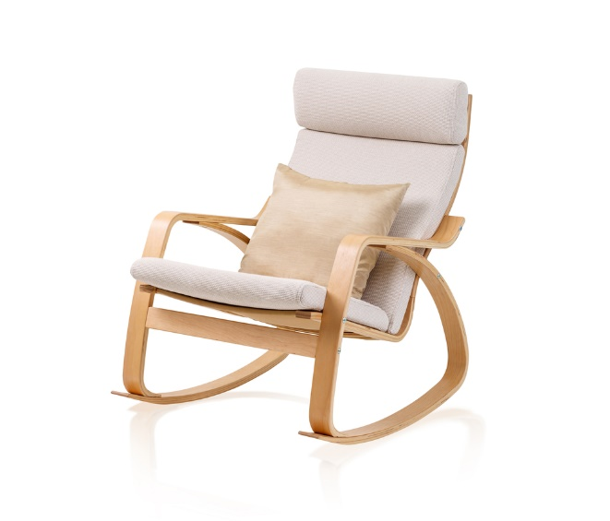
Figure 3
Look at the rocking chair in Figure 3. It is mass produced and supplied to the customer flat packed. Which aspect of the chair lends itself to sub assembly and why?
The seat cushion assembly – it requires specialist upholstery / sewing skills including fitting zips and sizing foam.
The chair is assembled using standard hex head bolts. The flat pack includes all fixings as well as an Allen key and pictorial instructions. What are the advantages to the manufacturer in supplying the furniture like this?
Not having to assemble the complete product in the factory saves time and money. It saves storage space in the warehouse and during transport. Savings may be passed on to the consumer making the product more accessible and desirable. The flat packed product is smaller easier to transport which means that the customer may be inclined to buy more.

Task 2
The billiard table is made from natural timber.
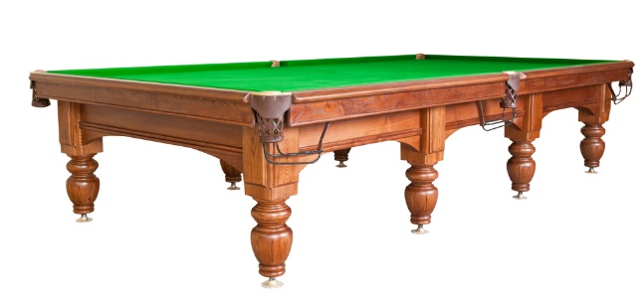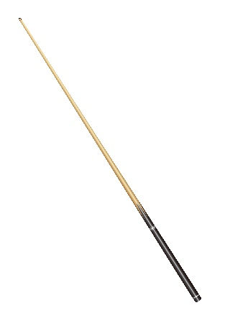
Suggest suitable commercial manufacturing techniques for finishing the detail on sides of the table, and for producing the legs and the cue.
Routing for the detail around the table, turning for the legs and cue.
Reason for choice:
Routers to accommodate large sheets, quick, accurate, incorporate extraction to remove harmful dust.
Lathe (possibly CNC) able to accept large and long sizes of wood.
What would be a suitable method of finishing and protecting the table?
Stain and varnish / lacquer. Bespoke polishes may be applied.
Reason for choice:
Stain to enhance the wood grain, clear varnish, available in gloss or matt finish, for protection against knocks and bumps.
Extension task
The wooden clock has been commercially made.
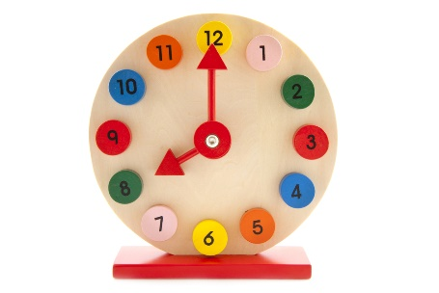
Why have bright colours been used for the numbers and hands on this clock?
To make the clock appealing, to highlight the numbers, to make the clock more fun.
What are the risks of using paint on a child's toy?
Younger children might chew smaller parts, some paints are toxic.
What can the manufacturer do to ensure the clock is safe?
Ensure all paints are non-toxic, ensure parts are either fixed or not small enough to be swallowed or choked on.

