Answers
Task 1
- Car manufacturers are producing new electric vehicles. Over the next 20 years, many nations have vowed to ban the internal combustion engine and the ‘traditional’ motor car.
Why is battery technology crucial in the development of electric vehicles?
Cars need to be able to travel long distances between recharging to make them more appealing. They also need to decrease charging time for short distances in an effort to be more similar to the time it takes to fill a petrol tank.
- An electric car requires far fewer moving parts with no gear box and no internal
combustion engine.
(a) How will the transition from the manufacture of combustion engines and gear trains to electric motors affect employment at car plants?
Employment is likely to fall in those mid-skilled areas that specialise in the production of engine parts and exhaust systems. Employment may rise in electronics departments. Less complicated manufacturing (with fewer parts) may result in a fall in the number of workers required to assemble vehicles.
(b) How might the skill set of a workforce change in vehicle servicing?
A vehicle servicing workforce is likely to require extensive retraining in electric motors and the problems they may face with any repairs. Workers who are unable or uninterested in retraining may lose their positions.
- Analyse the graph below. There were approximately 100,000 electric vehicles sold in 2012 worldwide.
Calculate the expected number of electric vehicle sales in 2017 based on the sales figure from 2012 – 2016. Show your working.
Each year increases by the same as the last plus an additional 50,000. 2017 is therefore predicted to increase by 300,000 vehicle sales to 1,100,000 total sales.
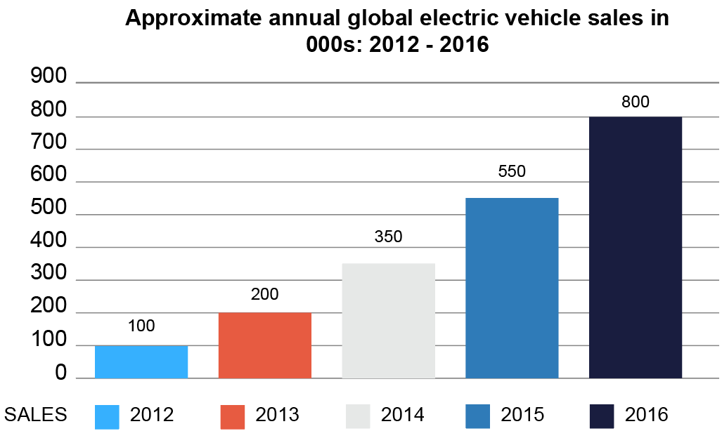
Task 2 The impact of new technology on enterprise
- 3D printing technology has been around for over a decade, but it is now starting to become widely accessible. One day all households may have a 3D printer with the ability to print anything to a similar level of quality as current manufacturing standards.
How might 3D printing change the spare parts industry for small household appliances?
Users may download a spare part printing file for a small fee.
Those without a printer may go to a local shop similar to a key cutter to ask for a part to almost anything, receive a print out, go home and install it.
Product longevity will increase, and manufactured obsolescence will be more difficult to achieve. Without the need to hold parts in stock for very old appliances, companies can offer lifetime support. People can access perfectly made parts indefinitely.
- Small, privately-owned businesses commonly have limited budgets and finances.
How might these businesses benefit from the latest print-on-demand and prototyping services provided by 3D printing technology?
Privately-owned businesses are commonly able to react quickly to changes in technology. 3D printing technology provides a very cost-effective way of prototyping new products before they are manufactured.
The repairs industry is likely to boom. People may be employed to create print files for anything. Small business will emerge to capitalise on a growing market for spare parts. These will all need employees.
- A not-for-profit organisation called CYBER Team has been started to help make 3D printed orthotics and prosthetics for US war veterans. The company also employ people from the veteran community, including those they are directly trying to help.
Explain how a not-for-profit organisation differs from a privately-owned business.
Not-for-profit organisations include charitable groups as well as those that generate their own revenue. Surplus revenues are reinvested back into their own causes. This may include local communities, animal welfare or medical advancement. They do not make private profit for directors, members or shareholders.
Privately-owned, profit-making companies aim to generate a profit to pay investors, employees and other stakeholders an interest share. Profits can be reinvested into the business (for example, research and development into new and emerging technologies) in order to generate greater future profits. This can increase the size of the businesses to provide greater employment and upskilling opportunities. It also helps incentivise employees to grow the business to further its own good causes.

