Answers
Task 1
Look at the product label below for a pair of shoes. List all the factors that contribute to the manufacturing footprint of this product and state how they affect the environment.
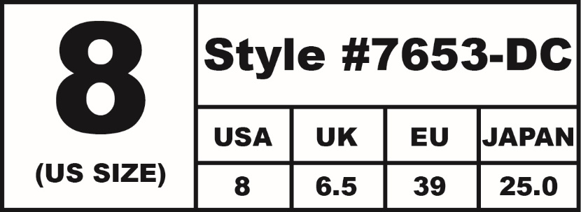
Style #7653-DC
Leather upper: made in China
Rubber sole made in USA
Manufactured in Canada
Steel lace eyelets
Patent finish

Leather involves animal skins; tanning process uses harmful chemicals. Patent finishes require additional chemical finishing processes. Rubber sole produced from oil or natural rubber from rubber trees; deforestation if not properly managed; process of converting rubber into a sole suitable for wear uses several industrial processes.
Product fuel mileage (assuming the product is sold in the UK) would be China to Canada 8000km by air, USA to Canada average 1700km by Road and Canada to the UK 5000km
by sea.
Shoes tend to go to landfill when they have been worn out. Not commonly recycled since they comprise many parts of different materials.
What finite resources may be used in the production of a pair of training shoes?
Oil – in the production of plastic or synthetic rubber components. Coal or gas – in powering power stations to fuel production processes. Leather use would also impact associated farming fuels.
How could these be replaced by alternative resources to make production ‘greener’?
Renewable fuel sources to power manufacturing processes. Other options may include vegetarian leathers*, recycled plastics (oceanic plastics) and textiles that are woven into new materials. (*Vegetarian leather also uses a large volume of chemicals in its production.)
Some students might suggest nuclear as a ‘greener’ energy source, but many would argue about the environmental soundness of nuclear power. This might form a useful discussion.

Task 2 Environmental impact
Compare the environmental impact of the pairs of products below. Remember to consider the following points:
- Demand on natural resources
- Transportation costs
- Oceanic pollution
- Atmospheric pollution
- Waste generation and disposal
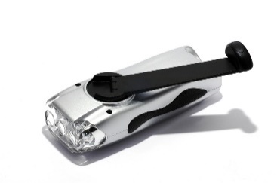  Wind-up torch | 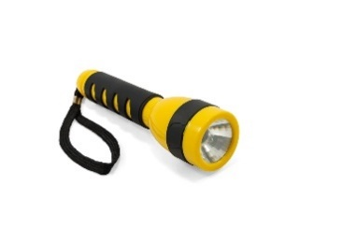  Battery powered torch
Responses may include:
Renewable power compared to battery power linked to dependency on fossil fuels
No need for battery disposal in wind-up torch and so fewer toxins released
No need to replace batteries in wind-up torch so less demand on resources
Both products require metals for their circuits which needs to be mined from the earth
Both products require plastics; processing plastic causes atmospheric pollution
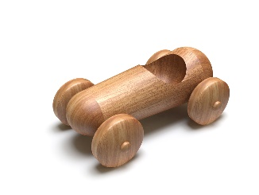  Wooden toy |   Plastic toy
Responses may include:
Wooden car is made from renewable materials compared to oil needed for polymers. Trees reduce CO₂ while growing and release oxygen.
Processing polymers from oils requires far more energy and produces far more toxins than processing timber
Wood can be sourced locally whereas oil for polymers is not
Use of tropical woods or woods without the FSC label may cause deforestation
Wood will biodegrade relatively quickly, whereas polymers do not biodegrade and will take hundreds of years to degrade.

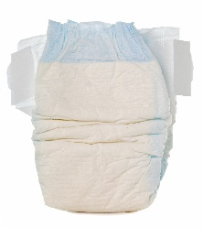  Disposable nappy | 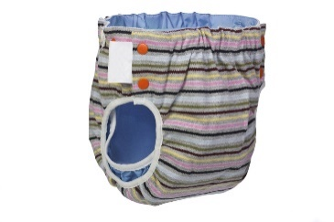  Reusable nappy
Responses may include:
Disposable nappies cannot be reused which increases demand for virgin materials
Polymers and chemicals used in disposable nappies
Disposable nappies take hundreds of years to biodegrade
Reusable nappies need to be washed which requires water, energy and detergents
By-products from the manufacture of both products could cause oceanic pollution
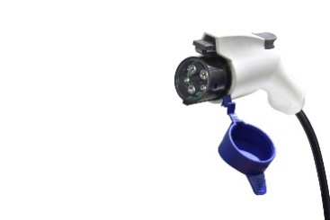  Electric car | 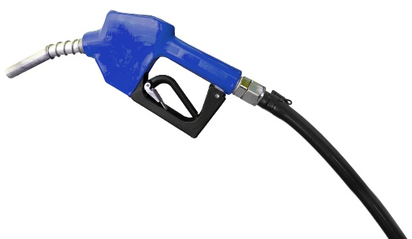  Diesel car
Responses may include:
Electric cars do not produce emissions in populated areas which makes for cleaner air in towns and cities
Electric cars still require energy which is still most likely to be sourced from non-renewable sources or multiple new nuclear power stations
Diesel comes from oil which is a fossil fuel and therefore will eventually run out
Electricity can be sourced from renewable sources whereas diesel cannot – cars must be converted to run off on biodiesel
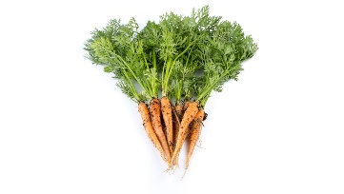  Homegrown vegetables | 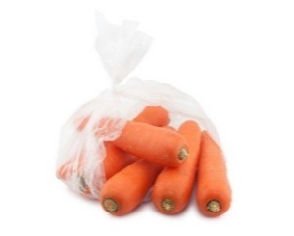  Supermarket vegetables
Responses may include:
Product miles are dramatically reduced with homegrown vegetables
Supermarket vegetables are often packaged
Homegrown vegetables are (usually) grown with fewer agrochemicals

