Answers
Task 1
Modern technology has enabled a wealth of new products with improved or enhanced functionality. Some of this has had a significant impact on job roles and in shaping the workforce.
Factories manufacturing mobile phone technology are becoming more and more automated, using robots for parts assembly and warehouse control. Despite this, some employ many thousands of people.
- What makes a role more or less likely to be replaced by a robot or an
automated process?
Roles that involve feeling, empathy or social intelligence are unlikely to be replaced. Those that require thinking, negotiation, care, assistance and originality are also unlikely to change.
Jobs that require assembly, repetitive structured processes, accessing small spaces or manipulating small objects are very likely to be automated.
See http://www.bbc.co.uk/news/technology-34066941
- Put the following job roles in order of those that are most under threat from automation:
Job role | Order  1 (Most under threat) - 10 | Skill level  (Low, Mid, High)
Personal assistant or secretary | 4 | Mid
Graphic designer | 9 | High
Sewing machinist | 2 | Mid
Large goods vehicle driver | 6 | Low
Vehicle assembler | 3 | Mid
Teacher | 10 | High
Pilot | 5 | High
Mechanical engineer | 8 | High
Packer, bottler, canner or filler | 7 | Low
Routine inspector and tester | 1 | Mid

It is interesting that the BBC put packers, bottlers, canners and fillers so low down this list. Why do students think that might be?
Skill levels are heavily open to debate since there are no official definitions of each sector but students may note that a pattern emerges where the mid-skilled jobs are placed lower in the order of those at threat.
- Discuss how the roles of people in manufacturing will have changed with the introduction of robotics and automated procedures.
Upskilling of new technicians to oversee equipment and maintenance. More highly-skilled workers such as programmers and software technicians are required to develop movement paths and customisations.
Task 2
Many companies including Google are developing autonomous self-driving vehicles.
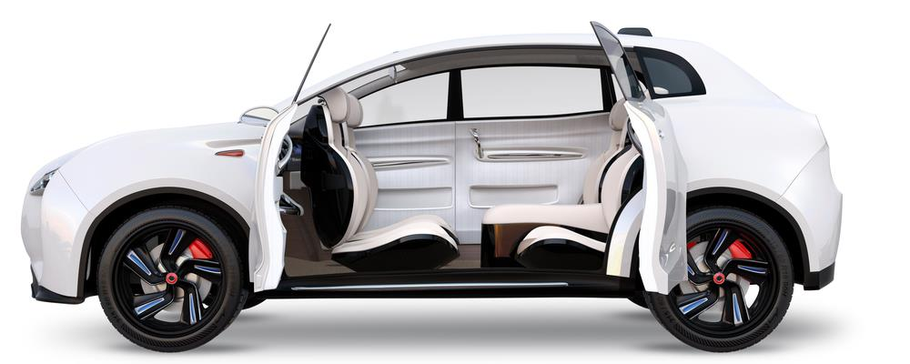
Explain how this might improve the lives of the elderly or impaired.
This is rapidly becoming reality with major companies such as Google, Uber, Tesla, BMW, Toyota, Volvo, Baidu and Apple all working on driverless vehicle systems.
The elderly often need to give up their driving freedom when their eyesight, reactions or strength deteriorates. An autonomous vehicle may allow them to maintain their sense of freedom.
Disabled or otherwise impaired people may also be able to travel privately without needing to be able to physically drive. Laws to this effect are yet to be decided.

Task 3
Amazon Air launched their first UK drone delivery in December 2016. A package was safely delivered to its destination in Cambridge in just 13 minutes after the order was placed.
Amazon drones take off and fly completely autonomously along pre-set flightpaths at 400m above ground level, guided by GPS. They are capable of carrying orders weighing up to 2.7KG and can easily be combined with the use of Amazon’s Dash button - a WiFi-connected device that reorders your favourite product with the press of a button.
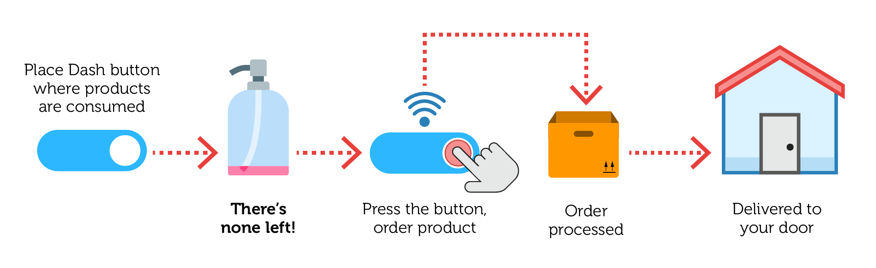
- How might the new Amazon Air delivery service affect those offering a traditional delivery service for Amazon?
Traditional delivery drivers may have fewer deliveries to make, affecting their income since they are frequently paid per delivery.
Drivers may be laid off if the Amazon Air service becomes widespread.
- What restrictions might there be on the operation of delivery drones?
Drones are currently restricted from flying in hours of darkness, in high winds, poor visibility, rain, snow or icy conditions. There are also strict limitations on altitude and designated flight paths. Drone operators will also be required to have a licence.
- How might the new service affect delivery services offered by competitors?
Cultural expectations surrounding delivery speed may add pressure on other companies to fulfil orders in faster and more convenient ways.
- What negative impacts might this service have on society?
Safety issues including collisions and falling objects, noise, interception of drone deliveries.

