Answers

1. Briefly explain the principle of ‘lean’ manufacturing? [1]
Elimination of waste (1).

2. A standard component is shown below.

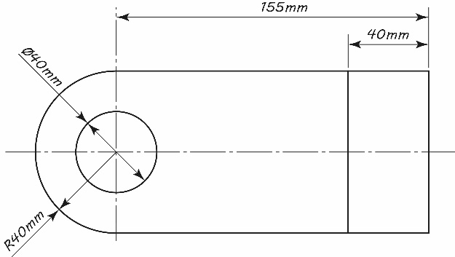
(a) The standard component is manufactured at a cost of £0.80 per unit. An employee realises that it could also be bought in at a cost of £0.56 per unit.
Calculate the percentage saving to the company in the cost of a bought in part. [3]
0.80 – 0.56 = 0.24 (1). 0.24 ÷ 0.80 = 0.3 (1) 0.3 * 100 = 30% cost saving (1).
(b) The part could be manufactured in-house or bought in as a standard part.
(i) Describe one disadvantage to the company of using standard parts. [2]
Award 1 mark for describing a disadvantage and a further mark for a relevant justification.
Loss of control over production quality (1) meaning that reputation is reliant on others (1).
Reliant on delivery arriving on time/stock elsewhere (1) potential to hold up production (1)
Parts may change and become non-standard for their use (1) meaning adaptation to the design would be needed (1).
(ii) Explain two benefits that just-in-time (JIT) manufacturing could have
for the manufacturer of the part. [4]
Award 1 mark for each explanation and a second mark for a justification/reason up to 4 marks. Accept alternative correct responses.
Less material will be held in stock (1); less money tied up in stock / materials they are not using (1).
Staff can be employed on a temporary basis (1); with more staff as peak periods dictate / lower wage bills (1).
Once parts have been made, they are immediately shipped (1); which negates any storage costs (1).
Payment is taken with the order (1); therefore, money is in the bank before outlay on materials/labour (1).

A retailer is looking for a lamp manufacturer.

Company A is a sole-trader - one highly skilled craftsperson and a well-equipped workshop. They will require one specialist tool to complete the project, costing £4.00. The craftsperson will charge £40 per hour and each lamp will take 4 hours to make.
Company B is a medium sized business with 20 semi-skilled workers. The cost of the specialist tools for the manufacture of the lamp is £100 and the workers need to be paid £7.50 each per hour. Five labourers can make a lamp in 2 hours.
(a) How much will it cost to make one unit with Company A? Show your workings. [2]
Award 1 mark for the correct working out and 1 mark for the correct answer.
Company A cost per unit = 4 + (40 x 4) = £164
(b) How much will it cost to make one unit with Company B? Show your workings. [2]
Award 1 mark for the correct working out and 1 mark for the correct answer.
Company B cost per unit = 100 + (7.5 x 5 x 2) = £175
(c) The retailer requires 50 lamps.
Discuss which company would offer better value for money and explain how the reduced cost per unit could be achieved. [6]
Indicative content:
- Company A cost per batch of 50 = 4 + (40 x 4 x 50) = £8,004
- Company B cost per batch of 50 = 100 + (7.5 x 5 x 2 x 50) = £3,850
- Company A cost per unit = £160.08, Company B cost per unit = £77.00
- Higher set up/tooling cost for Company B is spread over the 50 units so the more units that are made, the cheaper they become to manufacture (economies of scale)
- Use of jigs and templates to speed up manufacture, reduce waste, increase accuracy
- Reduced labour costs so more lamps can be made quickly for less
- Higher set up costs could be related to a higher level of automation which reduces labour costs and means the product can be made more efficiently

Level | Mark | Descriptor
 | 0 | No rewardable material
1 | 1-2 | - Attempts to interrogate and deconstruct information but connections and logical chains of reasoning are flawed.  - An unbalanced appraisal of the information/issues, containing judgements that show a limited awareness of the interrelationships between factors or competing arguments.  - A conclusion may be presented but it is likely to be generic assertions rather than supported by relevant judgements.
2 | 3-4 | - Interrogates and deconstructs information and provides some connections and logical chains of reasoning.  - A balanced appraisal of the information/issues, containing judgements that show an awareness of the interrelationships between factors or competing arguments.  - A conclusion is presented that is partially supported by relevant judgements.
3 | 5-6 | - Interrogates and deconstructs information and provides sustained connections and logical chains of reasoning.  - A well-balanced appraisal of the information/issues, containing judgements that show a thorough awareness of the interrelationships between factors or competing arguments.  - A conclusion is presented that is fully supported by relevant judgements.

[Total 20 Marks]

