Answers
Task 1
Lean manufacturing is based on a Japanese philosophy to eliminate wasteful activities and processes. Match the descriptions with an appropriate area of waste.
Issue |  | Waste area
Stock is kept in a warehouse for up to six months |  | Overproduction
Commonly connected parts are kept in storage bins two metres apart |  | Defects
The parts warehouse is three minutes by forklift truck from the assembly area |  | Excessive transportation
Goods are manufactured at twice the rate they can be finished |  | Unnecessary motion
Goods frequently fail quality control tests |  | Waiting

How does Just In Time manufacturing help to reduce areas of waste identified by Lean manufacturing philosophies?
JIT aims to manufacture just ahead of demand. This reduces the need to hold stock, reduces the time taken to manufacture the additional stock and prevents the deterioration of unnecessary stock.

Task 2

What is meant by the term “one-off” production? Use an example to illustrate your answer.

One product / unit is made to fulfil a specific set of needs / the needs of a specific client

Which of the following are examples of one-off production as opposed to personalisation?
Product | One-off Production | Personalised
Scanning your fingerprint to unlock a phone |  | X
A car number plate |  | X
A take-away drink with your name written on the cup |  | X
A built-in storage unit designed for your bedroom | X
A shop-bought canvas bag with a unique print on it |  | X
A hand-made invitation to a garden party |  | X
A made-to-measure piece of clothing | X

Task 3

Batch production uses jigs, patterns, templates and stencils to improve efficiency and consistency between products when performing repetitive tasks.

What tasks are the following jigs, patterns, templates or stencils used to perform?
Jig, pattern, stencil or template | 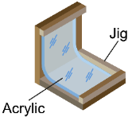 | 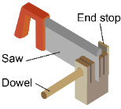 |  |  | 
Use | Jig for bending/ folding acrylic/ workpiece at 90 degrees | Jig for cutting dowels to a given length | Pattern/ template to draw out pattern pieces | Stencil used to draw isometric circles/ ellipses | Jig used to drill holes at an angle

Task 4
Different manufacturing processes are used for different scales of production. Consider the processes below and match them to the different scales of production based on the descriptions. Use the answers from Task 3 above to help you.
 |  | Scale of production
Hand Embroidery  A time-consuming process requiring skilled workers |  | One-off
Vacuum Forming  Unskilled workers perform this process which can be fully automated |  | Mass, although can be used for batch production as some moulds can be made cheaply
3D Printing  A process requiring skill using CAD/CAM software, very easy to edit | 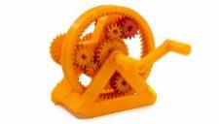 | One-off
Injection Moulding  Very expensive machines and moulds needed for this automated process |  | Mass
Laminating Wood  Jigs and formers used to ensure consistency between products | 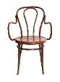 | Batch
Calendaring  Non-stop process for making rolls of materials such as paper or plastic sheets | 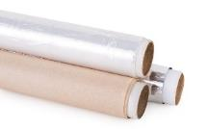 | Continuous
Sand Casting  Low-skilled but labour-intensive process with fairly low set-up costs | 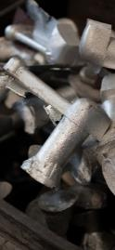 | Batch
Screen Printing  A flexible process with fairly low set up costs | 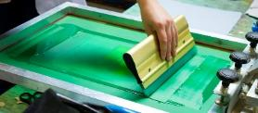 | Batch, although can be automated for mass production

Task 5
Consider the products below and the number of units required. Select the appropriate scale of production and explain the advantages and disadvantages of either one-off, batch, mass or continuous production.
You may use specific terms including: set-up costs, unit costs, flexibility, automation and lead times.
Tailored Garment | Units Required: | 1
Scale of Production? | One-off
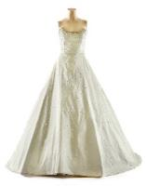 | Advantages:  - Low set-up costs  - Handmade aesthetic is of value to the recipient  - Unique, no two items are the same  - Made to measure / suit particular client |  | Disadvantages:  - Labour intensive  - Prone to human error  - High level of skill required for professional / high quality outcome  - Takes a long time to make  - High unit cost

Shopping Bags | Units Required: | 125 of each
Scale of Production? | Batch
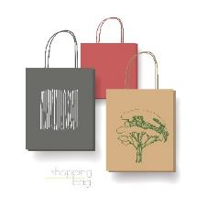 | Advantages:  - Low set-up costs  - Stencil / screen used to reprint design multiple times  - Jigs can be used to increase efficiency and accuracy  - Flexible process so print can be changed easily  - Short lead time so manufacturers can respond quickly to changing trends and demands |  | Disadvantages:  - Quite labour intensive  - Tools need to be set-up again or modified between batches  - Quite high level of skill required for professional / high quality outcome

Cutlery Set | Units Required: | 5,000,000
Scale of Production? | Mass Production
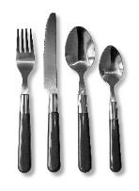 | Advantages:  - Low unit cost  - Low labour costs  - Higher level of automation so units can be produced quickly and cheaply once production is set up |  | Disadvantages:  - High set-up costs  - Lack of flexibility as changing tooling is expensive and time consuming  - Longer lead time
A4 Paper | Units Required: | Constant supply
Scale of Production? | Continuous
 | Advantages:  - Low labour costs  - Low unit cost  - Stock forms can be used to make many different products (primary processing)  - Production line does not have to stop |  | Disadvantages:  - High set up costs  - Lack of flexibility  - Longer lead time  - Problems with parts of machinery causes whole production line to stop

