Name: Class: Mark:

1. Briefly explain the principle of ‘lean’ manufacturing? [1]

2. A standard component is shown below.

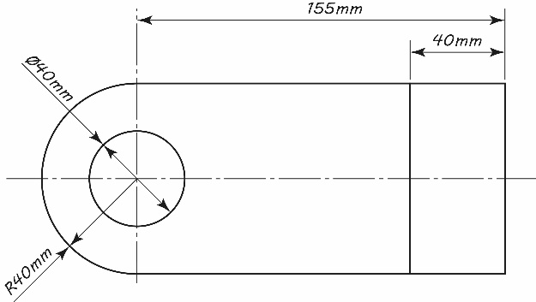
(a) The standard component is manufactured at a cost of £0.80 per unit. An employee realises that it could also be bought in at a cost of £0.56 per unit.
Calculate the percentage saving to the company in the cost of a bought in part. [3]

(b) The part could be manufactured in-house or bought in as a standard part.
(i) Describe one disadvantage to the company of using standard parts. [2]

(ii) Explain two benefits that just-in-time (JIT) manufacturing could have
for the manufacturer of the part. [4]

A retailer is looking for a lamp manufacturer.


Company A is a sole-trader - one highly skilled craftsperson and a well-equipped workshop. They will require one specialist tool to complete the project, costing £4.00. The craftsperson will charge £40 per hour and each lamp will take 4 hours to make.
Company B is a medium sized business with 20 semi-skilled workers. The cost of the specialist tools for the manufacture of the lamp is £100 and the workers need to be paid £7.50 each per hour. Five labourers can make a lamp in 2 hours.
(a) How much will it cost to make one unit with Company A? Show your workings. [2]

(b) How much will it cost to make one unit with Company B? Show your workings. [2]

(c) The retailer requires 50 lamps.
Discuss which company would offer better value for money and explain how the reduced cost per unit could be achieved. [6]

[Total 20 Marks]

