Name: Class:

Task 1
Lean manufacturing is based on a Japanese philosophy to eliminate wasteful activities and processes. Match the descriptions with an appropriate area of waste.
Issue |  | Waste area
Stock is kept in a warehouse for up to six months |  | Overproduction
Commonly connected parts are kept in storage bins two metres apart |  | Defects
The parts warehouse is three minutes by forklift truck from the assembly area |  | Excessive transportation
Goods are manufactured at twice the rate they can be finished |  | Unnecessary motion
Goods frequently fail quality control tests |  | Waiting

How does Just In Time manufacturing help to reduce areas of waste identified by Lean manufacturing philosophies?

Task 2

What is meant by the term “one-off” production? Use an example to illustrate your answer.

Which of the following are examples of one-off production as opposed to personalisation?
Product | One-off Production | Personalised
Scanning your fingerprint to unlock a phone
A car number plate
A take-away drink with your name written on the cup
A built-in storage unit designed for your bedroom
A shop-bought canvas bag with a unique print on it
A hand-made invitation to a garden party
A made-to-measure piece of clothing

Task 3

Batch production uses jigs, patterns, templates and stencils to improve efficiency and consistency between products when performing repetitive tasks.

What tasks are the following jigs, patterns, templates or stencils used to perform?
Jig, pattern, stencil or template | 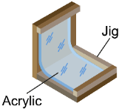 | 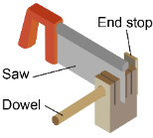 |  |  | 

Use

Task 4
Different manufacturing processes are used for different scales of production. Consider the processes below and match them to the different scales of production based on the descriptions. Use the answers from Task 3 above to help you.
 |  | Scale of production
Hand Embroidery  A time-consuming process requiring skilled workers | 
Vacuum Forming  Unskilled workers perform this process which can be fully automated | 
3D Printing  A process requiring skill using CAD/CAM software, very easy to edit | 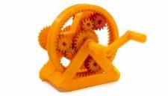
Injection Moulding  Very expensive machines and moulds needed for this automated process | 
Laminating Wood  Jigs and formers used to ensure consistency between products | 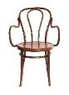
Calendaring  Non-stop process for making rolls of materials such as paper or plastic sheets | 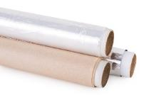
Sand Casting  Low-skilled but labour intensive process with fairly low set-up costs | 
Screen Printing  A flexible process with fairly low set up costs | 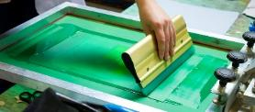

Task 5
Consider the products below and the number of units required. Select the appropriate scale of production and explain the advantages and disadvantages of either one-off, batch, mass or continuous production.
You may use specific terms including: set-up costs, unit costs, flexibility, automation and lead times.
Tailored Garment | Units Required: | 1
Scale of Production?
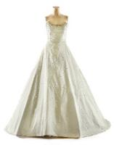 | Advantages: |  | Disadvantages:

Shopping Bags | Units Required: | 125 of each
Scale of Production?
 | Advantages: |  | Disadvantages:

Cutlery Set | Units Required: | 5,000,000
Scale of Production?
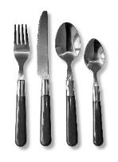 | Advantages: |  | Disadvantages:

A4 Paper | Units Required: | Constant supply
Scale of Production?
 | Advantages: |  | Disadvantages:

