Name: Class:

Task 1
Modern technology has enabled a wealth of new products with improved or enhanced functionality. Some of this has had a significant impact on job roles and in shaping the workforce.
Factories manufacturing mobile phone technology are becoming more and more automated, using robots for parts assembly and warehouse control. Despite this, some employ hundreds of thousands of people.
- What makes a role more or less likely to be replaced by a robot or an
automated process?

- Put the following job roles in order of those that are most under threat from automation:
Job role | Order  1 (Most under threat) - 10 | Skill level  (Low, Mid, High)
Personal assistant or secretary
Graphic designer
Sewing machinist
Large goods vehicle driver
Vehicle assembler
Teacher
Pilot
Mechanical engineer
Packer, bottler, canner or filler
Routine inspector and tester

- Discuss how the roles of people in manufacturing will have changed with the introduction of robotics and automated procedures.

Task 2
Many companies including Google are developing autonomous self-driving vehicles.
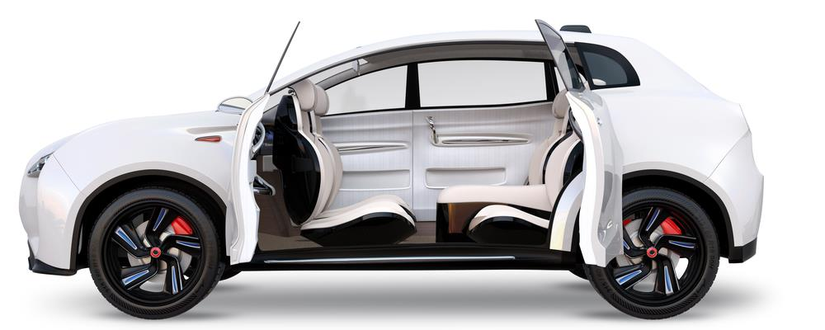
Explain how this might improve the lives of the elderly or impaired.

Task 3
Amazon Air launched their first UK drone delivery in December 2016. A package was safely delivered to its destination in Cambridge in just 13 minutes after the order was placed.
Amazon drones take off and fly completely autonomously along preset flightpaths at 400m above ground level, guided by GPS. They are capable of carrying orders weighing up to 2.7KG and can easily be combined with the use of Amazon’s Dash button - a WiFi-connected device that reorders your favourite product with the press of a button.
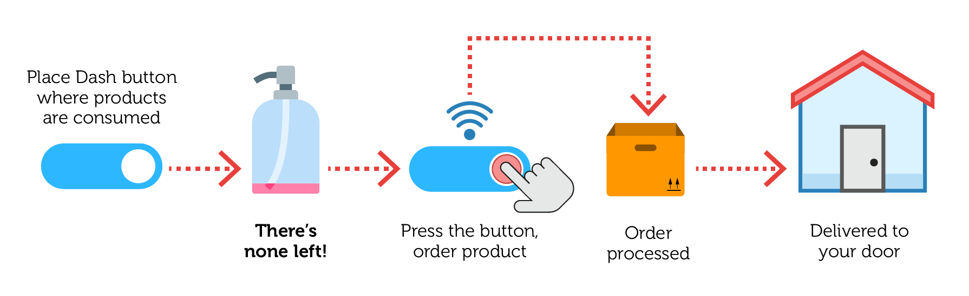
- How might the new Amazon Air delivery service affect those offering a traditional delivery service for Amazon?

- What restrictions might there be on the operation of delivery drones?

- How might the new service affect delivery services offered by competitors?

- What negative impacts might this service have on society?

