Name: Class:

Task 1
Look at the product label below for a pair of shoes. List all the factors that contribute to the manufacturing footprint of this product and state how they affect the environment.
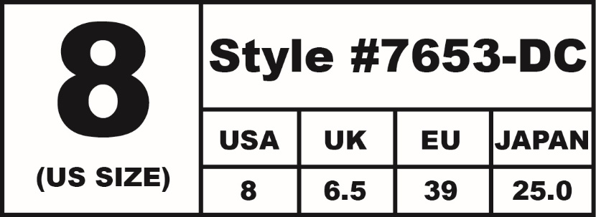
Style #7653-DC
Leather upper: made in China
Rubber sole made in USA
Manufactured in Canada
Steel lace eyelets
Patent finish

What finite resources may be used in the production of a pair of training shoes?

How could these be replaced by alternative resources to make production ‘greener’?

Task 2 Environmental impact
Compare the environmental impact of the pairs of products below. Remember to consider the following points:
- Demand on natural resources
- Transportation costs
- Oceanic pollution
- Atmospheric pollution
- Waste generation and disposal
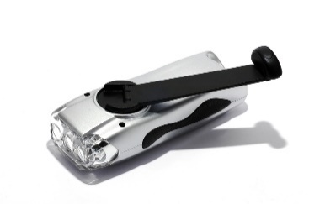  Wind-up torch | 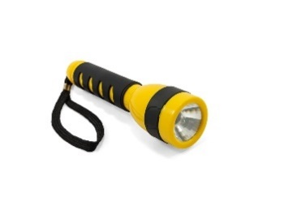  Battery powered torch
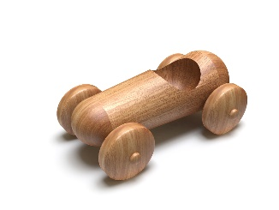  Wooden toy | 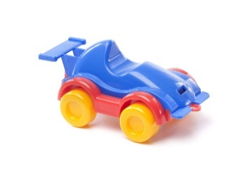  Plastic toy

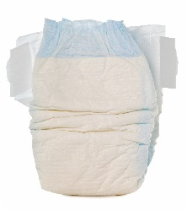  Disposable nappy | 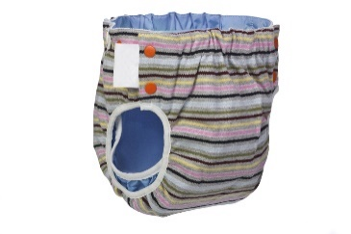  Reusable nappy
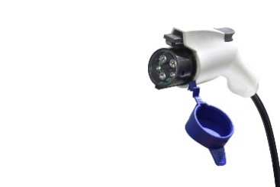  Electric car | 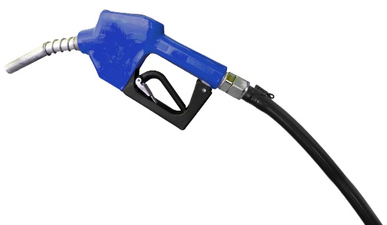  Diesel car
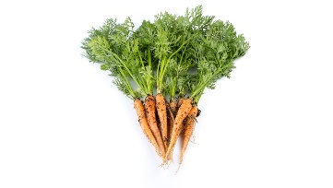  Homegrown vegetables | 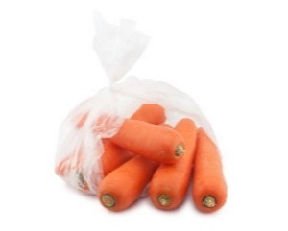  Supermarket vegetables

