Name: Class: Mark:

Task 1
- Car manufacturers are producing new electric vehicles. Over the next 20 years, many nations have vowed to ban the internal combustion engine and the ‘traditional’ motor car.
Why is battery technology crucial in the development of electric vehicles?

- An electric car requires far fewer moving parts with no gear box and no internal
combustion engine.
(a) How will the transition from the manufacture of combustion engines and gear trains to electric motors affect employment at car plants?

(b) How might the skill set of a workforce change in vehicle servicing?

- Analyse the graph below. There were approximately 100,000 electric vehicles sold in 2012 worldwide. Calculate the expected number of electric vehicle sales in 2017 based on the sales figure from 2012 – 2016. Show your working.
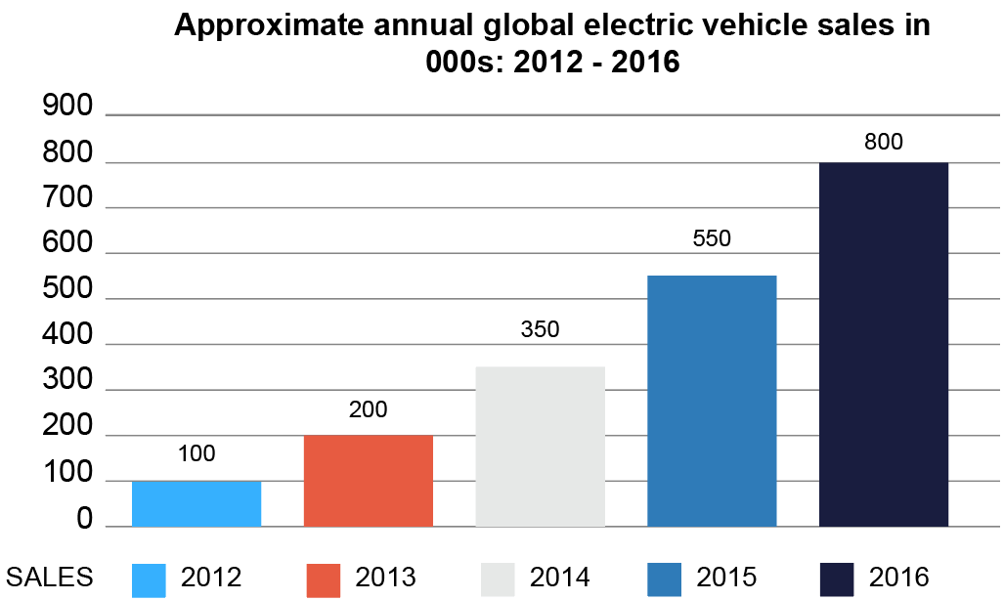
Task 2 The impact of new technology on enterprise
- 3D printing technology has been around for over a decade, but it is now starting to become widely accessible. One day all households may have a 3D printer with the ability to print anything to a similar level of quality as current manufacturing standards.
How might 3D printing change the spare parts industry for small household appliances?

- Small, privately-owned businesses commonly have limited budgets and finances.
How might these businesses benefit from the latest print-on-demand and prototyping services provided by 3D printing technology?

- A not-for-profit organisation called CYBER Team has been started to help make 3D printed orthotics and prosthetics for US war veterans. The company also employ people from the veteran community, including those they are directly trying to help.
Explain how a not-for-profit organisation differs from a privately-owned business.

