Natural Forms

Mark Eanes

Mark Eanes is a contemporary artist who focuses on capturing the details of natural forms, particularly plants. His use of texture, shape, and colour reflects the complexity of botanical life, encouraging viewers to explore the beauty of the natural world.

**Task 1: Observation and Analysis**

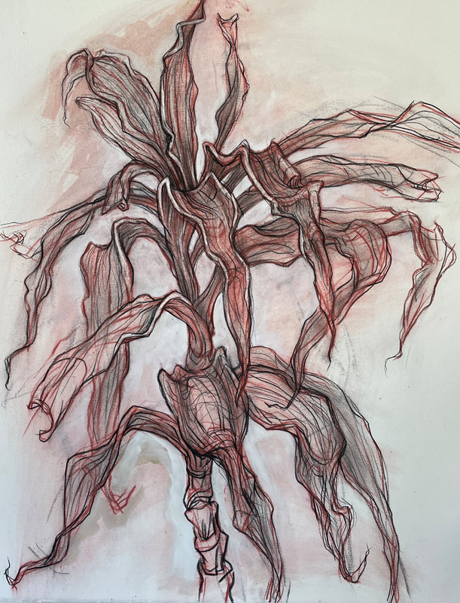

**Look closely at this botanical artwork by Mark Eanes. The artwork highlights delicate and intricate patterns, textures, and layers within the natural forms.**

1. **What do you see?** Describe the different parts of the artwork. Do you notice any specific plant-like structures or patterns? How do the layers of colour and the arrangement of lines create depth and dimension?

***Keywords:* intricate, texture, layers, patterns, organic, depth**

**I see…**

________________________________________________

________________________________________________

________________________________________________

________________________________________________

________________________________________________

1. **What does this artwork remind you of?** Does this artwork resemble something you’ve seen in nature, such as leaves, flowers, or roots? How does the composition relate to the natural world?

***Keywords:* nature, organic forms, botanical, plant-like structures**

***This artwork reminds me of…***

________________________________________________

________________________________________________

________________________________________________

________________________________________________

________________________________________________

1. **What feeling or mood does this artwork create?** Does it feel calm, alive, chaotic, or something else? Think about how the colours and shapes contribute to the mood of the piece.

***Keywords:* calm, natural, vibrant, flow, detail**

*The mood of this artwork feels…*

________________________________________________

________________________________________________

________________________________________________

________________________________________________

________________________________________________

**Challenge Question:**

1. **How do you think Mark Eanes uses colour and pattern to emphasise the natural forms?**  
   Look at how the colours interact with the shapes and patterns. Do they help create a sense of movement, stillness, or something else? Why do you think the artist used these techniques?

***Keywords:* color, movement, stillness, natural forms, contrast**

*The artwork feels… because…*

________________________________________________

________________________________________________

________________________________________________

________________________________________________

________________________________________________