International

GCSE

Biology (9-1)

HOMEWORK BOOK 4

Investigating Plant Vasculature and Trophic Responses

Term 2(b) Investigating Plant Vasculature and Trophic Responses

|  |  |  |  |  |
| --- | --- | --- | --- | --- |
| **Lesson Number** | **Lesson Title** | **Your Score** | **Total Score** | **Date completed and parental signature** |
| 38 | Water Uptake |  | 30 |  |
| 39 | Transport of water in Plants |  | 18 |  |
| 40 | The Role of Transpiration |  | 20 |  |
| 41 | Factors affecting Transpiration |  | 25 |  |
| 42 | CORE PRACTICAL Factors affecting Transpiration |  | 23 |  |
| 43 | Translocation in Phloem |  | 31 |  |
| 44 | The Trophic Responses of Plants to Stimuli |  | 26 |  |
| 45 | The Role of Auxins in Trophic Responses |  | 20 |  |
| 46 | CORE PRACTICAL Analyse Data About Transpiration |  | 12 |  |

**Lesson 38 Water Uptake**

**1 a** The diagram shows a plant root hair cell. Add labels to the diagram **(6 marks**).

*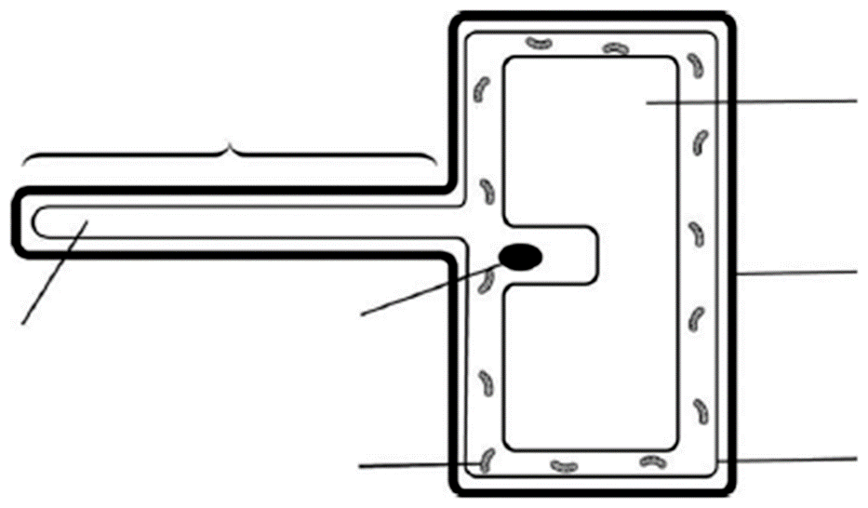*

**b** What part of the cell could be described as being partially permeable? (**1 mark**)

\_\_\_\_\_\_\_\_\_\_\_\_\_\_\_\_\_\_\_\_\_\_\_\_\_\_\_\_\_\_\_\_\_\_\_\_\_\_\_\_\_\_\_\_\_\_\_\_\_\_\_\_\_\_\_\_\_\_\_\_\_\_\_\_\_\_\_

**c** By what process does water enter the cell? (**1 mark**)

Tick one.

🞏 active transport

🞏 diffusion

🞏 osmosis

🞏 capillary action

**d** Explain how this process occurs. Use the term ‘water potential’ in your answer. (**2 marks**)

\_\_\_\_\_\_\_\_\_\_\_\_\_\_\_\_\_\_\_\_\_\_\_\_\_\_\_\_\_\_\_\_\_\_\_\_\_\_\_\_\_\_\_\_\_\_\_\_\_\_\_\_\_\_\_\_\_\_\_\_\_\_\_\_\_\_\_

\_\_\_\_\_\_\_\_\_\_\_\_\_\_\_\_\_\_\_\_\_\_\_\_\_\_\_\_\_\_\_\_\_\_\_\_\_\_\_\_\_\_\_\_\_\_\_\_\_\_\_\_\_\_\_\_\_\_\_\_\_\_\_\_\_\_\_

**e** Explain how the shape of the cell helps this process. (**2 marks**)

\_\_\_\_\_\_\_\_\_\_\_\_\_\_\_\_\_\_\_\_\_\_\_\_\_\_\_\_\_\_\_\_\_\_\_\_\_\_\_\_\_\_\_\_\_\_\_\_\_\_\_\_\_\_\_\_\_\_\_\_\_\_\_\_\_\_\_

\_\_\_\_\_\_\_\_\_\_\_\_\_\_\_\_\_\_\_\_\_\_\_\_\_\_\_\_\_\_\_\_\_\_\_\_\_\_\_\_\_\_\_\_\_\_\_\_\_\_\_\_\_\_\_\_\_\_\_\_\_\_\_\_\_\_\_

**f** Apart from absorbing water and mineral ions, state one other function of roots. (**1 mark**)

\_\_\_\_\_\_\_\_\_\_\_\_\_\_\_\_\_\_\_\_\_\_\_\_\_\_\_\_\_\_\_\_\_\_\_\_\_\_\_\_\_\_\_\_\_\_\_\_\_\_\_\_\_\_\_\_\_\_\_\_\_\_\_\_\_\_\_

**2** Which cells are responsible for carrying water out of the root and up the plant? (**1 mark**)

Tick one.

🞏 xylem

🞏 epidermis

🞏 spongy

🞏 phloem

**3 a** Give the name of the nitrogen-containing mineral ion that is important for producing proteins. (**1 mark**)

\_\_\_\_\_\_\_\_\_\_\_\_\_\_\_\_\_\_\_\_\_\_\_\_\_\_\_\_\_\_\_\_\_\_\_\_\_\_\_\_\_\_\_\_\_\_\_\_\_\_\_\_\_\_\_\_\_\_\_\_\_\_\_\_\_\_\_

**b** Explain why this mineral ion needs to be moved into a root hair cell by active transport. Use the term **concentration gradient** in your answer. (**2 marks**)

\_\_\_\_\_\_\_\_\_\_\_\_\_\_\_\_\_\_\_\_\_\_\_\_\_\_\_\_\_\_\_\_\_\_\_\_\_\_\_\_\_\_\_\_\_\_\_\_\_\_\_\_\_\_\_\_\_\_\_\_\_\_\_\_\_\_\_

\_\_\_\_\_\_\_\_\_\_\_\_\_\_\_\_\_\_\_\_\_\_\_\_\_\_\_\_\_\_\_\_\_\_\_\_\_\_\_\_\_\_\_\_\_\_\_\_\_\_\_\_\_\_\_\_\_\_\_\_\_\_\_\_\_\_\_

**c** State how this process affects the ‘water potential’ of the cell. (**1 mark**)

\_\_\_\_\_\_\_\_\_\_\_\_\_\_\_\_\_\_\_\_\_\_\_\_\_\_\_\_\_\_\_\_\_\_\_\_\_\_\_\_\_\_\_\_\_\_\_\_\_\_\_\_\_\_\_\_\_\_\_\_\_\_\_\_\_\_\_

**4** Some students set up an experiment to estimate the concentration of solutes in the cell sap of a potato. They used 15 g potato cores and left each one in a different concentration of sucrose for two hours.

**a** The results are shown in the table. Complete the values for the middle row (**2 marks**).

|  |  |  |  |  |  |
| --- | --- | --- | --- | --- | --- |
| Final mass of potato core (g) | 16.6 | 16.1 | 15.6 | 14.8 | 14.2 |
| Change in mass of potato core (g) |  |  |  |  |  |
| Concentration of sucrose (g/100 cm3) | 19 | 17 | 15 | 13 | 11 |

**b** Plot the change in mass against the concentration of sucrose on a suitable graph or chart. **(5 marks)**



**c** Suggest the concentration of cell sap in these potatoes. (**1 mark**) \_\_\_\_\_\_\_\_\_\_\_\_\_\_\_\_\_\_\_\_\_\_\_\_\_\_\_\_\_\_\_\_\_\_\_\_\_\_\_\_\_\_\_\_\_\_\_\_\_\_\_\_\_\_\_\_\_\_\_\_\_\_\_\_\_\_\_\_

**d** Explain how you chose the cell sap concentration. (**2 marks**)

\_\_\_\_\_\_\_\_\_\_\_\_\_\_\_\_\_\_\_\_\_\_\_\_\_\_\_\_\_\_\_\_\_\_\_\_\_\_\_\_\_\_\_\_\_\_\_\_\_\_\_\_\_\_\_\_\_\_\_\_\_\_\_\_\_\_\_\_

\_\_\_\_\_\_\_\_\_\_\_\_\_\_\_\_\_\_\_\_\_\_\_\_\_\_\_\_\_\_\_\_\_\_\_\_\_\_\_\_\_\_\_\_\_\_\_\_\_\_\_\_\_\_\_\_\_\_\_\_\_\_\_\_\_\_\_\_

\_\_\_\_\_\_\_\_\_\_\_\_\_\_\_\_\_\_\_\_\_\_\_\_\_\_\_\_\_\_\_\_\_\_\_\_\_\_\_\_\_\_\_\_\_\_\_\_\_\_\_\_\_\_\_\_\_\_\_\_\_\_\_\_\_\_\_\_

**e** Calculate the percentage change in mass for the potato core left in the 15 g/100cm3 concentration of sucrose. (**2 marks**)

**Total Marks = 30**

Lesson 39 Transport of Water in Plants

**1** State two ways in which water is important for plants. (**2 marks**)

\_\_\_\_\_\_\_\_\_\_\_\_\_\_\_\_\_\_\_\_\_\_\_\_\_\_\_\_\_\_\_\_\_\_\_\_\_\_\_\_\_\_\_\_\_\_\_\_\_\_\_\_\_\_\_\_\_\_\_\_\_\_\_\_\_\_\_\_\_\_

\_\_\_\_\_\_\_\_\_\_\_\_\_\_\_\_\_\_\_\_\_\_\_\_\_\_\_\_\_\_\_\_\_\_\_\_\_\_\_\_\_\_\_\_\_\_\_\_\_\_\_\_\_\_\_\_\_\_\_\_\_\_\_\_\_\_\_\_\_\_

**2** The diagram shows some cells in a root. The arrows show the movement of water.

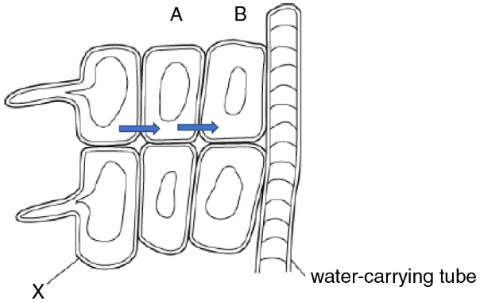

**a** Give the name of cell X. (**1 mark**)

\_\_\_\_\_\_\_\_\_\_\_\_\_\_\_\_\_\_\_\_\_\_\_\_\_\_\_\_\_\_\_\_\_\_\_\_\_\_\_\_\_\_\_\_\_\_\_\_\_\_\_\_\_\_\_\_\_\_\_\_\_\_\_\_\_\_\_\_

**b** Describe the function of cell X. (**1 mark**)

\_\_\_\_\_\_\_\_\_\_\_\_\_\_\_\_\_\_\_\_\_\_\_\_\_\_\_\_\_\_\_\_\_\_\_\_\_\_\_\_\_\_\_\_\_\_\_\_\_\_\_\_\_\_\_\_\_\_\_\_\_\_\_\_\_\_\_\_

**c** Give the reason for the shape of cell X. (**1 mark**)

\_\_\_\_\_\_\_\_\_\_\_\_\_\_\_\_\_\_\_\_\_\_\_\_\_\_\_\_\_\_\_\_\_\_\_\_\_\_\_\_\_\_\_\_\_\_\_\_\_\_\_\_\_\_\_\_\_\_\_\_\_\_\_\_\_\_\_\_

\_\_\_\_\_\_\_\_\_\_\_\_\_\_\_\_\_\_\_\_\_\_\_\_\_\_\_\_\_\_\_\_\_\_\_\_\_\_\_\_\_\_\_\_\_\_\_\_\_\_\_\_\_\_\_\_\_\_\_\_\_\_\_\_\_\_\_\_

**d** Give the name of the process shown by the arrows. (**1 mark**)

\_\_\_\_\_\_\_\_\_\_\_\_\_\_\_\_\_\_\_\_\_\_\_\_\_\_\_\_\_\_\_\_\_\_\_\_\_\_\_\_\_\_\_\_\_\_\_\_\_\_\_\_\_\_\_\_\_\_\_\_\_\_\_\_\_\_\_\_

**e** Explain why water flows from cell A into cell B in this process. (**2 marks**)

\_\_\_\_\_\_\_\_\_\_\_\_\_\_\_\_\_\_\_\_\_\_\_\_\_\_\_\_\_\_\_\_\_\_\_\_\_\_\_\_\_\_\_\_\_\_\_\_\_\_\_\_\_\_\_\_\_\_\_\_\_\_\_\_\_\_\_\_

\_\_\_\_\_\_\_\_\_\_\_\_\_\_\_\_\_\_\_\_\_\_\_\_\_\_\_\_\_\_\_\_\_\_\_\_\_\_\_\_\_\_\_\_\_\_\_\_\_\_\_\_\_\_\_\_\_\_\_\_\_\_\_\_\_\_\_\_

\_\_\_\_\_\_\_\_\_\_\_\_\_\_\_\_\_\_\_\_\_\_\_\_\_\_\_\_\_\_\_\_\_\_\_\_\_\_\_\_\_\_\_\_\_\_\_\_\_\_\_\_\_\_\_\_\_\_\_\_\_\_\_\_\_\_\_\_

**f** Give the name of the water-carrying tube. (**1 mark**)

\_\_\_\_\_\_\_\_\_\_\_\_\_\_\_\_\_\_\_\_\_\_\_\_\_\_\_\_\_\_\_\_\_\_\_\_\_\_\_\_\_\_\_\_\_\_\_\_\_\_\_\_\_\_\_\_\_\_\_\_\_\_\_\_\_\_\_\_

The tubes are covered with a substance called lignin. This makes them impermeable to water, but they have small holes in places where water needs to enter or leave.

**g** Explain *two* other ways in which these tubes are adapted to their function. (**2 marks**)

\_\_\_\_\_\_\_\_\_\_\_\_\_\_\_\_\_\_\_\_\_\_\_\_\_\_\_\_\_\_\_\_\_\_\_\_\_\_\_\_\_\_\_\_\_\_\_\_\_\_\_\_\_\_\_\_\_\_\_\_\_\_\_\_\_\_\_\_

\_\_\_\_\_\_\_\_\_\_\_\_\_\_\_\_\_\_\_\_\_\_\_\_\_\_\_\_\_\_\_\_\_\_\_\_\_\_\_\_\_\_\_\_\_\_\_\_\_\_\_\_\_\_\_\_\_\_\_\_\_\_\_\_\_\_\_\_

\_\_\_\_\_\_\_\_\_\_\_\_\_\_\_\_\_\_\_\_\_\_\_\_\_\_\_\_\_\_\_\_\_\_\_\_\_\_\_\_\_\_\_\_\_\_\_\_\_\_\_\_\_\_\_\_\_\_\_\_\_\_\_\_\_\_\_\_

\_\_\_\_\_\_\_\_\_\_\_\_\_\_\_\_\_\_\_\_\_\_\_\_\_\_\_\_\_\_\_\_\_\_\_\_\_\_\_\_\_\_\_\_\_\_\_\_\_\_\_\_\_\_\_\_\_\_\_\_\_\_\_\_\_\_\_\_

**h** In certain parts of a plant, these tubes are found together with phloem tubes.

Give the name for these collections of different types of tube. (**1 mark**)

\_\_\_\_\_\_\_\_\_\_\_\_\_\_\_\_\_\_\_\_\_\_\_\_\_\_\_\_\_\_\_\_\_\_\_\_\_\_\_\_\_\_\_\_\_\_\_\_\_\_\_\_\_\_\_\_\_\_\_\_\_\_\_\_\_\_\_\_

**3** Water also moves towards the centre of a root through the cell walls of the root cells. Water that moves in this way does not enter the cell cytoplasm.

Give the name of the process by which water moves through cell walls in roots. (**1 mark**)

\_\_\_\_\_\_\_\_\_\_\_\_\_\_\_\_\_\_\_\_\_\_\_\_\_\_\_\_\_\_\_\_\_\_\_\_\_\_\_\_\_\_\_\_\_\_\_\_\_\_\_\_\_\_\_\_\_\_\_\_\_\_\_\_\_\_\_\_

**4** A common substance in plant fertilisers is potassium nitrate. Plants need potassium to help move carbohydrates in and out of cells.

**a** For what do plants need nitrate? (**1 mark**)

\_\_\_\_\_\_\_\_\_\_\_\_\_\_\_\_\_\_\_\_\_\_\_\_\_\_\_\_\_\_\_\_\_\_\_\_\_\_\_\_\_\_\_\_\_\_\_\_\_\_\_\_\_\_\_\_\_\_\_\_\_\_\_\_\_\_\_\_

\_\_\_\_\_\_\_\_\_\_\_\_\_\_\_\_\_\_\_\_\_\_\_\_\_\_\_\_\_\_\_\_\_\_\_\_\_\_\_\_\_\_\_\_\_\_\_\_\_\_\_\_\_\_\_\_\_\_\_\_\_\_\_\_\_\_\_\_

**b** Give the name used to describe potassium and nitrate. (**1 mark**)

\_\_\_\_\_\_\_\_\_\_\_\_\_\_\_\_\_\_\_\_\_\_\_\_\_\_\_\_\_\_\_\_\_\_\_\_\_\_\_\_\_\_\_\_\_\_\_\_\_\_\_\_\_\_\_\_\_\_\_\_\_\_\_\_\_\_\_\_

**c** Describe how these substances are transported in a plant. (**1 mark**)

\_\_\_\_\_\_\_\_\_\_\_\_\_\_\_\_\_\_\_\_\_\_\_\_\_\_\_\_\_\_\_\_\_\_\_\_\_\_\_\_\_\_\_\_\_\_\_\_\_\_\_\_\_\_\_\_\_\_\_\_\_\_\_\_\_\_\_\_

\_\_\_\_\_\_\_\_\_\_\_\_\_\_\_\_\_\_\_\_\_\_\_\_\_\_\_\_\_\_\_\_\_\_\_\_\_\_\_\_\_\_\_\_\_\_\_\_\_\_\_\_\_\_\_\_\_\_\_\_\_\_\_\_\_\_\_\_

**d** A weedkiller called paraquat stops the activity of mitochondria. Plants that have been treated with paraquat no longer absorb potassium nitrate.

Explain what this tells you about the process of absorbing potassium nitrate. (**2 marks**)

\_\_\_\_\_\_\_\_\_\_\_\_\_\_\_\_\_\_\_\_\_\_\_\_\_\_\_\_\_\_\_\_\_\_\_\_\_\_\_\_\_\_\_\_\_\_\_\_\_\_\_\_\_\_\_\_\_\_\_\_\_\_\_\_\_\_\_\_

\_\_\_\_\_\_\_\_\_\_\_\_\_\_\_\_\_\_\_\_\_\_\_\_\_\_\_\_\_\_\_\_\_\_\_\_\_\_\_\_\_\_\_\_\_\_\_\_\_\_\_\_\_\_\_\_\_\_\_\_\_\_\_\_\_\_\_\_

**Total Marks = 18**

\_\_\_\_\_\_\_\_\_\_\_\_\_\_\_\_\_\_\_\_\_\_\_\_\_\_\_\_\_\_%

**Lesson 40 The Role of Transpiration**

**1** The diagram shows some cells in a leaf.

**a**

**i** Give the name of the cells just below the *upper* epidermis. (**1 mark**)

\_\_\_\_\_\_\_\_\_\_\_\_\_\_\_\_\_\_\_\_\_\_\_\_\_\_\_\_\_\_\_\_\_\_\_\_\_\_\_\_\_\_\_\_\_\_\_\_\_\_\_\_\_\_\_\_\_\_\_\_\_\_\_\_

**ii** Explain how these cells are adapted to their function. (**2 marks**)

\_\_\_\_\_\_\_\_\_\_\_\_\_\_\_\_\_\_\_\_\_\_\_\_\_\_\_\_\_\_\_\_\_\_\_\_\_\_\_\_\_\_\_\_\_\_\_\_\_\_\_\_\_\_\_\_\_\_\_\_\_\_\_\_

\_\_\_\_\_\_\_\_\_\_\_\_\_\_\_\_\_\_\_\_\_\_\_\_\_\_\_\_\_\_\_\_\_\_\_\_\_\_\_\_\_\_\_\_\_\_\_\_\_\_\_\_\_\_\_\_\_\_\_\_\_\_\_\_

**iii** Give the reason that these cells need a good supply of water. (**1 mark**)

\_\_\_\_\_\_\_\_\_\_\_\_\_\_\_\_\_\_\_\_\_\_\_\_\_\_\_\_\_\_\_\_\_\_\_\_\_\_\_\_\_\_\_\_\_\_\_\_\_\_\_\_\_\_\_\_\_\_\_\_\_\_\_\_

**iv** The cells above the *lower* epidermis have more irregular shapes that help to create air spaces. Give the name of these cells. (**1 mark**)

\_\_\_\_\_\_\_\_\_\_\_\_\_\_\_\_\_\_\_\_\_\_\_\_\_\_\_\_\_\_\_\_\_\_\_\_\_\_\_\_\_\_\_\_\_\_\_\_\_\_\_\_\_\_\_\_\_\_\_\_\_\_\_\_

**v** Describe a function of the air spaces. (**1 mark**)

\_\_\_\_\_\_\_\_\_\_\_\_\_\_\_\_\_\_\_\_\_\_\_\_\_\_\_\_\_\_\_\_\_\_\_\_\_\_\_\_\_\_\_\_\_\_\_\_\_\_\_\_\_\_\_\_\_\_\_\_\_\_\_\_

**b**

**i** What word describes water loss from leaves? (**1 mark**)

\_\_\_\_\_\_\_\_\_\_\_\_\_\_\_\_\_\_\_\_\_\_\_\_\_\_\_\_\_\_\_\_\_\_\_\_\_\_\_\_\_\_\_\_\_\_\_\_\_\_\_\_\_\_\_\_\_\_\_\_\_\_\_\_

**ii** The arrows in the diagram show how this water loss occurs. Describe what the arrows represent. (**1 mark**)

\_\_\_\_\_\_\_\_\_\_\_\_\_\_\_\_\_\_\_\_\_\_\_\_\_\_\_\_\_\_\_\_\_\_\_\_\_\_\_\_\_\_\_\_\_\_\_\_\_\_\_\_\_\_\_\_\_\_\_\_\_\_\_\_

\_\_\_\_\_\_\_\_\_\_\_\_\_\_\_\_\_\_\_\_\_\_\_\_\_\_\_\_\_\_\_\_\_\_\_\_\_\_\_\_\_\_\_\_\_\_\_\_\_\_\_\_\_\_\_\_\_\_\_\_\_\_\_\_

**c** Although the processes in part **b** cause a plant to lose a lot of water, the continual supply of fresh water to leaves is important for all the reactions that occur in leaves. Explain why. (**2 marks**)

\_\_\_\_\_\_\_\_\_\_\_\_\_\_\_\_\_\_\_\_\_\_\_\_\_\_\_\_\_\_\_\_\_\_\_\_\_\_\_\_\_\_\_\_\_\_\_\_\_\_\_\_\_\_\_\_\_\_\_\_\_\_\_\_\_\_

\_\_\_\_\_\_\_\_\_\_\_\_\_\_\_\_\_\_\_\_\_\_\_\_\_\_\_\_\_\_\_\_\_\_\_\_\_\_\_\_\_\_\_\_\_\_\_\_\_\_\_\_\_\_\_\_\_\_\_\_\_\_\_\_\_\_

**2** The diagram shows another leaf section, with the xylem labelled.

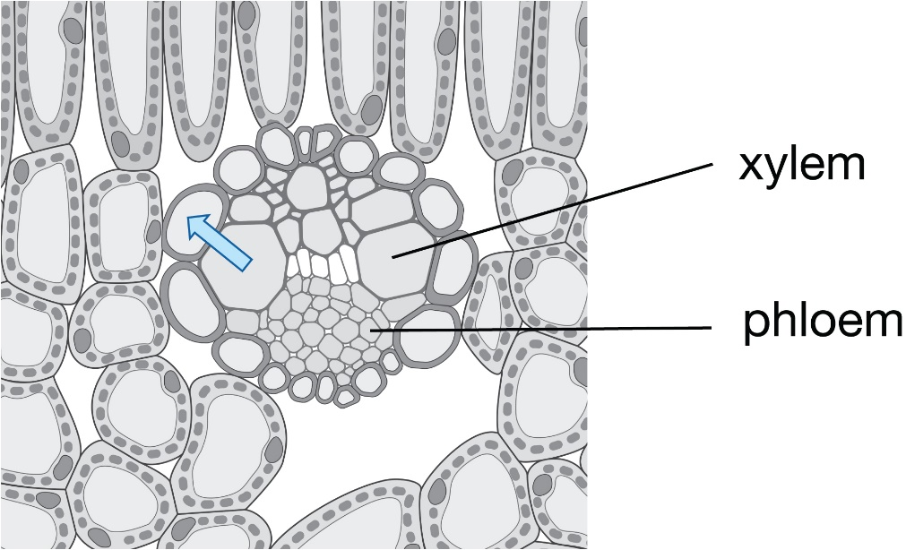

**a** Xylem vessels have tiny pores in their walls to allow water to leave. Explain two other ways in which xylem vessels are adapted to their function. (**2 marks**)

\_\_\_\_\_\_\_\_\_\_\_\_\_\_\_\_\_\_\_\_\_\_\_\_\_\_\_\_\_\_\_\_\_\_\_\_\_\_\_\_\_\_\_\_\_\_\_\_\_\_\_\_\_\_\_\_\_\_\_\_\_\_\_\_\_\_

\_\_\_\_\_\_\_\_\_\_\_\_\_\_\_\_\_\_\_\_\_\_\_\_\_\_\_\_\_\_\_\_\_\_\_\_\_\_\_\_\_\_\_\_\_\_\_\_\_\_\_\_\_\_\_\_\_\_\_\_\_\_\_\_\_\_

\_\_\_\_\_\_\_\_\_\_\_\_\_\_\_\_\_\_\_\_\_\_\_\_\_\_\_\_\_\_\_\_\_\_\_\_\_\_\_\_\_\_\_\_\_\_\_\_\_\_\_\_\_\_\_\_\_\_\_\_\_\_\_\_\_\_

\_\_\_\_\_\_\_\_\_\_\_\_\_\_\_\_\_\_\_\_\_\_\_\_\_\_\_\_\_\_\_\_\_\_\_\_\_\_\_\_\_\_\_\_\_\_\_\_\_\_\_\_\_\_\_\_\_\_\_\_\_\_\_\_\_\_

**b** Explain how water moves out of xylem vessels into the cytoplasm of neighbouring cells, shown by the arrow. (**2 marks**)

\_\_\_\_\_\_\_\_\_\_\_\_\_\_\_\_\_\_\_\_\_\_\_\_\_\_\_\_\_\_\_\_\_\_\_\_\_\_\_\_\_\_\_\_\_\_\_\_\_\_\_\_\_\_\_\_\_\_\_\_\_\_\_\_\_\_

\_\_\_\_\_\_\_\_\_\_\_\_\_\_\_\_\_\_\_\_\_\_\_\_\_\_\_\_\_\_\_\_\_\_\_\_\_\_\_\_\_\_\_\_\_\_\_\_\_\_\_\_\_\_\_\_\_\_\_\_\_\_\_\_\_\_

\_\_\_\_\_\_\_\_\_\_\_\_\_\_\_\_\_\_\_\_\_\_\_\_\_\_\_\_\_\_\_\_\_\_\_\_\_\_\_\_\_\_\_\_\_\_\_\_\_\_\_\_\_\_\_\_\_\_\_\_\_\_\_\_\_\_

\_\_\_\_\_\_\_\_\_\_\_\_\_\_\_\_\_\_\_\_\_\_\_\_\_\_\_\_\_\_\_\_\_\_\_\_\_\_\_\_\_\_\_\_\_\_\_\_\_\_\_\_\_\_\_\_\_\_\_\_\_\_\_\_\_\_

\_\_\_\_\_\_\_\_\_\_\_\_\_\_\_\_\_\_\_\_\_\_\_\_\_\_\_\_\_\_\_\_\_\_\_\_\_\_\_\_\_\_\_\_\_\_\_\_\_\_\_\_\_\_\_\_\_\_\_\_\_\_\_\_\_\_

**c** Describe why water flows continuously upwards in the water-carrying tubes. (**1 mark**)

\_\_\_\_\_\_\_\_\_\_\_\_\_\_\_\_\_\_\_\_\_\_\_\_\_\_\_\_\_\_\_\_\_\_\_\_\_\_\_\_\_\_\_\_\_\_\_\_\_\_\_\_\_\_\_\_\_\_\_\_\_\_\_\_\_\_

\_\_\_\_\_\_\_\_\_\_\_\_\_\_\_\_\_\_\_\_\_\_\_\_\_\_\_\_\_\_\_\_\_\_\_\_\_\_\_\_\_\_\_\_\_\_\_\_\_\_\_\_\_\_\_\_\_\_\_\_\_\_\_\_\_\_

\_\_\_\_\_\_\_\_\_\_\_\_\_\_\_\_\_\_\_\_\_\_\_\_\_\_\_\_\_\_\_\_\_\_\_\_\_\_\_\_\_\_\_\_\_\_\_\_\_\_\_\_\_\_\_\_\_\_\_\_\_\_\_\_\_\_

**3** The table shows different light intensities of light affect the opening of stomata.

|  |  |
| --- | --- |
| Light intensity/lux | Stomata opening/% (where 100% is maximum opening) |
| 0 | 0 |
| 10 000 | 25 |
| 20 000 | 68 |
| 30 000 | 83 |
| 40 000 | 92 |
| 50 000 | 100 |
| 60 000 | 100 |
| 70 000 | 100 |

**a** Give the name of the cells that control the opening of the stomata. (**1 mark**)

\_\_\_\_\_\_\_\_\_\_\_\_\_\_\_\_\_\_\_\_\_\_\_\_\_\_\_\_\_\_\_\_\_\_\_\_\_\_\_\_\_\_\_\_\_\_\_\_\_\_\_\_\_\_\_\_\_\_\_\_\_\_\_\_\_\_

**b** Describe the relationship between light intensity and stomata opening. (**1 mark**)

\_\_\_\_\_\_\_\_\_\_\_\_\_\_\_\_\_\_\_\_\_\_\_\_\_\_\_\_\_\_\_\_\_\_\_\_\_\_\_\_\_\_\_\_\_\_\_\_\_\_\_\_\_\_\_\_\_\_\_\_\_\_\_\_\_\_

\_\_\_\_\_\_\_\_\_\_\_\_\_\_\_\_\_\_\_\_\_\_\_\_\_\_\_\_\_\_\_\_\_\_\_\_\_\_\_\_\_\_\_\_\_\_\_\_\_\_\_\_\_\_\_\_\_\_\_\_\_\_\_\_\_\_

**c** Explain how this relationship benefits the plant. (**2 marks**)

\_\_\_\_\_\_\_\_\_\_\_\_\_\_\_\_\_\_\_\_\_\_\_\_\_\_\_\_\_\_\_\_\_\_\_\_\_\_\_\_\_\_\_\_\_\_\_\_\_\_\_\_\_\_\_\_\_\_\_\_\_\_\_\_\_\_

\_\_\_\_\_\_\_\_\_\_\_\_\_\_\_\_\_\_\_\_\_\_\_\_\_\_\_\_\_\_\_\_\_\_\_\_\_\_\_\_\_\_\_\_\_\_\_\_\_\_\_\_\_\_\_\_\_\_\_\_\_\_\_\_\_\_

**d** High temperatures cause stomata to start shutting. Suggest a reason for this. (**1 mark**)

\_\_\_\_\_\_\_\_\_\_\_\_\_\_\_\_\_\_\_\_\_\_\_\_\_\_\_\_\_\_\_\_\_\_\_\_\_\_\_\_\_\_\_\_\_\_\_\_\_\_\_\_\_\_\_\_\_\_\_\_\_\_\_\_\_\_

**Total marks = 20**

**Lesson 41 Factors Affecting Transpiration**

**1** Use words from the box to complete the sentences. Each word can be used once, more than once or not at all. **(7 marks)**

|  |  |  |  |  |
| --- | --- | --- | --- | --- |
| condensation | diffusion | | evaporation | gradient |
| osmosis | phloem | stomata | transpiration | xylem |

Inside a leaf, water leaves the \_\_\_\_\_\_\_\_\_\_\_ vessels and goes into neighbouring cells by the process of \_\_\_\_\_\_\_\_\_\_\_. \_\_\_\_\_\_\_\_\_\_\_ of liquid water from the surfaces of cells inside the leaf forms water vapour. There is then \_\_\_\_\_\_\_\_\_\_\_ of water molecules down their concentration \_\_\_\_\_\_\_\_\_\_\_and out through the \_\_\_\_\_\_\_\_\_\_\_. This loss of water is called \_\_\_\_\_\_\_\_\_\_\_.

**2** Large air samples were taken from three different regions on a mountainside; A, B and C. The volume of each sample was measured, as was the mass of water it contained.

|  |  |  |  |
| --- | --- | --- | --- |
| Region | Volume (m3) | Mass of water vapour (g) | Concentration of water (g/m3) |
| A | 2 | 24 | \_\_\_\_\_\_\_\_\_\_\_ |
| B | 10 | 150 | \_\_\_\_\_\_\_\_\_\_\_ |
| C | 5 | 55 | \_\_\_\_\_\_\_\_\_\_\_ |

**a** Calculate the concentration of water in each sample. Add your answers to the table. (**3 marks**)

**b** Explain which region had the highest humidity. (**2 marks**)

\_\_\_\_\_\_\_\_\_\_\_\_\_\_\_\_\_\_\_\_\_\_\_\_\_\_\_\_\_\_\_\_\_\_\_\_\_\_\_\_\_\_\_\_\_\_\_\_\_\_\_\_\_\_\_\_\_\_\_\_\_\_\_\_\_\_

\_\_\_\_\_\_\_\_\_\_\_\_\_\_\_\_\_\_\_\_\_\_\_\_\_\_\_\_\_\_\_\_\_\_\_\_\_\_\_\_\_\_\_\_\_\_\_\_\_\_\_\_\_\_\_\_\_\_\_\_\_\_\_\_\_\_

**c** Between which two regions would the rate of diffusion be greatest? (**1 mark**) \_\_\_\_\_\_\_\_\_\_\_\_\_\_\_\_\_\_\_\_\_\_\_\_\_\_\_\_\_\_\_\_\_\_\_\_\_\_\_\_\_\_\_\_\_\_\_\_\_\_\_\_\_\_\_\_\_\_\_\_\_\_\_\_\_\_

**d** Give a reason for your answer to part **c**. (**1 mark**)

\_\_\_\_\_\_\_\_\_\_\_\_\_\_\_\_\_\_\_\_\_\_\_\_\_\_\_\_\_\_\_\_\_\_\_\_\_\_\_\_\_\_\_\_\_\_\_\_\_\_\_\_\_\_\_\_\_\_\_\_\_\_\_\_\_\_

**3** Explain the effect of the following on the rate of transpiration. Use the word ‘because’ in each answer.

**a** light intensity falls to low levels (**1 mark**)

\_\_\_\_\_\_\_\_\_\_\_\_\_\_\_\_\_\_\_\_\_\_\_\_\_\_\_\_\_\_\_\_\_\_\_\_\_\_\_\_\_\_\_\_\_\_\_\_\_\_\_\_\_\_\_\_\_\_\_\_\_\_\_\_\_\_

\_\_\_\_\_\_\_\_\_\_\_\_\_\_\_\_\_\_\_\_\_\_\_\_\_\_\_\_\_\_\_\_\_\_\_\_\_\_\_\_\_\_\_\_\_\_\_\_\_\_\_\_\_\_\_\_\_\_\_\_\_\_\_\_\_\_

**b** humidity increases (**1 mark**)

\_\_\_\_\_\_\_\_\_\_\_\_\_\_\_\_\_\_\_\_\_\_\_\_\_\_\_\_\_\_\_\_\_\_\_\_\_\_\_\_\_\_\_\_\_\_\_\_\_\_\_\_\_\_\_\_\_\_\_\_\_\_\_\_\_\_

\_\_\_\_\_\_\_\_\_\_\_\_\_\_\_\_\_\_\_\_\_\_\_\_\_\_\_\_\_\_\_\_\_\_\_\_\_\_\_\_\_\_\_\_\_\_\_\_\_\_\_\_\_\_\_\_\_\_\_\_\_\_\_\_\_\_

**c** temperature increases from 10 °C to 20 °C (**1 mark**)

\_\_\_\_\_\_\_\_\_\_\_\_\_\_\_\_\_\_\_\_\_\_\_\_\_\_\_\_\_\_\_\_\_\_\_\_\_\_\_\_\_\_\_\_\_\_\_\_\_\_\_\_\_\_\_\_\_\_\_\_\_\_\_\_\_\_

\_\_\_\_\_\_\_\_\_\_\_\_\_\_\_\_\_\_\_\_\_\_\_\_\_\_\_\_\_\_\_\_\_\_\_\_\_\_\_\_\_\_\_\_\_\_\_\_\_\_\_\_\_\_\_\_\_\_\_\_\_\_\_\_\_\_

**d** wind speed decreases (**1 mark**)

\_\_\_\_\_\_\_\_\_\_\_\_\_\_\_\_\_\_\_\_\_\_\_\_\_\_\_\_\_\_\_\_\_\_\_\_\_\_\_\_\_\_\_\_\_\_\_\_\_\_\_\_\_\_\_\_\_\_\_\_\_\_\_\_\_\_

\_\_\_\_\_\_\_\_\_\_\_\_\_\_\_\_\_\_\_\_\_\_\_\_\_\_\_\_\_\_\_\_\_\_\_\_\_\_\_\_\_\_\_\_\_\_\_\_\_\_\_\_\_\_\_\_\_\_\_\_\_\_\_\_\_\_

**4** A student sets up a potometer as shown in the diagram, and puts it on a sunny windowsill.

The distance moved by the bubble in five minutes is measured. The measurement is repeated two more times and a mean is calculated

The student then uses the apparatus to test the effect of an independent variable.

The results are shown in the table.

|  |  |  |
| --- | --- | --- |
| Change in independent variable | Mean distance moved by the bubble (mm) | Transpiration rate (mm/min) |
| 0 | 3 | \_\_\_\_\_\_\_\_\_\_\_ |
| +1 | 6 | \_\_\_\_\_\_\_\_\_\_\_ |
| +2 | 8 | \_\_\_\_\_\_\_\_\_\_\_ |
| +3 | 11 | \_\_\_\_\_\_\_\_\_\_\_ |

**a** Calculate the transpiration rates. Add the values to the table. (**4 marks**)

**b** State an independent variable that would produce results similar to these. (**1 mark**)

\_\_\_\_\_\_\_\_\_\_\_\_\_\_\_\_\_\_\_\_\_\_\_\_\_\_\_\_\_\_\_\_\_\_\_\_\_\_\_\_\_\_\_\_\_\_\_\_\_\_\_\_\_\_\_\_\_\_\_\_\_\_\_\_\_\_

**c** Explain why the independent variable you chose in part (b) has this effect. (**1 mark**)

\_\_\_\_\_\_\_\_\_\_\_\_\_\_\_\_\_\_\_\_\_\_\_\_\_\_\_\_\_\_\_\_\_\_\_\_\_\_\_\_\_\_\_\_\_\_\_\_\_\_\_\_\_\_\_\_\_\_\_\_\_\_\_\_\_\_

\_\_\_\_\_\_\_\_\_\_\_\_\_\_\_\_\_\_\_\_\_\_\_\_\_\_\_\_\_\_\_\_\_\_\_\_\_\_\_\_\_\_\_\_\_\_\_\_\_\_\_\_\_\_\_\_\_\_\_\_\_\_\_\_\_\_

**d** Give the reason that the student repeated the readings to calculate a mean. (**1 mark**)

\_\_\_\_\_\_\_\_\_\_\_\_\_\_\_\_\_\_\_\_\_\_\_\_\_\_\_\_\_\_\_\_\_\_\_\_\_\_\_\_\_\_\_\_\_\_\_\_\_\_\_\_\_\_\_\_\_\_\_\_\_\_\_\_\_\_

**e** The student covered the bung with petroleum jelly to make a seal between the rubber stopper and the plant stem. Explain why doing this allows the student to collect valid measurements. (**2 marks**)

\_\_\_\_\_\_\_\_\_\_\_\_\_\_\_\_\_\_\_\_\_\_\_\_\_\_\_\_\_\_\_\_\_\_\_\_\_\_\_\_\_\_\_\_\_\_\_\_\_\_\_\_\_\_\_\_\_\_\_\_\_\_\_\_\_\_\_\_\_\_\_\_\_\_\_\_\_\_\_\_\_\_\_\_\_\_\_\_\_\_\_\_\_\_\_\_\_\_\_\_\_\_\_\_\_\_\_\_\_\_\_\_\_\_\_\_\_\_\_\_\_\_\_\_\_\_\_\_\_\_\_\_\_\_\_\_\_\_\_\_\_\_\_\_\_\_\_\_\_\_\_\_\_\_\_\_\_\_\_\_\_\_\_\_\_\_\_\_\_\_\_\_\_\_\_\_\_\_\_\_\_\_\_\_\_\_\_\_\_\_\_\_\_\_\_\_\_\_\_\_\_\_\_\_\_\_\_\_\_\_\_\_\_\_\_\_\_\_\_\_\_\_\_\_\_

**Total marks = 25**

Lesson 42 CORE PRACTICAL - Investigating Transpiration

**1** The diagram shows some cells in a leaf. Water is carried up the plant inside xylem vessels and into the leaves. It is then lost from the leaves in transpiration.

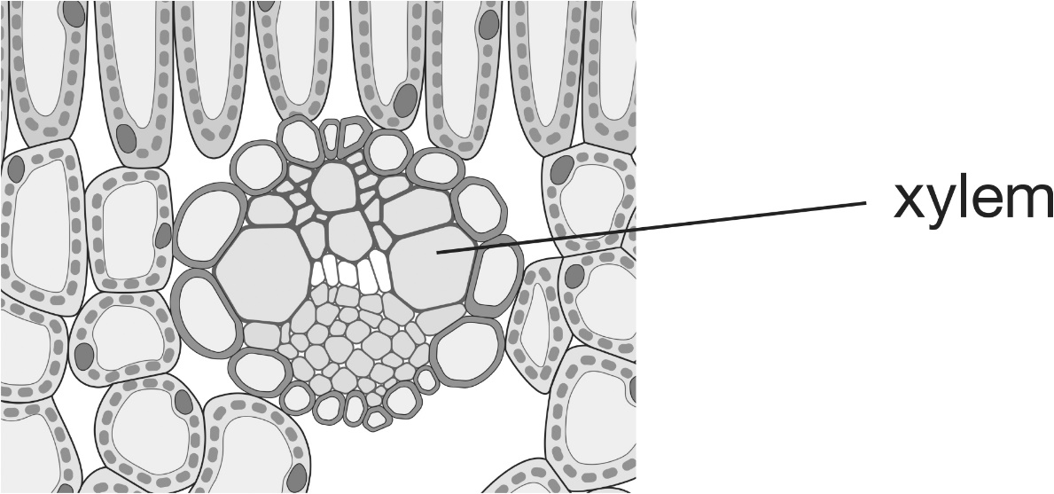

By what process does water:

**a** enter the cytoplasm of cells next to the xylem? \_\_\_\_\_\_\_\_\_\_\_\_\_\_\_\_\_\_\_\_\_\_\_\_\_

**b** change into vapour at the surfaces of cells? \_\_\_\_\_\_\_\_\_\_\_\_\_\_\_\_\_\_\_\_\_\_\_\_\_

**c** flow out of a leaf down its concentration gradient? \_\_\_\_\_\_\_\_\_\_\_\_\_\_\_\_\_\_\_\_\_\_\_\_\_

**(3 marks)**

**2** In an experiment using a potometer, the speed of a bubble in a capillary tube was used to work out the rate of transpiration at different temperatures.

**a** Complete the table. **(4 marks)**

|  |  |  |  |  |
| --- | --- | --- | --- | --- |
| Temperature (°C) | Position of bubble at start (mm) | Position of bubble after 25 mins (mm) | Distance travelled by the bubble (mm) | Rate of transpiration (mm/min) |
| 16 | 1 | 4 |  |  |
| 18 | 3 | 8 |  |  |
| 20 | 1 | 7 |  |  |
| 22 | 2 | 11 |  |  |

**b** State the relationship between the temperature and the rate of transpiration. (**1 mark**)

\_\_\_\_\_\_\_\_\_\_\_\_\_\_\_\_\_\_\_\_\_\_\_\_\_\_\_\_\_\_\_\_\_\_\_\_\_\_\_\_\_\_\_\_\_\_\_\_\_\_\_\_\_\_\_\_\_\_\_\_\_\_\_\_\_\_\_\_

**c** Explain this relationship. (**2 marks**)

\_\_\_\_\_\_\_\_\_\_\_\_\_\_\_\_\_\_\_\_\_\_\_\_\_\_\_\_\_\_\_\_\_\_\_\_\_\_\_\_\_\_\_\_\_\_\_\_\_\_\_\_\_\_\_\_\_\_\_\_\_\_\_\_\_\_\_\_

\_\_\_\_\_\_\_\_\_\_\_\_\_\_\_\_\_\_\_\_\_\_\_\_\_\_\_\_\_\_\_\_\_\_\_\_\_\_\_\_\_\_\_\_\_\_\_\_\_\_\_\_\_\_\_\_\_\_\_\_\_\_\_\_\_\_\_\_

\_\_\_\_\_\_\_\_\_\_\_\_\_\_\_\_\_\_\_\_\_\_\_\_\_\_\_\_\_\_\_\_\_\_\_\_\_\_\_\_\_\_\_\_\_\_\_\_\_\_\_\_\_\_\_\_\_\_\_\_\_\_\_\_\_\_\_\_

**3** A potometer is set up on a bench in a well-lit laboratory. The speed of the bubble is measured. What happens to the bubble speed when these conditions are changed?

Put one tick in each row. **(5 marks)**

|  |  |  |  |  |
| --- | --- | --- | --- | --- |
| Change in conditions | What happens to the movement of the bubble? | | | |
| moves faster | maintains same speed | moves slower | stops |
| the wind speed increases |  |  |  |  |
| the light intensity decreases |  |  |  |  |
| the temperature increases |  |  |  |  |
| the top sides of the leaves are coated in petroleum jelly |  |  |  |  |
| the undersides of the leaves are coated in petroleum jelly |  |  |  |  |

**4** Mass potometers of the type shown in the diagram are set up on a bench in a laboratory.

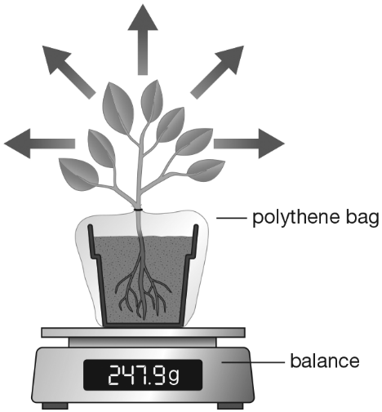

The pots of two plants (A and B) are sealed in clear bags as shown in the diagram.

The leaves of plant B are sealed in another clear plastic bag. Plant A is left uncovered.

The plants are left next to each other in the same conditions.

The masses of both plants are measured, and then measured again after 48 hours.

**a** Complete the table**. (2 marks)**

|  |  |  |  |  |  |
| --- | --- | --- | --- | --- | --- |
| Plant | Treatment | Initial mass (g) | Final mass (g) | Change in mass (g) | Change in mass (%) |
| A | leaves uncovered | 302 | 295 |  |  |
| B | leaves sealed in a bag | 331 | 328 |  |  |

**b** Give the reason a percentage change in mass needs to be calculated. (**1 mark**)

\_\_\_\_\_\_\_\_\_\_\_\_\_\_\_\_\_\_\_\_\_\_\_\_\_\_\_\_\_\_\_\_\_\_\_\_\_\_\_\_\_\_\_\_\_\_\_\_\_\_\_\_\_\_\_\_\_\_\_\_\_\_\_\_\_\_\_\_

**c** Explain the difference between the rates of transpiration in the two plants. (**1 mark**)

\_\_\_\_\_\_\_\_\_\_\_\_\_\_\_\_\_\_\_\_\_\_\_\_\_\_\_\_\_\_\_\_\_\_\_\_\_\_\_\_\_\_\_\_\_\_\_\_\_\_\_\_\_\_\_\_\_\_\_\_\_\_\_\_\_\_\_\_

\_\_\_\_\_\_\_\_\_\_\_\_\_\_\_\_\_\_\_\_\_\_\_\_\_\_\_\_\_\_\_\_\_\_\_\_\_\_\_\_\_\_\_\_\_\_\_\_\_\_\_\_\_\_\_\_\_\_\_\_\_\_\_\_\_\_\_\_

\_\_\_\_\_\_\_\_\_\_\_\_\_\_\_\_\_\_\_\_\_\_\_\_\_\_\_\_\_\_\_\_\_\_\_\_\_\_\_\_\_\_\_\_\_\_\_\_\_\_\_\_\_\_\_\_\_\_\_\_\_\_\_\_\_\_\_\_

**d** A third plant of the same type has its leaves coated with petroleum jelly. It is left next to the other two plants for 48 hours.

Predict how its change in mass compares to plant A and give a reason for your prediction. (**2 marks**)

\_\_\_\_\_\_\_\_\_\_\_\_\_\_\_\_\_\_\_\_\_\_\_\_\_\_\_\_\_\_\_\_\_\_\_\_\_\_\_\_\_\_\_\_\_\_\_\_\_\_\_\_\_\_\_\_\_\_\_\_\_\_\_\_\_\_\_\_

\_\_\_\_\_\_\_\_\_\_\_\_\_\_\_\_\_\_\_\_\_\_\_\_\_\_\_\_\_\_\_\_\_\_\_\_\_\_\_\_\_\_\_\_\_\_\_\_\_\_\_\_\_\_\_\_\_\_\_\_\_\_\_\_\_\_\_\_

\_\_\_\_\_\_\_\_\_\_\_\_\_\_\_\_\_\_\_\_\_\_\_\_\_\_\_\_\_\_\_\_\_\_\_\_\_\_\_\_\_\_\_\_\_\_\_\_\_\_\_\_\_\_\_\_\_\_\_\_\_\_\_\_\_\_\_\_

**e** The plants all had their pots covered with plastic bags, as shown in the diagram.

Explain why doing this allows valid measurements to be collected. (**2 marks**)

\_\_\_\_\_\_\_\_\_\_\_\_\_\_\_\_\_\_\_\_\_\_\_\_\_\_\_\_\_\_\_\_\_\_\_\_\_\_\_\_\_\_\_\_\_\_\_\_\_\_\_\_\_\_\_\_\_\_\_\_\_\_\_\_\_\_\_\_

\_\_\_\_\_\_\_\_\_\_\_\_\_\_\_\_\_\_\_\_\_\_\_\_\_\_\_\_\_\_\_\_\_\_\_\_\_\_\_\_\_\_\_\_\_\_\_\_\_\_\_\_\_\_\_\_\_\_\_\_\_\_\_\_\_\_\_\_

\_\_\_\_\_\_\_\_\_\_\_\_\_\_\_\_\_\_\_\_\_\_\_\_\_\_\_\_\_\_\_\_\_\_\_\_\_\_\_\_\_\_\_\_\_\_\_\_\_\_\_\_\_\_\_\_\_\_\_\_\_\_\_\_\_\_\_\_

**Total marks = 23**

Lesson 43 Translocation in Phloem

**1** The diagram shows two cells in the phloem, X and Y.

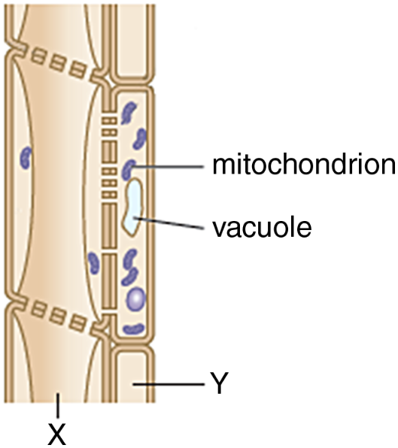

**a** Cells of type X link together to form phloem tubes. Give the names of cells X and Y. (**2 marks**)

**X** \_\_\_\_\_\_\_\_\_\_\_\_\_\_\_\_\_\_\_\_\_\_\_\_ **Y** \_\_\_\_\_\_\_\_\_\_\_\_\_\_\_\_\_\_\_\_\_\_\_\_

**b** Explain one way in which cell X is adapted for its function. (**2 marks**)

\_\_\_\_\_\_\_\_\_\_\_\_\_\_\_\_\_\_\_\_\_\_\_\_\_\_\_\_\_\_\_\_\_\_\_\_\_\_\_\_\_\_\_\_\_\_\_\_\_\_\_\_\_\_\_\_\_\_\_\_\_\_\_\_\_\_\_\_

\_\_\_\_\_\_\_\_\_\_\_\_\_\_\_\_\_\_\_\_\_\_\_\_\_\_\_\_\_\_\_\_\_\_\_\_\_\_\_\_\_\_\_\_\_\_\_\_\_\_\_\_\_\_\_\_\_\_\_\_\_\_\_\_\_\_\_\_

**c** Explain one way in which cell Y is adapted for its function. (**2 marks**)

\_\_\_\_\_\_\_\_\_\_\_\_\_\_\_\_\_\_\_\_\_\_\_\_\_\_\_\_\_\_\_\_\_\_\_\_\_\_\_\_\_\_\_\_\_\_\_\_\_\_\_\_\_\_\_\_\_\_\_\_\_\_\_\_\_\_\_\_

\_\_\_\_\_\_\_\_\_\_\_\_\_\_\_\_\_\_\_\_\_\_\_\_\_\_\_\_\_\_\_\_\_\_\_\_\_\_\_\_\_\_\_\_\_\_\_\_\_\_\_\_\_\_\_\_\_\_\_\_\_\_\_\_\_\_\_\_

The phloem transports sugars and other organic molecules (such as amino acids).

**d** What name is given to this transport process? Tick one. (**1 mark**)

**A** transpiration 🞎

**B** translocation 🞎

**C** transition 🞎

**D** translation 🞎

**e** State the mineral ion needed to make amino acids. (**1 mark**) \_\_\_\_\_\_\_\_\_\_\_\_\_\_\_\_\_\_\_\_\_\_\_\_\_\_\_\_\_\_\_\_\_\_\_\_\_\_\_\_\_\_\_\_\_\_\_\_\_\_\_\_\_\_\_\_\_\_\_\_\_\_\_\_\_\_\_

**f** Name the polymers that amino acids are used to make. (**1 mark**) \_\_\_\_\_\_\_\_\_\_\_\_\_\_\_\_\_\_\_\_\_\_\_\_\_\_\_\_\_\_\_\_\_\_\_\_\_\_\_\_\_\_\_\_\_\_\_\_\_\_\_\_\_\_\_\_\_\_\_\_\_\_\_\_\_\_\_

**2 a** Glucose is produced by photosynthesis. Glucose is used directly and is also converted into many other substances. Draw lines to link each substance with one of its uses. (**5 marks**)

|  |  |  |
| --- | --- | --- |
| Substance |  | Use |
|  |  |  |
| cellulose |  | respiration |
|  |  |  |
| glucose |  | transport sugar |
|  |  |  |
| starch |  | **cell walls** |
|  |  |  |
| sucrose |  | **storage** |

**b** List the polymers in the table. (**1 mark**)

\_\_\_\_\_\_\_\_\_\_\_\_\_\_\_\_\_\_\_\_\_\_\_\_\_\_\_\_\_\_\_\_\_\_\_\_\_\_\_\_\_\_\_\_\_\_\_\_\_\_\_\_\_\_\_\_\_\_\_\_\_\_\_\_\_\_\_

**3** Complete the table to show how each process occurs. Put one tick in each row. (**4 marks**)

|  |  |  |  |
| --- | --- | --- | --- |
| Process | Diffusion | Osmosis | Active transport |
| water moving from soil into root hair cell cytoplasm |  |  |  |
| sucrose moving into phloem tubes |  |  |  |
| water vapour moving through stomata |  |  |  |
| mineral ions moving into root hair cell cytoplasm |  |  |  |

**4** Complete the table to compare xylem and phloem. Put one *or* two ticks in each row**.(9 marks)**

|  |  |  |
| --- | --- | --- |
|  | Xylem | Phloem |
| carries substances downwards |  |  |
| carries substances upwards |  |  |
| cells are thickened with lignin |  |  |
| cells form tubes |  |  |
| mainly transport water |  |  |
| tubes made of living cells |  |  |
| transport mineral ions |  |  |
| transport amino acids |  |  |
| transport sugars |  |  |

**5** Phloem and xylem form a plant’s transport system. Explain why plants need a transport system. (**3 marks**)

\_\_\_\_\_\_\_\_\_\_\_\_\_\_\_\_\_\_\_\_\_\_\_\_\_\_\_\_\_\_\_\_\_\_\_\_\_\_\_\_\_\_\_\_\_\_\_\_\_\_\_\_\_\_\_\_\_\_\_\_\_\_\_\_\_\_\_\_\_\_

\_\_\_\_\_\_\_\_\_\_\_\_\_\_\_\_\_\_\_\_\_\_\_\_\_\_\_\_\_\_\_\_\_\_\_\_\_\_\_\_\_\_\_\_\_\_\_\_\_\_\_\_\_\_\_\_\_\_\_\_\_\_\_\_\_\_\_\_\_\_

\_\_\_\_\_\_\_\_\_\_\_\_\_\_\_\_\_\_\_\_\_\_\_\_\_\_\_\_\_\_\_\_\_\_\_\_\_\_\_\_\_\_\_\_\_\_\_\_\_\_\_\_\_\_\_\_\_\_\_\_\_\_\_\_\_\_\_\_\_\_

**Total = 31 marks**

**Lesson 44 The Trophic Responses of Plants to Stimuli**

**1** A plant root grows towards a region of greater moisture in the soil.

**a** What is the stimulus? Choose one. (**1 mark**)

|  |  |  |  |
| --- | --- | --- | --- |
| **A** the plant root | **B** growth | **C** gravity | **D** water |

**b** What is the response? Choose one. (**1 mark**)

|  |  |  |  |
| --- | --- | --- | --- |
| **A** the plant root | **B** growth | **C** gravity | **D** water |

**c** Which life process involves responding to stimuli? (**1 mark**) \_\_\_\_\_\_\_\_\_\_\_\_\_\_\_\_\_\_\_\_\_\_\_\_\_\_\_\_\_\_\_\_\_\_\_\_\_\_\_\_\_\_\_\_\_\_\_\_\_\_\_\_\_\_\_\_\_\_\_\_\_\_\_\_\_\_\_\_

**2** Use two words from the box to identify each tropic response described in **a**–**c**. (**6 marks**)

|  |  |  |  |  |
| --- | --- | --- | --- | --- |
| geotropism | negative | neutral | phototropism | positive |

**a** A vertical plant shoot starts to bend and grow towards light coming from one side.

\_\_\_\_\_\_\_\_\_\_\_\_\_\_\_\_\_\_\_\_\_\_\_\_\_\_\_\_\_\_\_\_\_\_\_\_\_\_\_\_\_\_\_\_\_\_\_\_\_\_\_\_\_\_\_\_\_\_\_\_\_\_\_\_\_\_\_\_

**b** A horizontal underground root starts to bend and grow downwards.

\_\_\_\_\_\_\_\_\_\_\_\_\_\_\_\_\_\_\_\_\_\_\_\_\_\_\_\_\_\_\_\_\_\_\_\_\_\_\_\_\_\_\_\_\_\_\_\_\_\_\_\_\_\_\_\_\_\_\_\_\_\_\_\_\_\_\_\_

**c** A root grows so that it bends away from light coming from one side.

\_\_\_\_\_\_\_\_\_\_\_\_\_\_\_\_\_\_\_\_\_\_\_\_\_\_\_\_\_\_\_\_\_\_\_\_\_\_\_\_\_\_\_\_\_\_\_\_\_\_\_\_\_\_\_\_\_\_\_\_\_\_\_\_\_\_\_\_

**3 a** Give two reasons why the tropic response of roots to gravity helps a plant to survive. (**2 marks**)

\_\_\_\_\_\_\_\_\_\_\_\_\_\_\_\_\_\_\_\_\_\_\_\_\_\_\_\_\_\_\_\_\_\_\_\_\_\_\_\_\_\_\_\_\_\_\_\_\_\_\_\_\_\_\_\_\_\_\_\_\_\_\_\_\_\_\_

\_\_\_\_\_\_\_\_\_\_\_\_\_\_\_\_\_\_\_\_\_\_\_\_\_\_\_\_\_\_\_\_\_\_\_\_\_\_\_\_\_\_\_\_\_\_\_\_\_\_\_\_\_\_\_\_\_\_\_\_\_\_\_\_\_\_\_

**b** Give a reason why the tropic response of shoots to light helps a plant to survive. (**1 mark**)

\_\_\_\_\_\_\_\_\_\_\_\_\_\_\_\_\_\_\_\_\_\_\_\_\_\_\_\_\_\_\_\_\_\_\_\_\_\_\_\_\_\_\_\_\_\_\_\_\_\_\_\_\_\_\_\_\_\_\_\_\_\_\_\_\_\_\_

**c** A new shoot from a germinating seed that is underground always grows upwards. This means that the shoot can grow above the surface of the soil and find light. Explain one other way in which this response helps the seedling to survive. (**2 marks**)

\_\_\_\_\_\_\_\_\_\_\_\_\_\_\_\_\_\_\_\_\_\_\_\_\_\_\_\_\_\_\_\_\_\_\_\_\_\_\_\_\_\_\_\_\_\_\_\_\_\_\_\_\_\_\_\_\_\_\_\_\_\_\_\_\_\_\_

\_\_\_\_\_\_\_\_\_\_\_\_\_\_\_\_\_\_\_\_\_\_\_\_\_\_\_\_\_\_\_\_\_\_\_\_\_\_\_\_\_\_\_\_\_\_\_\_\_\_\_\_\_\_\_\_\_\_\_\_\_\_\_\_\_\_\_

**4** A student investigates the effect of different colours of light on shoots.

The student takes three bean seedlings with shoots that are growing vertically upwards. Each is placed in an identical cardboard box that has a slit cut into one side. Each slit is covered with a different plastic filter (to create a different colour of light). After 2 days, the student uses a protractor to measure how much each seedling has bent in the direction of the slit.

The results are shown in the table.

|  |  |
| --- | --- |
| Filter colour | Amount of bending towards the slit (º) |
| blue | 15 |
| green | 0 |
| red | 3 |

**a** State:

**i** the independent variable (**1 mark**)

\_\_\_\_\_\_\_\_\_\_\_\_\_\_\_\_\_\_\_\_\_\_\_\_\_\_\_\_\_\_\_\_\_\_\_\_\_\_\_\_\_\_\_\_\_\_\_\_\_\_\_\_\_\_\_\_\_\_\_\_\_\_\_\_\_\_\_

**ii** the dependent variable (**1 mark**)

\_\_\_\_\_\_\_\_\_\_\_\_\_\_\_\_\_\_\_\_\_\_\_\_\_\_\_\_\_\_\_\_\_\_\_\_\_\_\_\_\_\_\_\_\_\_\_\_\_\_\_\_\_\_\_\_\_\_\_\_\_\_\_\_\_\_\_\_

**iii** two control variables mentioned in the paragraph. (**2 marks**)

\_\_\_\_\_\_\_\_\_\_\_\_\_\_\_\_\_\_\_\_\_\_\_\_\_\_\_\_\_\_\_\_\_\_\_\_\_\_\_\_\_\_\_\_\_\_\_\_\_\_\_\_\_\_\_\_\_\_\_\_\_\_\_\_\_

**b** The student has written: The results shows that plants respond best to blue light.

**i** State how this conclusion is supported by the results. (**1 mark**)

\_\_\_\_\_\_\_\_\_\_\_\_\_\_\_\_\_\_\_\_\_\_\_\_\_\_\_\_\_\_\_\_\_\_\_\_\_\_\_\_\_\_\_\_\_\_\_\_\_\_\_\_\_\_\_\_\_\_\_\_\_\_\_\_\_

**ii** Give a reason why this is not a valid conclusion. (**1 mark**)

\_\_\_\_\_\_\_\_\_\_\_\_\_\_\_\_\_\_\_\_\_\_\_\_\_\_\_\_\_\_\_\_\_\_\_\_\_\_\_\_\_\_\_\_\_\_\_\_\_\_\_\_\_\_\_\_\_\_\_\_\_\_\_\_\_

\_\_\_\_\_\_\_\_\_\_\_\_\_\_\_\_\_\_\_\_\_\_\_\_\_\_\_\_\_\_\_\_\_\_\_\_\_\_\_\_\_\_\_\_\_\_\_\_\_\_\_\_\_\_\_\_\_\_\_\_\_\_\_\_\_

**c** Explain how the student should collect more reliable data in the original experiment. (**2 marks**)

\_\_\_\_\_\_\_\_\_\_\_\_\_\_\_\_\_\_\_\_\_\_\_\_\_\_\_\_\_\_\_\_\_\_\_\_\_\_\_\_\_\_\_\_\_\_\_\_\_\_\_\_\_\_\_\_\_\_\_\_\_\_\_\_\_\_\_\_

\_\_\_\_\_\_\_\_\_\_\_\_\_\_\_\_\_\_\_\_\_\_\_\_\_\_\_\_\_\_\_\_\_\_\_\_\_\_\_\_\_\_\_\_\_\_\_\_\_\_\_\_\_\_\_\_\_\_\_\_\_\_\_\_\_\_\_\_

\_\_\_\_\_\_\_\_\_\_\_\_\_\_\_\_\_\_\_\_\_\_\_\_\_\_\_\_\_\_\_\_\_\_\_\_\_\_\_\_\_\_\_\_\_\_\_\_\_\_\_\_\_\_\_\_\_\_\_\_\_\_\_\_\_\_\_\_

**5** The apparatus in the diagram is a clinostat. Two clinostats are set up with four bean seeds pinned to each. One is set to revolve slowly (in the direction of the arrow) and the other is left switched off.

**a** Explain what will happen. (**2 marks**)

\_\_\_\_\_\_\_\_\_\_\_\_\_\_\_\_\_\_\_\_\_\_\_\_\_\_\_\_\_\_\_\_\_\_\_\_\_\_\_\_\_\_\_\_\_\_\_\_\_\_\_\_\_\_\_\_\_\_\_\_\_\_\_\_\_\_\_\_

\_\_\_\_\_\_\_\_\_\_\_\_\_\_\_\_\_\_\_\_\_\_\_\_\_\_\_\_\_\_\_\_\_\_\_\_\_\_\_\_\_\_\_\_\_\_\_\_\_\_\_\_\_\_\_\_\_\_\_\_\_\_\_\_\_\_\_\_

\_\_\_\_\_\_\_\_\_\_\_\_\_\_\_\_\_\_\_\_\_\_\_\_\_\_\_\_\_\_\_\_\_\_\_\_\_\_\_\_\_\_\_\_\_\_\_\_\_\_\_\_\_\_\_\_\_\_\_\_\_\_\_\_\_\_\_\_

**b** The experiment is repeated but with the clinostats in a vertical position (so that the platform to which the beans are pinned is horizontal). Explain what will happen. (**2 marks**)

\_\_\_\_\_\_\_\_\_\_\_\_\_\_\_\_\_\_\_\_\_\_\_\_\_\_\_\_\_\_\_\_\_\_\_\_\_\_\_\_\_\_\_\_\_\_\_\_\_\_\_\_\_\_\_\_\_\_\_\_\_\_\_\_\_\_\_\_

\_\_\_\_\_\_\_\_\_\_\_\_\_\_\_\_\_\_\_\_\_\_\_\_\_\_\_\_\_\_\_\_\_\_\_\_\_\_\_\_\_\_\_\_\_\_\_\_\_\_\_\_\_\_\_\_\_\_\_\_\_\_\_\_\_\_\_\_

\_\_\_\_\_\_\_\_\_\_\_\_\_\_\_\_\_\_\_\_\_\_\_\_\_\_\_\_\_\_\_\_\_\_\_\_\_\_\_\_\_\_\_\_\_\_\_\_\_\_\_\_\_\_\_\_\_\_\_\_\_\_\_\_\_\_\_\_

**Total marks = 26**

**Lesson 45 The Role of Auxin in Trophic Responses**

**1 a** What are the advantages for a plant if its roots grow *in* the direction of gravity? Give two advantages. (**2 marks**)

\_\_\_\_\_\_\_\_\_\_\_\_\_\_\_\_\_\_\_\_\_\_\_\_\_\_\_\_\_\_\_\_\_\_\_\_\_\_\_\_\_\_\_\_\_\_\_\_\_\_\_\_\_\_\_\_\_\_\_\_\_\_

\_\_\_\_\_\_\_\_\_\_\_\_\_\_\_\_\_\_\_\_\_\_\_\_\_\_\_\_\_\_\_\_\_\_\_\_\_\_\_\_\_\_\_\_\_\_\_\_\_\_\_\_\_\_\_\_\_\_\_\_\_\_

**b** What is the process described in part **a** called? Tick one. (**1 mark**)

◻ **A** positive phototropism

◻ **B** positive geotropism

◻ **C** negative phototropism

◻ **D** negative geotropism

**c** Give one advantage for a plant if its shoots grow away from the direction of gravity. (**1 mark**)

\_\_\_\_\_\_\_\_\_\_\_\_\_\_\_\_\_\_\_\_\_\_\_\_\_\_\_\_\_\_\_\_\_\_\_\_\_\_\_\_\_\_\_\_\_\_\_\_\_\_\_\_\_\_\_\_\_\_\_\_\_\_

\_\_\_\_\_\_\_\_\_\_\_\_\_\_\_\_\_\_\_\_\_\_\_\_\_\_\_\_\_\_\_\_\_\_\_\_\_\_\_\_\_\_\_\_\_\_\_\_\_\_\_\_\_\_\_\_\_\_\_\_\_\_

**d** What is this tropism called? (**1 mark**)

\_\_\_\_\_\_\_\_\_\_\_\_\_\_\_\_\_\_\_\_\_\_\_\_\_\_\_\_\_\_\_\_\_\_\_\_\_\_\_\_\_\_\_\_\_\_\_\_\_\_\_\_\_\_\_\_\_\_\_\_\_\_

**2** In 1880, Charles Darwin did experiments on the growth of plant shoots. These are shown in the drawings.

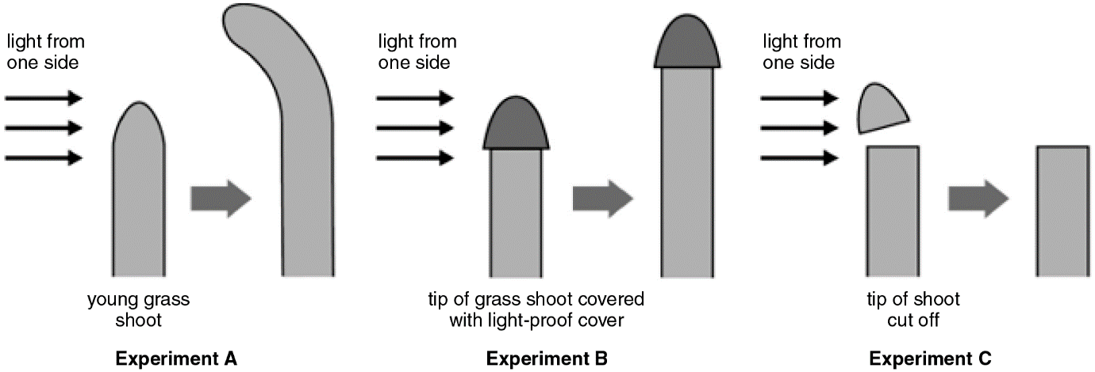

**a** Describe what happened in each experiment – **A**, **B** and **C**. (**3 marks**)

In **A**, \_\_\_\_\_\_\_\_\_\_\_\_\_\_\_\_\_\_\_\_\_\_\_\_\_\_\_\_\_\_\_\_\_\_\_\_\_\_\_\_\_\_\_\_\_\_\_\_\_\_\_\_\_\_\_\_\_

In **B**, \_\_\_\_\_\_\_\_\_\_\_\_\_\_\_\_\_\_\_\_\_\_\_\_\_\_\_\_\_\_\_\_\_\_\_\_\_\_\_\_\_\_\_\_\_\_\_\_\_\_\_\_\_\_\_\_\_

In **C**, \_\_\_\_\_\_\_\_\_\_\_\_\_\_\_\_\_\_\_\_\_\_\_\_\_\_\_\_\_\_\_\_\_\_\_\_\_\_\_\_\_\_\_\_\_\_\_\_\_\_\_\_\_\_\_\_\_

We now know that plant hormones cause these things to happen. In experiment **A**, light causes plant hormones called auxins to move towards the darker part of the shoot.

**b** On the diagram for experiment **A**, draw where auxins have moved to. (**1 mark**)

**c** What effect do auxins have on the part of the shoot they move to? (**1 mark**)

\_\_\_\_\_\_\_\_\_\_\_\_\_\_\_\_\_\_\_\_\_\_\_\_\_\_\_\_\_\_\_\_\_\_\_\_\_\_\_\_\_\_\_\_\_\_\_\_\_\_\_\_\_\_\_\_\_\_\_\_\_\_

**d** Why is this useful to the plant? (**1 mark**)

\_\_\_\_\_\_\_\_\_\_\_\_\_\_\_\_\_\_\_\_\_\_\_\_\_\_\_\_\_\_\_\_\_\_\_\_\_\_\_\_\_\_\_\_\_\_\_\_\_\_\_\_\_\_\_\_\_\_\_\_\_\_

\_\_\_\_\_\_\_\_\_\_\_\_\_\_\_\_\_\_\_\_\_\_\_\_\_\_\_\_\_\_\_\_\_\_\_\_\_\_\_\_\_\_\_\_\_\_\_\_\_\_\_\_\_\_\_\_\_\_\_\_\_\_

**e** Use the drawings to explain how you can tell that auxins are produced only in the shoot tip. (**2 marks**)

\_\_\_\_\_\_\_\_\_\_\_\_\_\_\_\_\_\_\_\_\_\_\_\_\_\_\_\_\_\_\_\_\_\_\_\_\_\_\_\_\_\_\_\_\_\_\_\_\_\_\_\_\_\_\_\_\_\_\_\_\_\_

\_\_\_\_\_\_\_\_\_\_\_\_\_\_\_\_\_\_\_\_\_\_\_\_\_\_\_\_\_\_\_\_\_\_\_\_\_\_\_\_\_\_\_\_\_\_\_\_\_\_\_\_\_\_\_\_\_\_\_\_\_\_

**3** Plant roots can be attracted towards moisture.

**a** This is hydrotropism. Is this tropism positive or negative? (**1 mark**)

\_\_\_\_\_\_\_\_\_\_\_\_\_\_\_\_\_\_\_\_\_\_\_\_\_\_\_\_\_\_\_\_\_\_\_\_\_\_\_\_\_\_\_\_\_\_\_\_\_\_\_\_\_\_\_\_\_\_\_\_\_\_\_\_\_

**b** Give two reasons why water is important for the plant. (**2 marks**)

\_\_\_\_\_\_\_\_\_\_\_\_\_\_\_\_\_\_\_\_\_\_\_\_\_\_\_\_\_\_\_\_\_\_\_\_\_\_\_\_\_\_\_\_\_\_\_\_\_\_\_\_\_\_\_\_\_\_\_\_\_\_

\_\_\_\_\_\_\_\_\_\_\_\_\_\_\_\_\_\_\_\_\_\_\_\_\_\_\_\_\_\_\_\_\_\_\_\_\_\_\_\_\_\_\_\_\_\_\_\_\_\_\_\_\_\_\_\_\_\_\_\_\_\_

**4** An experiment with clinostats is set up as shown.

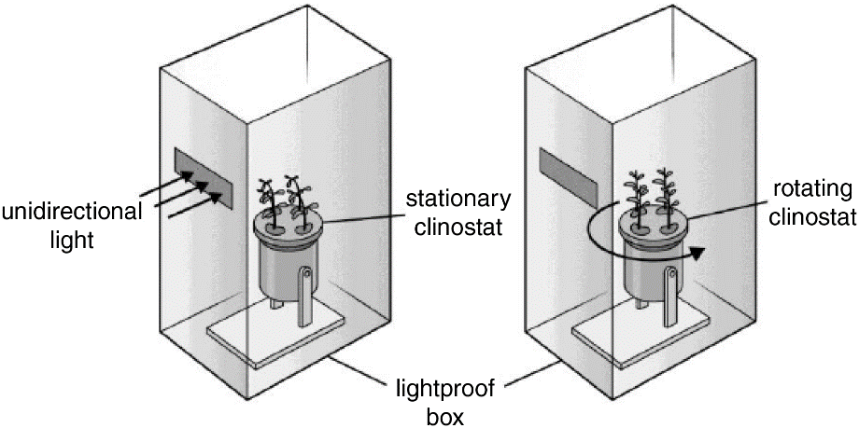

Use the idea of auxins to explain what happens. (**4 marks**)

\_\_\_\_\_\_\_\_\_\_\_\_\_\_\_\_\_\_\_\_\_\_\_\_\_\_\_\_\_\_\_\_\_\_\_\_\_\_\_\_\_\_\_\_\_\_\_\_\_\_\_\_\_\_\_\_\_\_\_\_\_\_\_\_

\_\_\_\_\_\_\_\_\_\_\_\_\_\_\_\_\_\_\_\_\_\_\_\_\_\_\_\_\_\_\_\_\_\_\_\_\_\_\_\_\_\_\_\_\_\_\_\_\_\_\_\_\_\_\_\_\_\_\_\_\_\_\_\_

\_\_\_\_\_\_\_\_\_\_\_\_\_\_\_\_\_\_\_\_\_\_\_\_\_\_\_\_\_\_\_\_\_\_\_\_\_\_\_\_\_\_\_\_\_\_\_\_\_\_\_\_\_\_\_\_\_\_\_\_\_\_\_\_

\_\_\_\_\_\_\_\_\_\_\_\_\_\_\_\_\_\_\_\_\_\_\_\_\_\_\_\_\_\_\_\_\_\_\_\_\_\_\_\_\_\_\_\_\_\_\_\_\_\_\_\_\_\_\_\_\_\_\_\_\_\_\_\_

**Total marks = 20**

**Lesson 46 Analyse Data About Transpiration**

**1** An experiment was carried out to examine the effect of the size of stomatal pores on the rate of transpiration. The data was collected in still air and in moving air.

|  |  |  |
| --- | --- | --- |
| Size of stomatal pore (μm) | Rate of transpiration (mg/m2/s) | |
|  | Still air | Moving air |
| 0 | 0 | 0 |
| 4 | 22 | 38 |
| 8 | 46 | 140 |
| 12 | 48 | 165 |
| 16 | 50 | 210 |
| 20 | 50 | 248 |
| 24 | 50 | 264 |

**a** In the experiment with still air, state:

**i** the independent variable. (**1 mark**)

\_\_\_\_\_\_\_\_\_\_\_\_\_\_\_\_\_\_\_\_\_\_\_\_\_\_\_\_\_\_\_\_\_\_\_\_\_\_\_\_\_\_\_\_\_\_\_\_\_\_\_\_\_\_\_\_\_\_\_\_\_\_\_\_\_\_\_

**ii** the dependent variable. (**1 mark**)

\_\_\_\_\_\_\_\_\_\_\_\_\_\_\_\_\_\_\_\_\_\_\_\_\_\_\_\_\_\_\_\_\_\_\_\_\_\_\_\_\_\_\_\_\_\_\_\_\_\_\_\_\_\_\_\_\_\_\_\_\_\_\_\_\_\_\_

**iii** two variables that should be controlled to make the investigation valid (**2 marks**)

\_\_\_\_\_\_\_\_\_\_\_\_\_\_\_\_\_\_\_\_\_\_\_\_\_\_\_\_\_\_\_\_\_\_\_\_\_\_\_\_\_\_\_\_\_\_\_\_\_\_\_\_\_\_\_\_\_\_\_\_\_\_\_\_\_

\_\_\_\_\_\_\_\_\_\_\_\_\_\_\_\_\_\_\_\_\_\_\_\_\_\_\_\_\_\_\_\_\_\_\_\_\_\_\_\_\_\_\_\_\_\_\_\_\_\_\_\_\_\_\_\_\_\_\_\_\_\_\_\_\_

**b** Tick the boxes to describe the data in the table. (**2 mark**)

🞏 qualitative

🞏 quantitative

🞏 continuous

🞏 discrete

**c** Plot a line graph to show the effect of stomatal pore size on transpiration rates in still and moving air. Use a ruler and pencil to connect the points on your graph.

**d** Describe how the rates of transpiration compare in still and moving air. (**2 marks**)

\_\_\_\_\_\_\_\_\_\_\_\_\_\_\_\_\_\_\_\_\_\_\_\_\_\_\_\_\_\_\_\_\_\_\_\_\_\_\_\_\_\_\_\_\_\_\_\_\_\_\_\_\_\_\_\_\_\_\_\_\_\_\_\_\_\_\_\_

\_\_\_\_\_\_\_\_\_\_\_\_\_\_\_\_\_\_\_\_\_\_\_\_\_\_\_\_\_\_\_\_\_\_\_\_\_\_\_\_\_\_\_\_\_\_\_\_\_\_\_\_\_\_\_\_\_\_\_\_\_\_\_\_\_\_\_\_

**e** Explain how still and moving air affect the transpiration rate. (**2 marks**)

\_\_\_\_\_\_\_\_\_\_\_\_\_\_\_\_\_\_\_\_\_\_\_\_\_\_\_\_\_\_\_\_\_\_\_\_\_\_\_\_\_\_\_\_\_\_\_\_\_\_\_\_\_\_\_\_\_\_\_\_\_\_\_\_\_\_\_\_

\_\_\_\_\_\_\_\_\_\_\_\_\_\_\_\_\_\_\_\_\_\_\_\_\_\_\_\_\_\_\_\_\_\_\_\_\_\_\_\_\_\_\_\_\_\_\_\_\_\_\_\_\_\_\_\_\_\_\_\_\_\_\_\_\_\_\_\_

**f** Which point in the results for moving air could be anomalous? (**1 mark**)

\_\_\_\_\_\_\_\_\_\_\_\_\_\_\_\_\_\_\_\_\_\_\_\_\_\_\_\_\_\_\_\_\_\_\_\_\_\_\_\_\_\_\_\_\_\_\_\_\_\_\_\_\_\_\_\_\_\_\_\_\_\_\_\_\_\_\_\_

**g** Describe one way that the reliability of the experiment could be improved. (**1 mark**)

\_\_\_\_\_\_\_\_\_\_\_\_\_\_\_\_\_\_\_\_\_\_\_\_\_\_\_\_\_\_\_\_\_\_\_\_\_\_\_\_\_\_\_\_\_\_\_\_\_\_\_\_\_\_\_\_\_\_\_\_\_\_\_\_\_\_\_\_

**Total = 12 marks**

Checklist: Investigating Plant Vasculature and Trophic Responses

|  |  |  |  |  |  |  |  |
| --- | --- | --- | --- | --- | --- | --- | --- |
| **Checklist (Lessons 37–46)** | | | | | | | |
| Look at the points in each topic. Decide if you fully understand (C:\Users\005228\Downloads\Fw_ Image\1.png) partly understand (C:\Users\005228\Downloads\Fw_ Image\2.png), or do not understand (C:\Users\005228\Downloads\Fw_ Image\3.png) each point and tick () the relevant column. This will show you the areas that you need to work on after this lesson. | | | | | | | |
| **Topic** | **Specification reference** | | **C:\Users\005228\Downloads\Fw_ Image\4.png** |  | **C:\Users\005228\Downloads\Fw_ Image\5.png** | **Lesson number** | **Student Book pages** |
| Problems with **Gas exchange in plants**? Try questions 2, 6 and 7 on pp. 148–151 of the **Student Book**. | | | | | | | |
| **Transport in plants** | **A** | understand why simple, unicellular organisms can rely on diffusion for movement of substances in and out of the cell |  |  |  | 37 | 16, 70–71 |
| **B** | understand the need for a transport system in multicellular organisms |  |  |  | 37 | 16, 70–71 |
| **C** | describe the role of phloem in transporting sucrose and amino acids between the leaves and other parts of the plant |  |  |  | 43 | 140, 144, 160 |
| **D** | describe the role of xylem in transporting water and mineral ions from the roots to other parts of the plant |  |  |  | 39 | 159–160 |
| **E** | understand how water is absorbed by root hair cells |  |  |  | 38 | 158 |
| **F** | understand that transpiration is the evaporation of water from the surface of a plant |  |  |  | 40 | 159–161 |
| **G** | understand how the rate of transpiration is affected by changes in humidity, wind speed, temperature and light intensity |  |  |  | 41 | 162 |
|  | **H** | *practical: investigate the role of environmental factors in determining the rate of transpiration from a leafy shoot* |  |  |  | 42, 46 | 164–166  Lab Book  48–52 |
| Problems with **Transport** **in plants**? Try questions 2, 3, 4, 6 and 9 on pp. 148–151 of the **Student Book**. | | | | | | | |
| **Tropisms in plants** | **A** | understand that plants respond to stimuli |  |  |  | 44 | 168–169 |
| **B** | describe the geotropic and phototropic responses of roots and stems |  |  |  | 44 | 169,  171– 172 |
| **C** | understand the role of auxin in the phototropic response of stems |  |  |  | 45 | 169–171 |
| Problems with **Tropisms**? Try questions 1, 2, 3, and 7 on pp. 172–173 of the **Student Book**. | | | | | | | |

|  |
| --- |
| **NEXT STEPS?** |
| Which areas do you feel confident about? |
|  |
| Write down any specific areas that you need to improve and what you might do. |
|  |