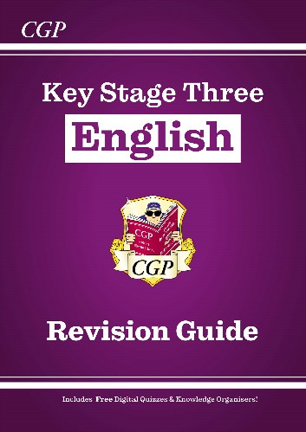**Year 8 Revision Guide Support**

All students were given a purple CGP KS3 English Revision guide in their English lesson and so they should use the following pages in their revision guide to support this.

There is also a QR code at the start of the book that will allow students to access the digital copy with online quizzes.

|  |  |
| --- | --- |
| **Page Number** | **Topic** |
| 25 | Character |
| 26 | Language for effect |
| 27 | Mood |
| 33-35 | Play Features |
| 73 | Planning your analytical answer |
| 78 | Using quotes |
| 79 | Explaining quotes |