**Formal Elements of Art: Workbook Name ____________________**

Cut out all of the images in this workbook and answer the relevant question in your sketchbook. Make sure that you title the pages with the question and that you present your work in a creative (but neat) way.

The Elements of Art

List the 7 visual elements of art:

The Principles of Art

List at least 5 of the principles of art:

What is the art-specific word for that way that something is laid out on the page?

C___________________

**How do artists create movement in their artwork?**

For each of the following images, draw lines on the image to show how lines are used to lead the eye, often drawing our attention to a certain area.

[Don’t forget to cut the images out and stick them into your sketchbook]

**Example: In the artwork below, the line in between the stones creates a spiral effect that leads the eye to the middle of the page.**

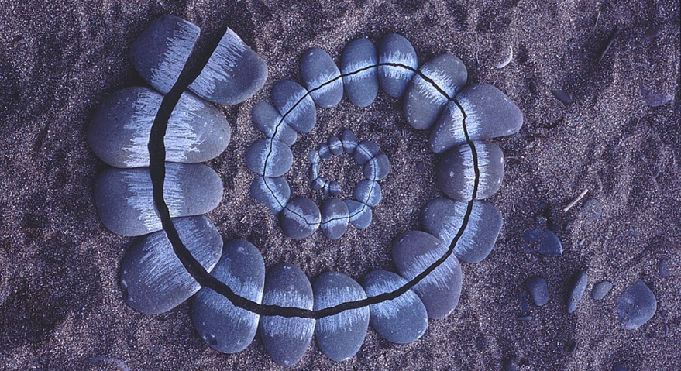

Now try these ones:

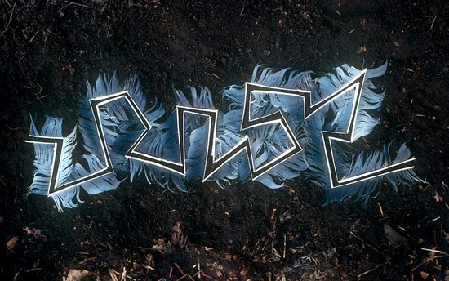

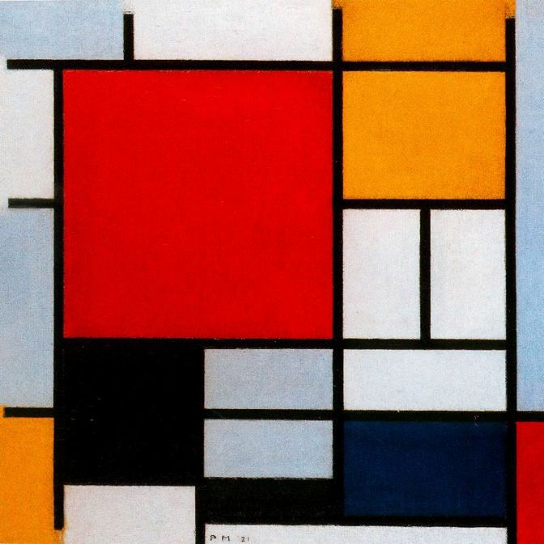

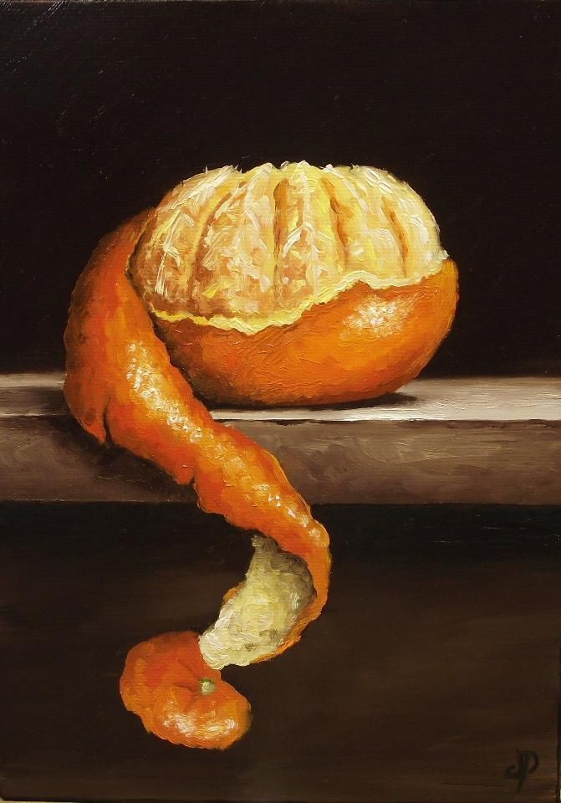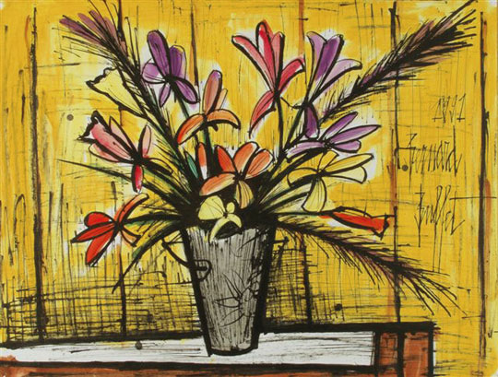

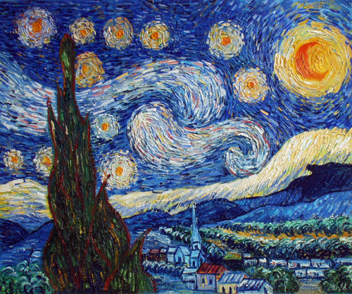

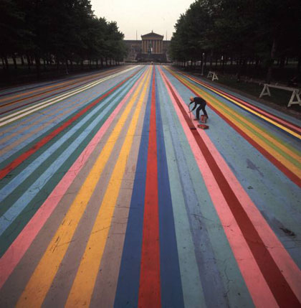

**What are the most important visual elements?**

Write below each of the following images what you believe is the **ONE MOST IMPORTANT** visual element in the image.

*Note: Often there is no single correct answer. The best way to do this is to think about each visual element in turn and ask yourself if the element is really important for this picture. Then decide which you feel is the* ***most*** *important.*

[Don’t forget to cut the images out and stick them into your sketchbook]

Example:

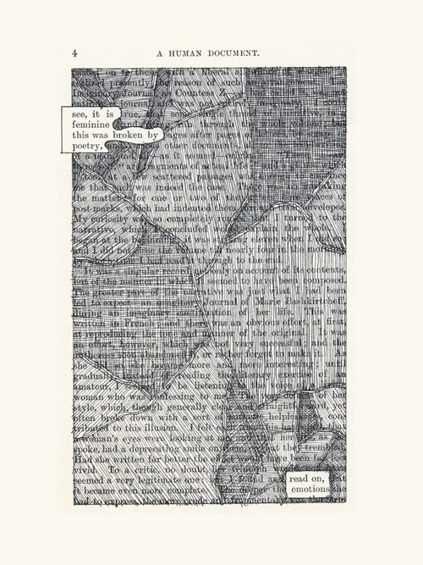

**Value** is the most important visual element in this work.

**The comment above will get you a *working towards* grade. If you are aiming for an *exceeding* grade you should try to give a reason or why you think this like the example below.**

**Value** is the most important visual element in this work because the artist has used different tones to try to hide the text. The darker parts of the work are what I look at first, so this for me is the most prominent element of art in this piece.

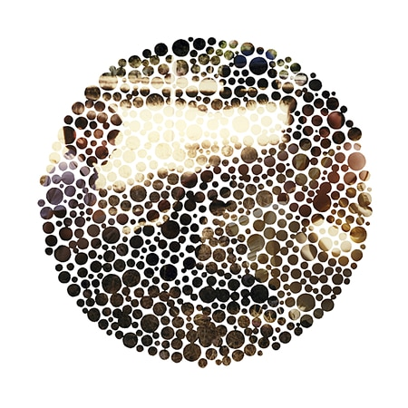Now try these ones:

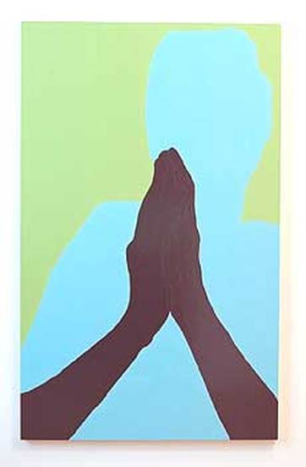

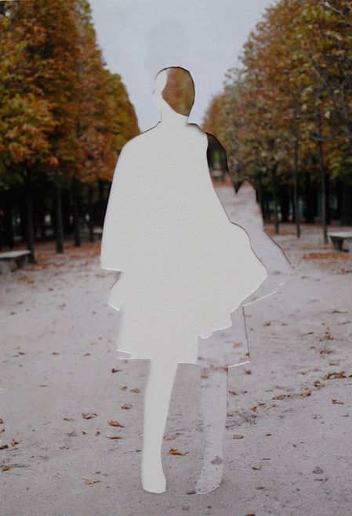

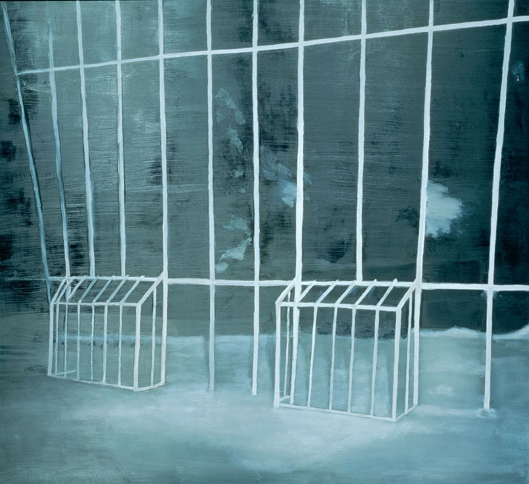

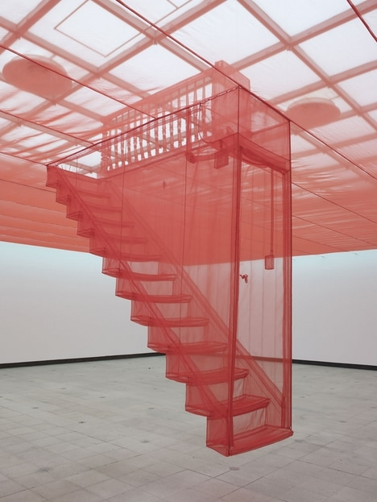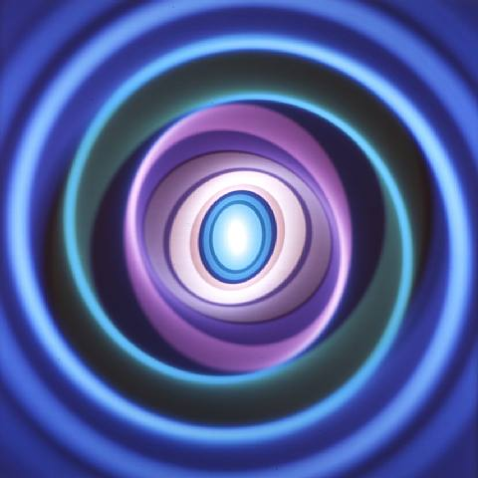

**What are the most and least important visual elements?**

For the following images, state which element of elements are the **most** and **least** prominent or important. Don’t forget to cut the images out and stick them into your sketchbook.

Example:

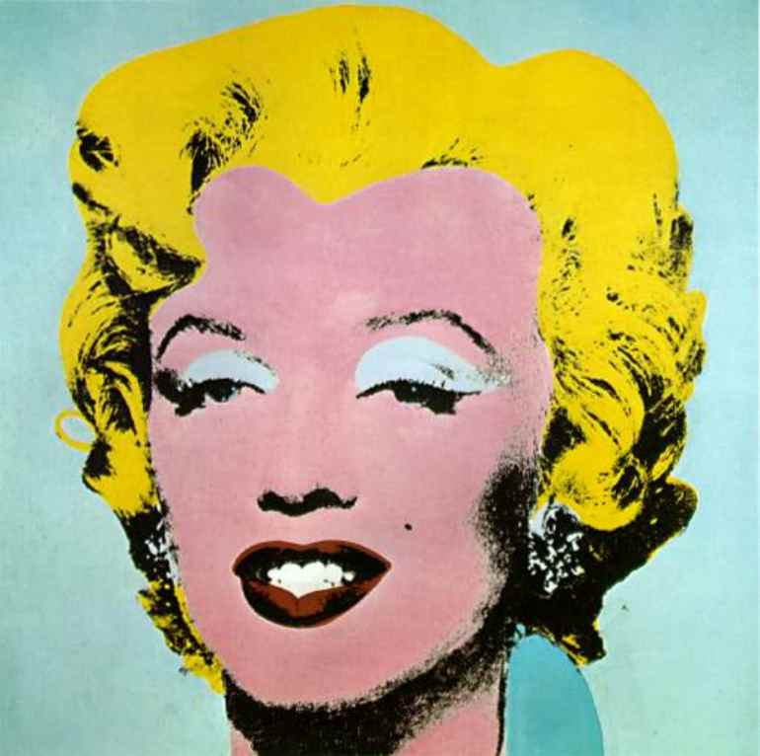

The most important visual elements are:

**Colour and Shape**

The most important visual elements are:

**Form and Line**

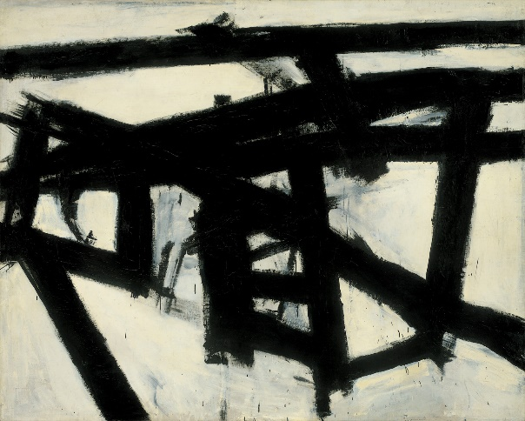

The most important visual elements are:

_________________________________________________________________________________________________________

The most important visual elements are:

_________________________________________________________________________________________________________

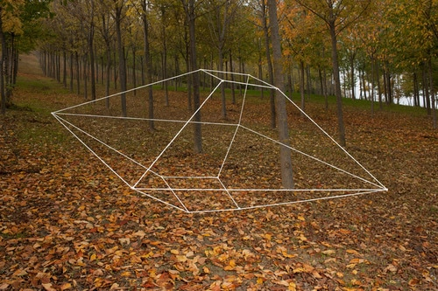

The most important visual elements are:

_________________________________________________________________________________________________________

The most important visual elements are:

_________________________________________________________________________________________________________



The most important visual elements are:

_________________________________________________________________________________________________________

The most important visual elements are:

_________________________________________________________________________________________________________

The most important visual elements are:

_________________________________________________________________________________________________________

The most important visual elements are:

_________________________________________________________________________________________________________

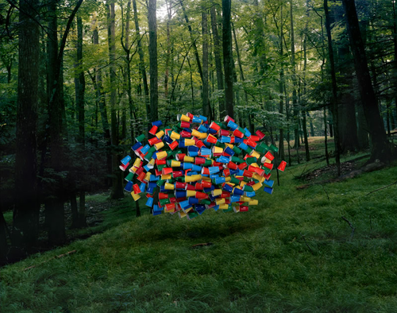

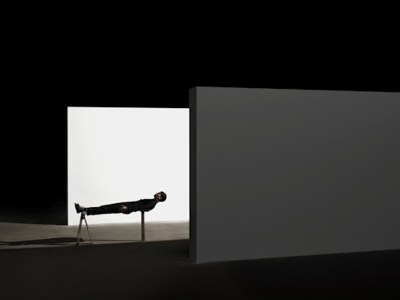

The most important visual elements are:

_________________________________________________________________________________________________________

The most important visual elements are:

_________________________________________________________________________________________________________