Unit: 1 - Who am I?

Van Gogh

Vincent Willem van Gogh was a Dutch post-impressionist painter. After his death, he became one of the most famous and influential artists in Western art. Over 10 years, he created around 2,100 artworks, including 860 oil paintings. Most of his best-known works were painted in the last two years of his life.

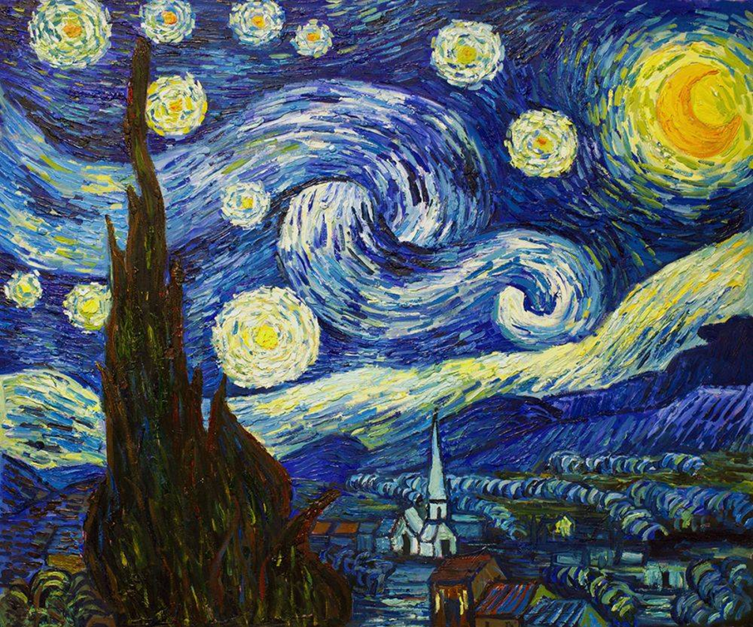

Title: Starry Night Artist: Vincent Van Gogh Date: 1889

Analytical Questions

**Step 1: Observation**

Look closely at the painting 'Starry Night.' Write down your observations. Consider:

* + What objects, shapes, and colours can you see?
  + How do the stars, moon, and sky look?

***I see…***

________________________________________________

________________________________________________

________________________________________________

________________________________________________

________________________________________________

**Step 2: Reflection**

What do you think about this painting? How does it make you feel? Does it remind you of something?

***I think…***

________________________________________________

________________________________________________

________________________________________________

________________________________________________

**Step 3: Curiosity**

What does this painting make you wonder about? Is there something in the painting that sparks questions? Write down any thoughts or curiosities.

***I wonder…***

________________________________________________

________________________________________________

________________________________________________

________________________________________________

**Step 4: Your Opinion**

What do you like most about this painting? Is it the colours, the mood, or something else?

***I like…***

________________________________________________

________________________________________________

________________________________________________

________________________________________________

**Creative Task**

* In your sketchbook, make your own coloured version of *Starry Night.*
* Use oil pastels to bring your artwork to life, focusing on the colours and swirls that van Gogh used.