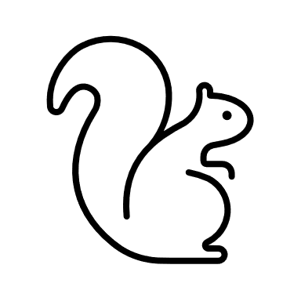 | Bird Feeder  Optional KS3 Home learning task

The Task
The animal kingdom demonstrates many wonderful ways in which animals evolve and adopt to their environment. Observing animals in these environments often reveals how this adaption has not just happened by chance.
Design a bird feeder to explore the intelligence of birds.
Take a look at the video below to show how smart animals can be and also to show some features designers have incorporated in the past.
The animal kingdom demonstrates many wonderful ways in which animals evolve and adopt to their environment. Observing animals in these environments often reveals how this adaption has not just happened by chance.

Manage homework time
1 - | What are you first thoughts and ideas? What is important for this project design?
2 - | What will your design have to do and be like to be successful?
3 - | Show us your ideas. You can use notes, sketches etc…
4 - | Make a list of all the things you need to find out. How will you do this?
1.
2.
3.
4.

5 - | What did you find out that will be helpful to your project?
6 - | Use this space to show where your idea is now
7 - | Classmate feedback- Get someone to give you some feedback on your idea
8 - | From your partners feedback what do you think…
 | …is good …needs work
9 - | Do you agree with your partners feedback? what will you do next?
10 - | Model your ideas to help you find out more about your design.  Insert a picture of your model.  What did you learn from modelling your design?  Record a short video presenting your design.

