**Year 7 – Term 1**

Unit: 1 - Who am I?

Jasper Johns

Jasper Johns is an American painter, sculptor and printmaker.

He was born in 1930.

His work is associated with abstract impressionism and pop art.

He is well known for his depictions of the American flag and other US related topics.

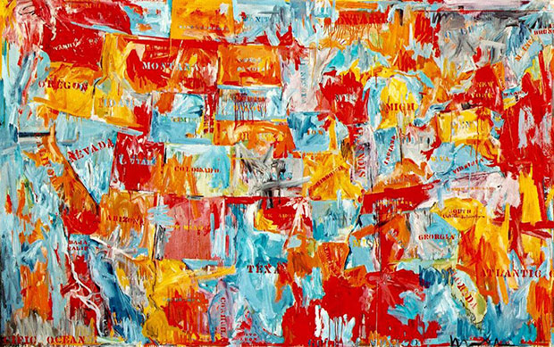

Title: Map Artist: Jasper Johns Date: 1961

Medium: Oil on canvas Dimensions: (198.2 x 314.7 cm)

How would you describe this artwork? What do you…

**See ?** _ _ _ _ _ _ _ _ _ _ _ _ _ _ _ _ _ _ _ _ _ _ _ _ _ _ _ _ _ _ _ _ _ _ _ _ _ _ _ _ _ _ _ _ _ _ _ _ _ _ _ _ _ _ _ _ _ _ _ _ _ _ _ _ _ _ _ _ _ _ _ _ _ _ _ _ _ _ _ _ _ _ _ _ _ _ _ _ _ _ _ _ _ _ _ _ _ _ _ _ _ _ _ _ _ _ _ _ _ _ _ _ _ _ _ _ _ _ _ _ _ _ _ _ _ _ _ _ _ _ _ _ __ _ _ _ _ _ _ _ _ _ _ _ _ _ _ _ _ _ _ _ _ _ _ _ _ _ _ _ _ _ _ _ _ _ _ _ _ _ _ _ _ _ _ _ _ _ _ _ _ _ _ _ _ _ _ _ _ _ _ _ _ _ _ _ _ _ _

**Think?** _ _ _ _ _ _ _ _ _ _ _ _ _ _ _ _ _ _ _ _ _ _ _ _ _ _ _ _ _ _ _ _ _ _ _ _ _ _ _ _ _ _ _ _ _ _ _ _ _ _ _ _ _ _ _ _ _ _ _ _ _ _ _ _ _ _ _ _ _ _ _ _ _ _ _ _ _ _ _ _ _ _ _ _ _ _ _ _ _ _ _ _ _ _ _ _ _ _ _ _ _ _ _ _ _ _ _ _ _ _ _ _ _ _ _ _ _ _ _ _ _ _ _ _ _ _ _ _ _ _ _

_ _ _ _ _ _ _ _ _ _ _ _ _ _ _ _ _ _ _ _ _ _ _ _ _ _ _ _ _ _ _ _ _ _ _ _ _ _ _ _ _ _ _ _ _ _ _ _ _ _ _ _ _ _ _ _ _ _ _ _ _ _ _ _ _ _ _ _ _ _ _ _ _ _ _ _ _ _ _ _ _ _ _ _ _ _ _ _ _ _ _ _ _ _ _ _ _ _ _ _ _ _ _ _ _ _ _ _ _ _ _ _ _ _ _ _ _ _ _ _ _ _ _ _ _ _ _ _ _ _ _ _ _ _ _ _

**Wonder?**_ _ _ _ _ _ _ _ _ _ _ _ _ _ _ _ _ _ _ _ _ _ _ _ _ _ _ _ _ _ _ _ _ _ _ _ _ _ _ _ _ _ _ _ _ _ _ _ _ _ _ _ _ _ _ _ _ _ _ _ _ _ _ _ _ _ _ _ _ _ _ _ _ _ _ _ _ _ _ _ _ _ _ _ _ _ _ _ _ _ _ _ _ _ _ _ _ _ _ _ _ _ _ _ _ _ _ _ _ _ _ _ _ _ _ _ _ _ _ _ _ _ _ _ _ _ _ _ _ _ _ _ _ _ _ _ _ _ _ _ _ _ _ _ _ _ _ _ _ _ _ _ _ _ _ _ _ _ _ _ _ _ _ _ _ _ _ _ _ _ _ _ _ _ _ _ _ _ _ _ _ _ _ _ _ _ _ _ _ _ _ _ _ _ _ _ _ _

**What country are you from?** _ _ _ _ _ _ _ _ _ _ _ _ _ _ _ _ _ _ _ _ _ _ _ _ _ _ _ _ _ _ _ _ _ _ _ _ _ _ _ _ _ _ _ _ _ _ _ _ _ _ _ _ _ _ _ _ _ _ _ _ _ _ _ _ _ _ _ _ _ _ _ _ _ _ _ _ _ _ _ _ _ _ _ _ _ _ _ _ _ _ _ _ _ _ _ _ _ _ _ _ _ _ _ _ _ _ _ _ _ _ _ _ _ _ _ _ _ _