How do I... Analyse a Native American Indian Mask?
To get a level 4, you should answer all the green questions, to be in for a chance to get a level 6 you should also answer the orange questions and for a level 8 you might answer the blue questions too. You should write your answers in full sentences. Remember, quality over quantity!

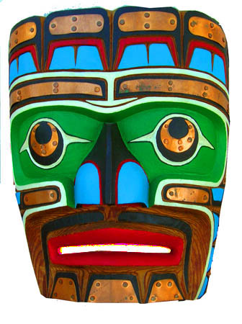
1. Describe – What do I see?
- Describe what you see in your mask.
- Describe the colour you see.
- Describe the shapes you see.
- What is the main focus/where is your eye drawn to?
2. Analyse – How is the work organised?
- How are the colours organised? (e.g. red around the eyes makes the mask look angry)
- How are the shapes arranged on the mask?
- Can you talk about any of the formal elements that are shown? Line, Colour, Shape, Form, Texture, Pattern, Tone... How has the artist achieved the meaning, concept, or message in the image?
- What techniques has the artist used to create the meaning/concept or message?
3. Interpret – What is happening?
This is VERY important so do not leave it out! By answering this question, you will be explaining just how you intend to use this photographers’ work to inspire your own work.
- I think this mask is about…
YEAR 7
- What is the Mood or Feeling? calm, violent, sad, joyful, angry, hopeful, scared…
- The mask reminds me of…
- What are the symbols, metaphors, meaning and context?
4. Judge – What do I think about the artwork?
YEAR 7
- The best part of the mask is…
- The strengths of the work are…
- The weaknesses of the work are…
- The artist communicates ideas by…
5. Presentation – Make it exciting! Use…
- Different styles and sizes of writing
- Bold use of bright colours
- Your own drawings in colour with tonal shading to make them 3D
- Use of different materials, shapes, and textures to make your presentation visually exciting.
- At least 3 drawings in colour with tonal shading to make them 3D

