Unit: 1 - Who am I?

Alberto Giacometti

**Alberto Giacometti** was a Swiss sculptor and painter, known for his unique style that focused on the human form. His work is characterised by **continuous lines**, **expressive strokes**, and a sense of **fragility**. He was heavily influenced by **Cubism** and **Surrealism** and created both sculptures and drawings that explore the human figure in space.

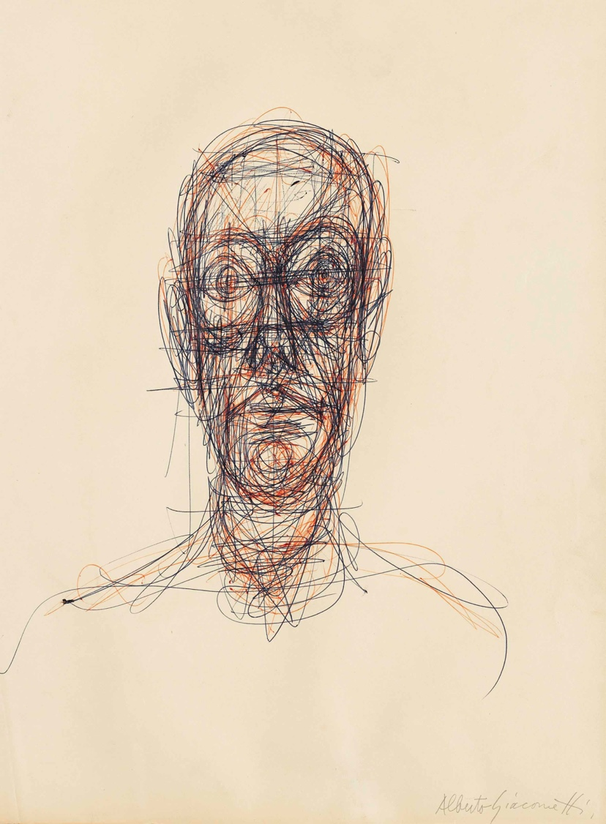

Analytical Questions

**Look at Giacometti’s drawing “Portrait de Diego.”**

1. **What can you see? Describe the lines and shapes you notice. Use the**

**keywords: continuous, gestural, scribbled, layered.**

***I can see…***

________________________________________________

________________________________________________

________________________________________________

________________________________________________

________________________________________________

________________________________________________

________________________________________________

________________________________________________

________________________________________________

________________________________________________

**How does this drawing make you feel?**

* **Explain the emotions or energy that the drawing conveys.**

**Use the keywords: dynamic, tense, raw, expressive.**

***This drawing makes me feel…***

________________________________________________

________________________________________________

________________________________________________

________________________________________________

________________________________________________

________________________________________________

**What do you think Giacometti was trying to express?**

* **Reflect on the meaning behind the artwork. Was it about capturing a moment, expressing a feeling, or something else?**

**Use the keywords: intention, energy, moment, expression.**

***I think Giacometti wanted to express…***

________________________________________________

________________________________________________

________________________________________________

________________________________________________

________________________________________________

________________________________________________