Unit: 1 - Who am I?

Alexander Calder

**Alexander Calder** was an American artist famous for creating sculptures that move! He invented a type of artwork called a **mobile**, which is made from pieces of metal and wire that hang and gently spin with the wind. Calder loved to experiment with balance and shape, turning simple materials into playful, moving sculptures. His unique style made him one of the most important artists of the 20th century.

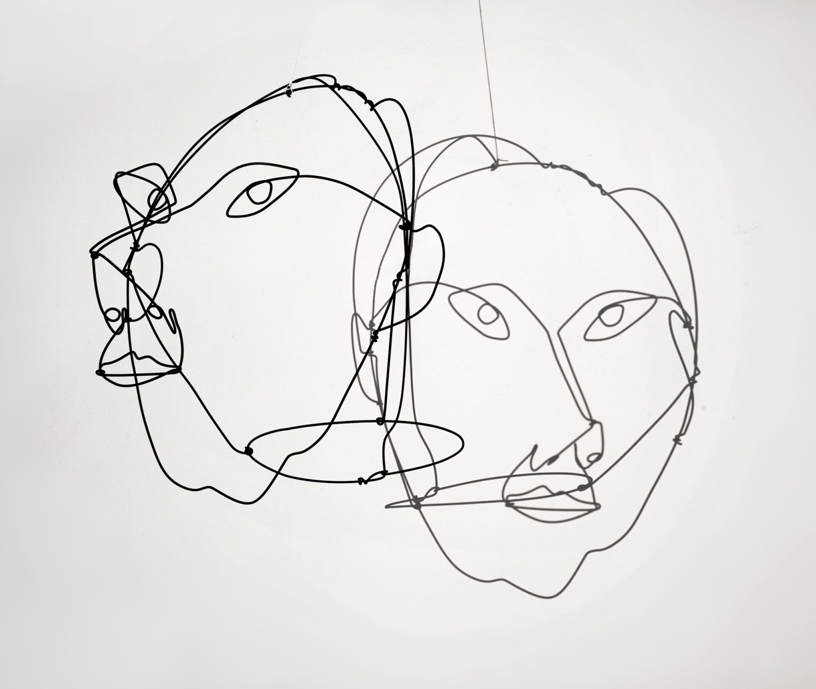

Analytical Questions

**Look at the wire sculpture shown above. This piece uses simple lines to suggest the forms of two faces in space.**

1. **What do you notice about the lines and shapes?**
   * **Describe how the lines form the faces. Are the lines continuous or broken? Do they suggest movement or stillness?**
   * **Use the keywords: fluid, contour, minimal, outline, overlap.**

***I can see…***

________________________________________________

________________________________________________

________________________________________________

________________________________________________

________________________________________________

1. **How does the sculpture make you feel?**
   * **Think about the emotional effect of the overlapping faces and the use of space. Does it feel light, heavy, simple, or complex?**
   * **Use the keywords: abstract, open, airy, balanced, energetic.**

***This sculpture makes me feel…***

________________________________________________

________________________________________________

________________________________________________

________________________________________________

________________________________________________

1. **What do you think the artist intended to express?**
   * **Reflect on why the artist might have chosen to create this sculpture with such minimal, overlapping lines. What does the use of wire instead of solid material add to the work?**
   * **Use the keywords: transparency, interaction, negative space, lightness, movement.**

***I think the artist wanted to express…***

________________________________________________

________________________________________________

________________________________________________

________________________________________________

________________________________________________