## Section 1: Illustrator (Beta) Practical Skills Lesson1: Get into Shapes Learning objectives

* Use tools to draw and modify shapes
* Change the position and rotation shapes
* Explain how z-order determines what is visible

## Key vocabulary

Vector, fill, stroke, rotate, reposition, z-order, layer, handle

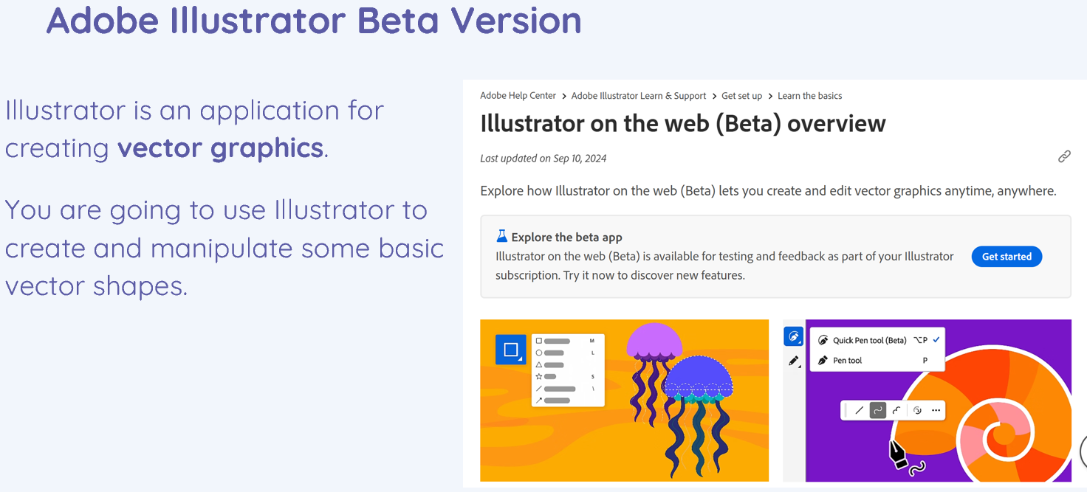

|  |  |
| --- | --- |
|  |  |

# Lesson 2: Working with multiple objects

## Learning objectives

* Use tools to align and distribute objects to create uniformity
* Explain how grouping can be used to work with several objects at once
* Combine two shapes using union, intersection, and difference

## Key vocabulary

Object, select, group, ungroup, align, distribute, combine, union, difference, intersection

|  |  |
| --- | --- |
|  |  |
|  |  |
|  |  |

# Lesson 3**:** Paths

## Learning objectives

* Explain that vector graphics are made up of paths
* Create and modify straight and curved paths
* Change shapes to paths and edit them

## Key vocabulary

Path, node, freehand, object

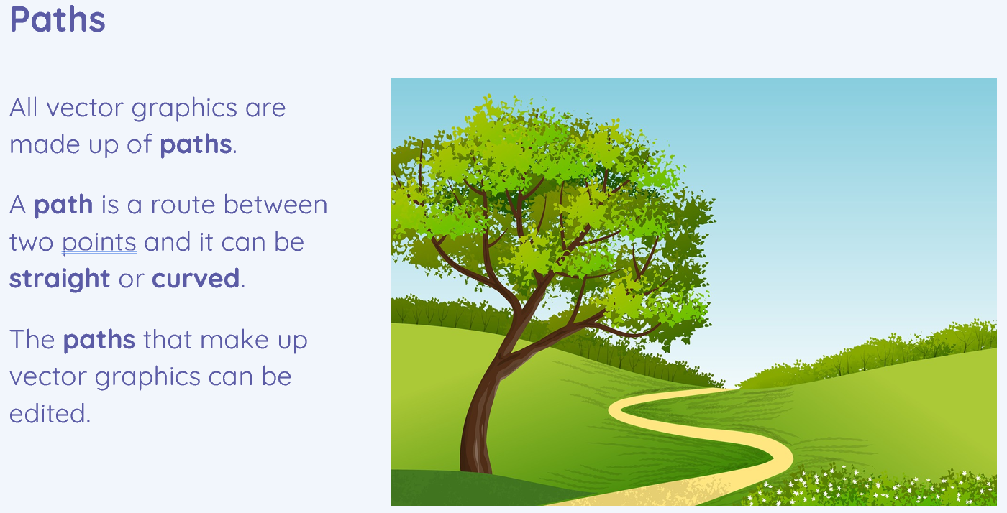

Section 2: Bitmap & Vector Theory



