**How do I... Analyse a photographer’s work?**

To get a level 4, you should answer all the **green** questions, to be in for a chance to get a level 6 you should also answer the **orange** questions and for a level 8 you might answer the **blue** questions too. Remember, **quality** **over quantity**!

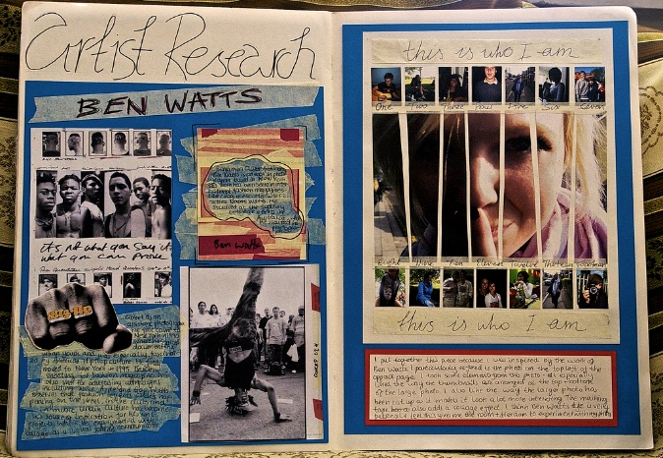**1. Basic Information**

* **The name of the photographer.**
* **What country are they from? (This is important as it puts the work into context)**
* **The name and date of the series that you are interested in.**
* **The name and date of any images you choose to analyse.**
* **What is the image about? (This could be researched or your own opinion)**

**2. Visual Qualities** (select one photo to write about in detail)

* **What does the photograph show?**
* **What is the main focus/where is your eye drawn to? What do you like about the image?**
* **What composition style have they used? leading lines, framing, the rule of thirds... etc. How have they used the lighting in the image?**
* **If they have used people in their photos, can you read any body or facial language?**
* **Can you talk about any of the formal elements that are shown? Line, Colour, Shape, Form, Texture, Pattern, Tone... How has the artist achieved the meaning, concept, or message in the image?**
* **What techniques has the artist used to create the meaning/concept or message?**

**3. Relate to your own work**

This is VERY important so do not leave it out! By answering this question, you will be explaining just how you intend to use this photographers’ work to inspire your own work.

* **How will you be influenced by this photographers’ work when planning and taking your own photos?**

**YEAR 8**