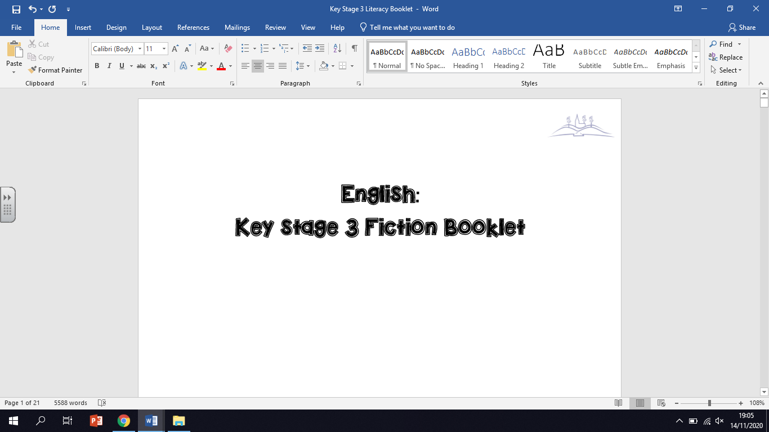

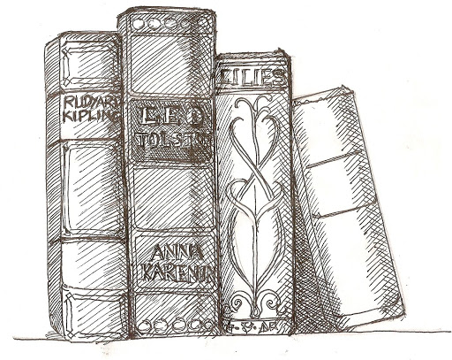

**Name: ­­_______________________**

**Class: ________**

**Teacher: _______________________**

*This booklet has been designed to help you read and understand the deeper meaning of texts. Work your way through the following booklet. Have a go at completing all the activities. Read the instructions carefully. Write your answers in the booklet or on a different piece of paper. Each lesson follows a similar format.*

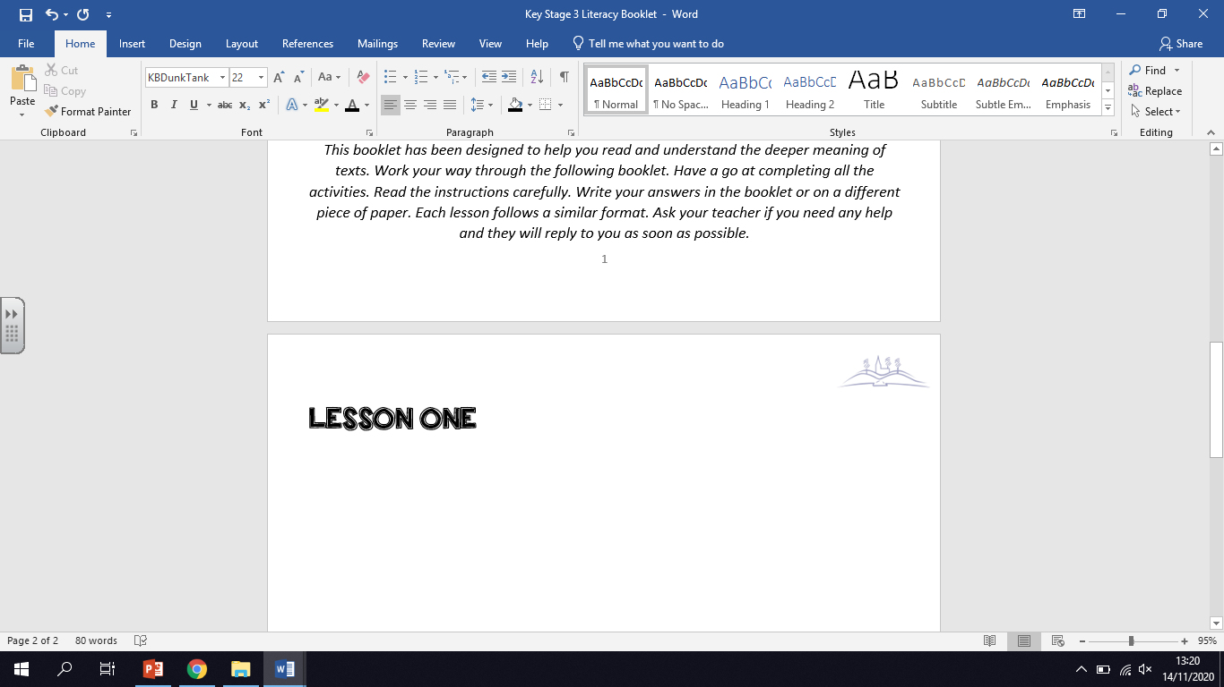

*In this lesson, you will be reading a short extract from a novel called ‘How to Stop Time’ by Matt Haig. In the extract, the main character is watching a concert by a very famous composer called Tchaikovsky. Complete the activities below.*

**ACTIVITY ONE:** Consider the vocabulary below. These words all appear in the extract you are about to read. Look at the word and read the definition. Below each definition is the example of the word in a sentence. Transform each word into a small image to help you remember it. One has been done for you.

|  |  |  |
| --- | --- | --- |
| **Word** | **Definition** | **Image of word** |
| **semblance** | Having an outward appearance that resembles something desired, even if the reality does not match the appearance.  *The teacher managed to achieve some* ***semblance*** *of order before he left the room.* |  |
| **baton** | A thin stick used by a conductor to direct an orchestra or choir.  *He tapped his* ***baton*** *and the orchestra fell silent. The concert was about to begin.* |  |
| **summoning** | An order for someone or something to be present.  *From across the restaurant, she could see a customer* ***summoning*** *one of the waiters.* |  |
| **tantalising** | Teasing someone with the promise of something they cannot have. Appealing.  *The smell of the freshly baked bread was incredibly* ***tantalising****.* |  |
| **symphonic** | A long piece of music written for an orchestra.  *His latest* ***symphonic*** *piece was described by those who listened to it as a masterpiece.* |  |
| **yearning** | A feeling of intense longing for something.  *After having lived in another country for several years, he suddenly felt a* ***yearning*** *to return home.* |  |

**ACTIVITY TWO:** Look back at the list of words. Choose one that you are not confident with using and write it down in the middle of the mind map. Complete the activities around the mind map. If you are confident with using all of the words, choose one you use the least when speaking or writing.

1. Write a new definition in your own words:

2. Use the term correctly in a sentence:

**Word: ________________**

4. Think of other words that mean the same thing (synonyms) and make a list below:

3.Write a question where the word is the answer:

**ACTIVITY THREE:** Based on the vocabulary you have been given, write down what you think the extract is about. What do you think will happen in the extract and why? Refer back to the vocabulary in your explanation. If you are stuck with how to begin, use the sentence starter below. Write no more than five sentences.

*Eg. The words ‘baton’ and ‘symphonic’ makes me thing the article will be about … because…*

*Secondly, the word ‘…’ makes me think…*

___________________________________________________________________________________________________________________________________________________________________________________________________________________________________________________________________________________________________________________________________________________________________________________________________________________________________________________

**ACTIVITY FOUR:** Now read the extract. The words you have been working with are underlined and highlighted in red. When you come across a highlighted word, go back and remind yourself of the definition. If there are any words you do not understand when you read, highlighted or not, write them down here:

1. _______________________ 3. __________________________
2. _______________________ 4. __________________________

A frail-looking man with an intense expression and thinning hair walked towards the centre of the stage. He stood in front of the crowd and gave the **semblance** of a smile. The whole hall erupted in applause. He stayed there, silent, just staring out at us for a while. And then he - Tchaikovsky – turned towards the little lectern that was on the stage, picked up his **baton** and held it in the air. He paused a moment. It was like watching an old wizard with a wand, **summoning** the energy needed to cast the spell.

The hall fell silent. I had never heard a silence like it. The whole hall seemed to be holding its breath. It felt civilised and modern. It felt refined and **tantalising** all at once.

Time slowed, inside that moment.

Then the music began.

I hadn’t enjoyed music for years. So I sat in my seat waiting, as always, for nothing at all.

After a blast of trumpets the violins and cellos were left on their own for a while, creating a noise that started small and tender, and rose to create a kind of **symphonic** storm.

And, yes, it did nothing at first. But then, somehow, it *got in*.

No. Not got in. That’s the wrong way of putting it. Music doesn’t get in. Music is already in. Music simply uncovers what is there, makes you feel emotions that you didn’t necessarily known you had inside you, and runs around waking them all up. A rebirth of sorts.

There was such a **yearning** and energy to it. I closed my eyes. I could not describe here on the page how I felt. The very reason such music exists is because it is a language that couldn’t be communicated in any other way. But all I can say is that I felt suddenly alive again.

As the trumpets and French horns and bass drum thundered in, it had such power my heart quickened and my mind felt dizzy. When I opened my eyes I saw Tchaikovsky with his **baton**, seemingly pulling the music right out of the air, as if music was something already in the atmosphere that you just had to locate.

Then, when it was all over, the composer seemed to deflate again. Even as the whole hall got to its feet and showered him with wave after wave of applause, and the odd roar of ‘Bravo!’, he gave the smallest of smiles and the smallest of bows.

**ACTIVITY FIVE:** Answer the extract specific questions below in full sentences.

1. How does the writer, Matt Haig, describe Tchaikovsky’s appearance?

__________________________________________________________________________________________________________________________________________________________________

1. What are the first instruments to play in the orchestra?

__________________________________________________________________________________________________________________________________________________________________

1. The narrator closes his eyes whilst listening. Why do you think he does this?

__________________________________________________________________________________________________________________________________________________________________

1. How do the audience react to Tchaikovsky’s music?

__________________________________________________________________________________________________________________________________________________________________

1. Tchaikovsky gives the ‘smallest of smiles and the smallest of bows.’ What does this tell the reader about him as a person?

__________________________________________________________________________________________________________________________________________________________________

**ACTIVITY SIX:** As students of English, it is our job to think about why a writer may have used certain words to describe what is happening. There are thousands of words a writer *could* have used. We have to ask ourselves: why has the writer used this *particular* word?

**Why has the writer used the following words to describe the music?**

Look at the words in the grid. Write down three reasons as to why you think the writer has used these words to describe the music. One has been done for you as an example.

|  |  |
| --- | --- |
| **Word:** small  **Reason 1:** I think the writer has chosen this word because it makes the music sound quiet.  **Reason 2:** The music is not very grand at this point.  **Reason 3:** The music is peaceful. | **Word:** storm  **Reason 1:** I think the writer has chosen this word to describe the music because…  **Reason 2:**  **Reason 3:** |
| **Word:** thundered  **Reason 1:**  **Reason 2:**  **Reason 3:** | **EXTRA CHALLENGE - Word:** yearning  **Reason 1:**  **Reason 2:**  **Reason 3:** |

**ACTIVITY SEVEN:** Now it is time to join up our ideas! Choose a word from the grid to help you answer the following question: **How does Matt Haig describe the music in the concert?**

Look at the example answer in the box below and look at how I have joined up my notes from the grid. Notice how I have added a little more detail to the reasons I wrote in the grid. I want you to do the same thing.

Matt Haig initially describes the music in the concert as ‘small’. Perhaps Haig has used the adjective ‘small’ to show the reader how quiet the music is. Tchaikovsky’s symphony is not grand at this point but is very soft and low. Haig may be trying to tell the reader that the music is peaceful which is perhaps why the narrator closes his eyes later on in the extract.

Now see if you can have a go! Link up your notes from one or two of the words in the grid on the previous page. Try and expand on your notes when you write them up in full sentences. If you are not sure how to begin, use the sentence starters below:

* *Matt Haig describes how the ‘small’ and ‘tender’ music begins to build up into a ‘storm’. Perhaps Haig uses the word ‘storm’ to describe the sound of the music because…*
* *Haig describes how the trumpets in the orchestra ‘thundered’. Haig may have used the word ‘thundered’ because he wants to show readers how…*

________________________________________________________________________________________________________________________________________________________________________________________________________________________________________________________________________________________________________________________________________________________________________________________________________________________________________________________________________________________________________________________________________________________________________________________________________________________________________________________________________________________________________________________

**FINAL ACTIVITY:** Test yourselves on the vocabulary from the beginning by writing down the definitions of the words. When you have finished, look back at your vocabulary lists to check your work. Mark your answers in a different colour pen. Give yourself a tick or a cross and make any corrections you need to make.

1. semblance: _____________________________
2. baton: _________________________________
3. summoning: ____________________________
4. tantalising: _____________________________
5. symphonic: _____________________________
6. yearning: _______________________________

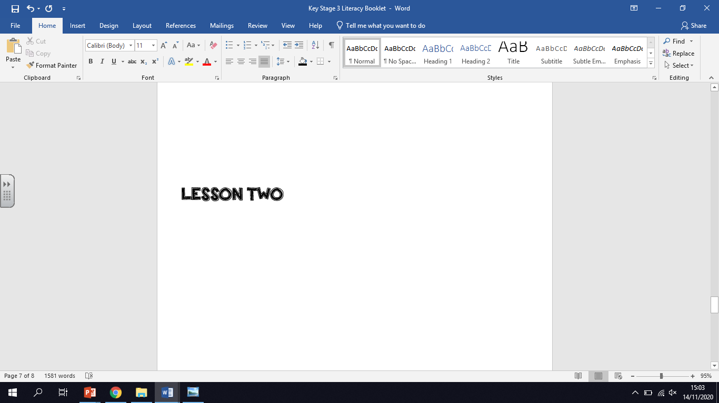

*In this lesson, you will be reading a short extract from a novel called ‘A Fine Balance’ by Rohinton Mistry. In the extract, a character called Maneck Kohlah is journeying on a train.*

**ACTIVITY ONE:** Consider the vocabulary below. These words all appear in the extract you are about to read. Look at the word and read the definition. Below each definition is the example of the word in a sentence. Transform each word into a small image to help you remember it. One has been done for you.

|  |  |  |
| --- | --- | --- |
| **Word** | **Definition** | **Image of word** |
| **bloated** | Swollen or made bigger.  *After being stung by a wasp, James’ face was very* ***bloated.*** |  |
| **lurched** | An unsteady, uncontrolled series of movements that usually involves stopping and starting quickly.  *The car was having engine trouble and so* ***lurched*** *forward.* |  |
| **deception** | Hiding the truth. Being misleading.  *Sam was so good at lying that no one could see through his* ***deception****.* |  |
| **distended** | Increasing in size due to pressure from inside. Similar to bloated.  *The cat had eaten so much food that her stomach was* ***distended****.* |  |
| **perilously** | In a way that is full of danger and risk.  *The car was* ***perilously*** *hanging off the edge of the cliff.* |  |
| **slender** | Slim.  *She screamed as the* ***slender****, green snake slid up her arm.* |  |

**ACTIVITY TWO:** Look back at the list of words. Choose one that you are not confident with using and write it down in the middle of the mind map. Complete the activities around the mind map. If you are confident with using all of the words, choose one you use the least when speaking or writing.

1. Write a new definition in your own words:

2. Use the term correctly in a sentence:

**Word: ________________**

4. Think of other words that mean the same thing (synonyms) and make a list below:

3.Write a question where the word is the answer:

**ACTIVITY THREE:** Based on the vocabulary you have been given, write down what you think the extract is about. What do you think will happen in the extract and why? Remember, the main character is journeying on a train in the extract. What do you think it will be like based on this vocabulary? Refer back to the vocabulary in your explanation. If you are stuck with how to begin, use the sentence starter below. Write no more than five sentences.

*Eg. The words ‘lurched’ and ‘perilously’ make me think the train journey is going to be … because…*

*Secondly, the word ‘…’ makes me think…*

___________________________________________________________________________________________________________________________________________________________________________________________________________________________________________________________________________________________________________________________________________________________________________________________________________________________________________________

**ACTIVITY FOUR:** Now read the extract. The words you have been working with are underlined and highlighted in red. When you come across a highlighted word, go back and remind yourself of the definition. If there are any words you do not understand when you read, highlighted or not, write them down here:

1. _______________________ 3. __________________________
2. _______________________ 4. __________________________

The morning express **bloated** with passengers slowed to a crawl, then **lurched** forward suddenly, as though to resume full speed. The train’s brief **deception** jolted its riders. The bulge of humans hanging out of the doorway **distended** **perilously**, like a soap bubble at its limit.

Inside the compartment, Maneck Kohlah held on to the overhead railing, propped up securely within the crush. He felt someone’s elbow knock his textbooks from his hand. In the seats nearby, a thin young fellow was catapulted into the arms of the man opposite him. Maneck’s textbooks fell upon them.

“Ow!” said the young fellow, as volume one slammed into his back.

Laughing, he and his uncle untangled themselves. Ishvar Darji, who had a disfigured left cheek, helped his nephew out of his lap and back onto the seat. “Everything all right, Om?”

“Apart from the dent in my back, everything is all right,” said Omprakash Darji, picking up the two books covered in brown paper. He hefted them in his **slender** hands and looked around to find who had dropped them.

Maneck acknowledged ownership. The thought of his heavy textbooks thumping that frail spine made him shudder. He remembered the sparrow he had killed with a stone, years ago; afterwards, it had made him sick.

His apology was frantic. “Very sorry, the books slipped and—”

“Not to worry,” said Ishvar. “Wasn’t your fault.” To his nephew he added, “Good thing it didn’t happen in reverse, hahn? If I fell in your lap, my weight would crack your bones.” They laughed again, Maneck too, to supplement his apology.

**ACTIVITY FIVE:** Answer the extract specific questions below in full sentences.

1. What happens to Maneck Kohlah’s textbooks?

__________________________________________________________________________________________________________________________________________________________________

1. Who are the two characters that Maneck meets on the train and how are they related?

__________________________________________________________________________________________________________________________________________________________________

1. Why does the thought of textbooks hitting a ‘frail spine’ make Maneck shudder?

__________________________________________________________________________________________________________________________________________________________________

1. Bearing in mind the characters are on the ‘morning express’, what can we predict about why the train is so busy?

__________________________________________________________________________________________________________________________________________________________________

1. What do we learn about the character, Ishvar Darji in the extract? List two things.

__________________________________________________________________________________________________________________________________________________________________

**ACTIVITY SIX:** As students of English, it is our job to think about why a writer may have used certain words to describe what is happening. There are thousands of words a writer *could* have used. We have to ask ourselves: why has the writer used this *particular* word?

**Why has the writer used the following words to describe the train, the journey and the passengers?**

Look at the words in the grid. Write down three reasons as to why you think the writer has used these words to describe the train and the journey. One has been done for you as an example.

|  |  |
| --- | --- |
| **Word:** bloated  **Reason 1:** I think the writer uses this word to show how the train is stuffed full of passengers.  **Reason 2:** It shows how uncomfortable the train must be.  **Reason 3:** There are so many people crammed onto the train that it is almost bursting. | **Word:** lurched  **Reason 1:** I think the writer has chosen this word to describe the train’s movements because…  **Reason 2:**  **Reason 3:** |
| **Word:** crush  **Reason 1:** I think the writer has chosen this word to describe the inside of the train because…  **Reason 2:**  **Reason 3:** | **Word: EXTRA CHALLENGE -** distended  **Reason 1:**  **Reason 2:**  **Reason 3:** |

**ACTIVITY SEVEN:** Now it is time to join up our ideas! Choose a word from the grid to help you answer the following question: **How does Rohinton Mistry use language to describe the train, the journey and the passengers?**

Look at the example answer in the box below and look at how I have joined up my notes from the grid. Notice how I have added a little more detail to the reasons I wrote in the grid. I want you to do the same thing.

Rohinton Mistry describes the morning express train as ‘bloated’. Mistry may describe the train as ‘bloated’ to emphasise just how crowded and stuffed it is with passengers. It sounds like the train is close to bursting and cannot carry anyone else. As a result, travelling on the train must be very uncomfortable. It is not a pleasant journey because of the amount of people crammed into such a small space.

Now see if you can have a go! Link up your notes from one or two of the words in the grid on the previous page. Try and expand on your notes when you write them up in full sentences. If you are not sure how to begin, use the sentence starters below:

* *Rohinton Mistry describes how the train ‘lurched’. Perhaps Mistry describes the movements of the train in this way because he wants to show the reader that…*
* *The inside of the train is described as a ‘crush’. This tells the reader that…*

________________________________________________________________________________________________________________________________________________________________________________________________________________________________________________________________________________________________________________________________________________________________________________________________________________________________________________________________________________________________________________________________________________________________________________________________________________________________________________________________________________________________________________________

**FINAL ACTIVITY:** Test yourselves on the vocabulary from the beginning by writing down the definitions of the words. When you have finished, look back at your vocabulary lists to check your work. Mark your answers in a different colour pen. Give yourself a tick or a cross and make any corrections you need to make.

4. distended: _____________________________

5. perilously: _____________________________

6. slender: _______________________________

1. bloated: _________________________________

2. lurched: _________________________________

3. deception: _______________________________

1. distended: _____________________________

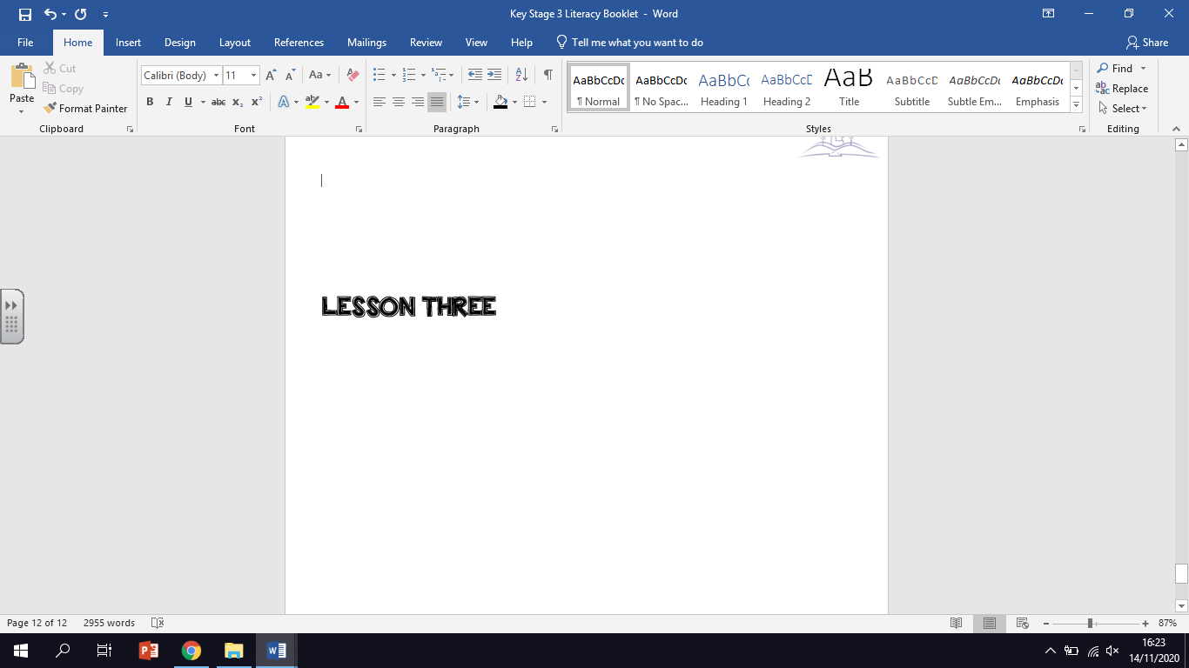

*In this lesson, you will be reading a short extract from a novel called ‘The Absolutist’ by John Boyne. In the extract, a character called Tristan Sadler is fighting in the trenches of World War I in France.*

**ACTIVITY ONE:** Consider the vocabulary below. These words all appear in the extract you are about to read. Look at the word and read the definition. Below each definition is the example of the word in a sentence. Transform each word into a small image to help you remember it. One has been done for you.

|  |  |  |
| --- | --- | --- |
| **Word** | **Definition** | **Image of word** |
| **emanates** | To come out of.  *A sob* ***emanates*** *from me as I say goodbye to them for the last time.* |  |
| **dissolve** | To become broken up or to disappear into something else.  *I watched the small sugar cube* ***dissolve*** *into my cup of tea.* |  |
| **barricade** | A barrier which is put up to stop or delay the movement of someone or something, usually an enemy.  *I had an argument with my parents so I decided to* ***barricade*** *myself in my room.* |  |
| **excavated** | To dig a hole or to remove something from the ground.  *The* ***excavated*** *remains of the dinosaur bones were moved to the museum.* |  |
| **errand** | Small tasks or jobs.  *Sarah had to complete several* ***errands*** *at the weekend.* |  |
| **sporadic** | Only happening every now and then. Infrequent.  *He did not like how his success was* ***sporadic****. He needed to get better.* |  |

**ACTIVITY TWO:** Look back at the list of words. Choose one that you are not confident with using and write it down in the middle of the mind map. Complete the activities around the mind map. If you are confident with using all of the words, choose one you use the least when speaking or writing.

1. Write a new definition in your own words:

2. Use the term correctly in a sentence:

**Word: ________________**

4. Think of other words that mean the same thing (synonyms) and make a list below:

3.Write a question where the word is the answer:

**ACTIVITY THREE:** Based on the vocabulary you have been given, write down what you think the extract is about. What do you think will happen in the extract and why? Remember, the main character is fighting in the trenches in World War I in France. What do you think the character will experienced based on the vocabulary? Refer back to the words in your explanation. If you are stuck with how to begin, use the sentence starter below. Write no more than five sentences.

*Eg. From the words ‘barricade’ and ‘sporadic’, I predict that…*

*The word ‘excavated’ also makes me think that…*

___________________________________________________________________________________________________________________________________________________________________________________________________________________________________________________________________________________________________________________________________________________________________________________________________________________________________________________

**ACTIVITY FOUR:** Now read the extract. The words you have been working with are underlined and highlighted in red. When you come across a highlighted word, go back and remind yourself of the definition. If there are any words you do not understand when you read, highlighted or not, write them down here:

1. _______________________ 3. __________________________

2. _______________________ 4. __________________________

A cry of despair and weariness **emanates** from the pit of my stomach as the wall behind me begins to crumble and **dissolve** into a slow-moving river of thick, black, rat-infused mud that slides down my back and slips into the gaps at the top of my boots. I feel the sludge seeping its way into my already sodden socks and throw myself against the tide, desperate to push the **barricade** back into place before I am submerged beneath it. A tail passes quickly across my hands, whipping me sharply, then another; next, a sharp bite.

“Sadler!” cries Henley, his voice hoarse, his breathing laboured. He’s standing only a few feet away from me with Unsworth, I think, by his side and Corporal Wells next along the line. The rain is falling in such heavy sheets that I’m spitting it from my lips along with mouthfuls of foul dirt and it’s difficult to make any of them out. “The sandbags – look, they’re over here – pile them as high as you can.”

I make my way forward, trying to pull my boots out of three feet of mud. The terrible sucking sound they make as they emerge reminds of the echo of a man’s last breath, deep and frantic, gasping for air, failing.

Instinctively, I open my arms as a sandbag filled with **excavated** earth comes at me, almost knocking me off my feet when it hits me in the chest but although I am winded I am equally quick to turn back to the wall, slamming the sandbag where I think the base must be, turning for another, catching it, padding the wall again, and another and another and another. Now there are five or six of us all doing the same thing, piling the sandbags high, crying out for more before the whole bloody place collapses about us, and it feels like a fool’s **errand**, but somehow it works and it is over and we forget that we have nearly died today as we wait to die again tomorrow.

The Germans use concrete; we use wood and sand.

It’s been raining for days, an endless torrent that makes the trenches feel like troughs for the pigs rather than defences in which our regiment can take cover as we launch our **sporadic** attacks. When we arrived, I was told that the chalky ground of Picardy, through which we have been advancing for days now, is less liable to crumble than that of other parts of the line, particularly those miserable fields towards Belgium.

**ACTIVITY FIVE:** Answer the extract specific questions below in full sentences.

1. What bites Tristan Sadler’s hand at the beginning of the extract?

__________________________________________________________________________________________________________________________________________________________________

1. What is the mud like in the trenches and how does it make Tristan’s job difficult?

__________________________________________________________________________________________________________________________________________________________________

1. What are the sandbags filled with? Why do you think this is?

__________________________________________________________________________________________________________________________________________________________________

1. Tristan says the attacks made against German forces are ‘sporadic’. What does he mean?

_________________________________________________________________________________

1. What does Tristan compare the trenches to at the end of the extract and why?

__________________________________________________________________________________________________________________________________________________________________

**ACTIVITY SIX:** As students of English, it is our job to think about why a writer may have used certain words to describe what is happening. There are thousands of words a writer *could* have used. We have to ask ourselves: why has the writer used this *particular* word?

**Why has the writer used the following words to describe the trenches and Tristan’s experiences?**

Look at the words in the grid. Write down three reasons as to why you think the writer has used these words to describe the trenches and Tristan’s experiences. One has been done for you as an example.

|  |  |
| --- | --- |
| **Word:** rat-infused  **Reason 1:** This word shows how disgusting the conditions of the trenches are.  **Reason 2:** It shows the men have to fight alongside vermin that can easily spread disease.  **Reason 3:** It shows that the rats cannot be gotten rid of easily. | **Word:** dissolve  **Reason 1:** I think the writer has chosen this word to describe what is happening to the trench to show…  **Reason 2:**  **Reason 3:** |
| **Word:** sludge  **Reason 1:** I think the writer has chosen this word to describe what is in the trench because…  **Reason 2:**  **Reason 3:** | **Word: EXTRA CHALLENGE -** sporadic  **Reason 1:**  **Reason 2:**  **Reason 3:** |

**ACTIVITY SEVEN:** Now it is time to join up our ideas! Choose a word from the grid to help you answer the following question: **How does John Boyne use language to describe the trench and Tristan’s experiences?**

Look at the example answer in the box below and look at how I have joined up my notes from the grid. Notice how I have added a little more detail to the reasons I wrote in the grid. I want you to do the same thing.

John Boyne describes the trenches as being ‘rat-infused’, which means that Tristan’s experiences are miserable. ‘Rat-infused’ may have been used to highlight the disgusting conditions of the trenches; the men have to fight alongside the vermin that can spread disease easily, another danger the soldiers have to face. The fact the trenches are ‘infused’ with these rats show they cannot be gotten rid of easily. They are always there.

Now see if you can have a go! Link up your notes from one or two of the words in the grid on the previous page. Try and expand on your notes when you write them up in full sentences. If you are not sure how to begin, use the sentence starters below:

* *Perhaps John Boyne highlights the ‘sludge’ that is present in the trenches because he wants to show the reader…*
* *We are told the trench is beginning to ‘dissolve’. Boyne may have used this word because…*

________________________________________________________________________________________________________________________________________________________________________________________________________________________________________________________________________________________________________________________________________________________________________________________________________________________________________________________________________________________________________________________________________________________________________________________________________________________________________________________________________________________________________________________

**FINAL ACTIVITY:** Test yourselves on the vocabulary from the beginning by writing down the definitions of the words. When you have finished, look back at your vocabulary lists to check your work. Mark your answers in a different colour pen. Give yourself a tick or a cross and make any corrections you need to make.

1. errand: _____________________________
2. sporadic: ___________________________
3. emanates: _____________________________
4. dissolve: ______________________________
5. barricade: _____________________________
6. excavated: _____________________________

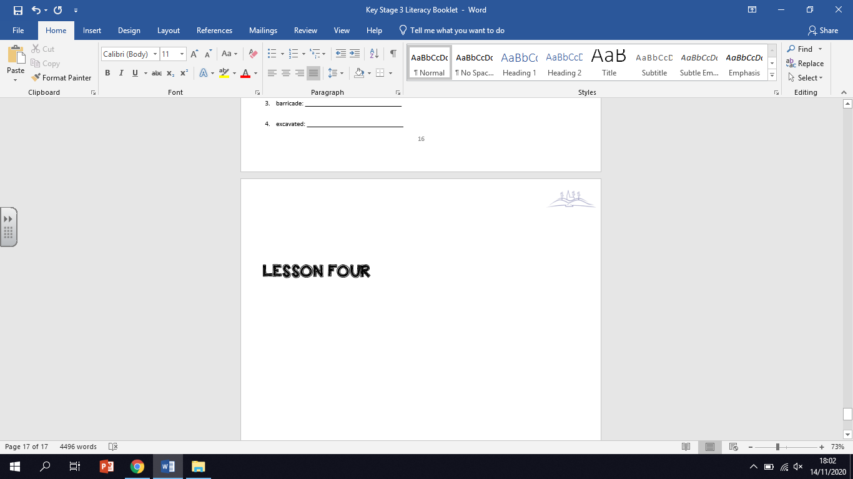

*In this lesson, you will be reading a short extract from a novel called ‘Americanah’ by* *Chimamanda Ngozi Adichie. In the extract, the narrator is describing the different American cities she has been to.*

**ACTIVITY ONE:** Consider the vocabulary below. These words all appear in the extract you are about to read. Look at the word and read the definition. Below each definition is the example of the word in a sentence. Transform each word into a small image to help you remember it. One has been done for you.

|  |  |  |
| --- | --- | --- |
| **Word** | **Definition** | **Image of word** |
| **tranquil** | Calm and peaceful.  *As I wandered down the forest’s path, I took in the* ***tranquil*** *sight.* |  |
| **stately** | Impressive or grand in size and appearance.  *Sometimes,* ***stately*** *homes are opened to the public for tours.* |  |
| **abiding** | Lasting a long time. Continuing.  *She had an* ***abiding*** *love of History when she was at school.* |  |
| **neglect** | Fail to care for properly.  *The park was overgrown and littered from years of* ***neglect****.* |  |
| **effusive** | An expression of great emotion or enthusiasm.  *Sally was* ***effusive*** *in her praise of the judges who awarded her the trophy.* |  |
| **affluent** | Having a great deal of money; wealthy.  *They moved to a more* ***affluent*** *area.* |  |

**ACTIVITY TWO:** Look back at the list of words. Choose one that you are not confident with using and write it down in the middle of the mind map. Complete the activities around the mind map. If you are confident with using all of the words, choose one you use the least when speaking or writing.

1. Write a new definition in your own words:

2. Use the term correctly in a sentence:

**Word: ________________**

4. Think of other words that mean the same thing (synonyms) and make a list below:

3.Write a question where the word is the answer:

**ACTIVITY THREE:** Based on the vocabulary you have been given, write down what you think the extract is about. What do you think will happen in the extract and why? Remember, the narrator is describing American cities. What do you think the cities are like based on the vocabulary? Refer back to the words in your explanation. If you are stuck with how to begin, use the sentence starter below. Write no more than five sentences.

*Eg. The words ‘tranquil’ and ‘affluent’ suggest to me that American cities are… because…*

*However, the word ‘neglect’ makes me think cities can also be… because…*

___________________________________________________________________________________________________________________________________________________________________________________________________________________________________________________________________________________________________________________________________________________________________________________________________________________________________________________

**ACTIVITY FOUR:** Now read the extract. The words you have been working with are underlined and highlighted in red. When you come across a highlighted word, go back and remind yourself of the definition. If there are any words you do not understand when you read, highlighted or not, write them down here:

1. _______________________ 3. __________________________

2. _______________________ 4. __________________________

Princeton, in the summer, smelled of nothing, and although Ifemelu liked the **tranquil** greenness of the many trees, the clean streets and **stately** homes, the delicately overpriced shops, and the quiet, **abiding** air of earned grace, it was this, the lack of a smell, that most appealed to her, perhaps because the other American cities she knew well had all smelled distinctly. Philadelphia had the musty scent of history. New Haven smelled of **neglect**. Baltimore smelled of brine, and Brooklyn of sun-warmed garbage. But Princeton had no smell. She liked taking deep breaths here. She liked watching the locals who drove with pointed courtesy and parked their latest-model cars outside the organic grocery store on Nassau Street or outside the sushi restaurants or outside the ice cream shop that had fifty different flavours including red pepper or outside the post office where **effusive** staff bounded out to greet them at the entrance. She liked the campus, grave with knowledge, the Gothic buildings with their vine-laced walls, and the way everything transformed, in the half-light of night, into a ghostly scene. She liked, most of all, that in this place of **affluent** ease, she could pretend to be someone else, someone specially admitted into a hallowed American club, someone adorned with certainty.

**ACTIVITY FIVE:** Answer the extract specific questions below in full sentences.

1) What appeals to Ifemelu the most about Princeton?

__________________________________________________________________________________________________________________________________________________________________

2) Ifemelu says that New Haven smells of ‘neglect’. What do you think she means?

__________________________________________________________________________________________________________________________________________________________________

3) What are the locals in Princeton like?

__________________________________________________________________________________________________________________________________________________________________

4) Philadelphia is described as having the ‘musty scent of history’. What do we learn about the city from this quotation?

__________________________________________________________________________________________________________________________________________________________________

5) What evidence is there in the text that Princeton is an affluent area?

__________________________________________________________________________________________________________________________________________________________________

**ACTIVITY SIX:** As students of English, it is our job to think about why a writer may have used certain words to describe what is happening. There are thousands of words a writer *could* have used. We have to ask ourselves: why has the writer used this *particular* word?

**Why has the writer used the following words to describe Princeton?**

Look at the words in the grid. Write down three reasons as to why you think the writer has used these words to describe Princeton. There are no examples for this extract. If you are stuck, have a look at this task in previous lessons to help you understand what you need to do.

|  |  |
| --- | --- |
| **Word:** tranquil  **Reason 1:**  **Reason 2:**  **Reason 3:** | **Word:** stately  **Reason 1:**  **Reason 2:**  **Reason 3:** |
| **Word:** overpriced  **Reason 1:**  **Reason 2:**  **Reason 3:** | **Word:** affluent  **Reason 1:**  **Reason 2:**  **Reason 3:** |

**ACTIVITY SEVEN:** Now it is time to join up our ideas! Choose a word from the grid to help you answer the following question: **How does Chimamanda Ngozi Adichie use language to describe Princeton?**

Link up your notes from one or two of the words in the box above. Try and expand on your notes when you write them up in full sentences. If you are not sure how to begin, use the sentence starters below:

* *When describing Princeton, Chimamanda Ngozi Adichie has Ifemelu notice how ‘tranquil’ the place is. Perhaps Adichie uses the word ‘tranquil’ to emphasise…*
* *Princeton, we are told, is an ‘affluent’ area, suggesting…*

________________________________________________________________________________________________________________________________________________________________________________________________________________________________________________________________________________________________________________________________________________________________________________________________________________________________________________________________________________________________________________________________________________________________________________________________________________________________________________________________________________________________________________________

**FINAL ACTIVITY:** Test yourselves on the vocabulary from the beginning by writing down the definitions of the words. When you have finished, look back at your vocabulary lists to check your work. Mark your answers in a different colour pen. Give yourself a tick or a cross and make any corrections you need to make.

1. tranquil: _____________________________

2. stately: ______________________________

3. abiding: _____________________________

4. neglect: _____________________________

5. effusive _____________________________

6. affluent: ____________________________