**My most successful photograph (the outcome)**

**YEAR 8**

**Use this sheet to help you write about the best photograph you have taken for this project. Remember to present your evaluation creatively in your sketchbook.**

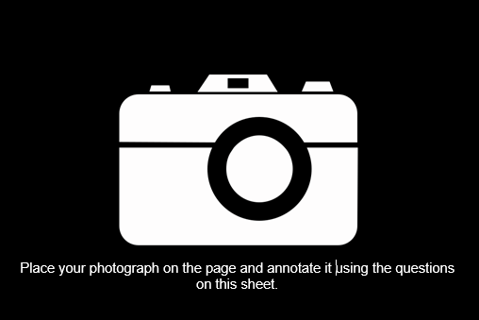

To get a level 4, you should answer all the **green** questions, to be in for a chance to get a level 6 you should also answer the **orange** questions and for a level 8 you might answer the **blue** questions too. Remember, **quality** **over quantity**!

1. Describe what is in the photo...
2. Why is it the most successful image? (What do you like about it?)
3. Comment on the FORMS in the photograph... (Are there interesting shapes? What shapes can you see?)
4. Comment on the TEXTURES in the photograph... (How does the surface of the object/item photographed look?)
5. Comment on the PATTERNS in the photograph... (Are there repeat patterns, zigzags, stripes, checks, random patterns, circles etc.)
6. To improve this photo, I could (take it from another angle, focus on a different section, make it more in focus)
7. Does it link with any artist’s/photographer's work? (Describe how it is similar)
8. Comment on the COLOURS in the image (hot/cold, bright/dark, contrasting/harmonising, pastel, earthy, natural, neon, monochrome, multi-coloured)
9. Comment on the TONES in the image... (light and dark, different shades of grey, shadows)
10. Comment on the COMPOSITION of the image... (The layout of the photo, section/angle, rule of thirds etc)
11. Comment on the DETAILS in the image... (Are there intricate (tiny) details? No details? Some detail in parts?)