Unit: 1 - Who am I?

Peter Blake

Peter Blake is a British pop artist, famous for his bright and bold works inspired by popular culture. His most famous work is the album cover for *The Beatles’ Sgt. Pepper's Lonely Hearts Club Band*, but he has also created art that explores everyday life and celebrates ordinary objects and people.

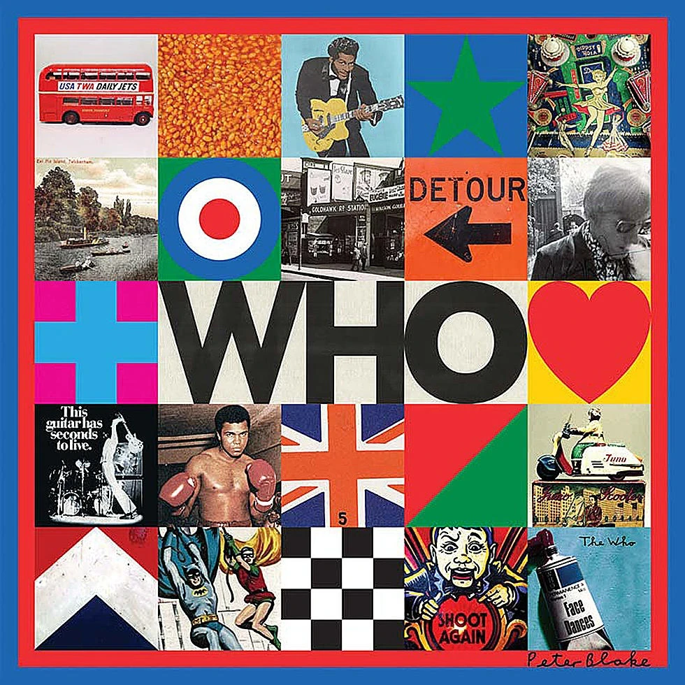

Analytical Questions

1. **What catches your eye first in this artwork?**
   * Look at the colours, shapes, and text in the artwork. What stands out the most to you and why?

See:

________________________________________________

________________________________________________

________________________________________________

________________________________________________

________________________________________________

1. **What connections do you see between the different elements?**
   * Blake often mixes imagery from popular culture and everyday life. Look at the arrangement of the objects and text. How do they relate to each other? Are they random, or do they tell a story?

Connect:

________________________________________________

________________________________________________

________________________________________________

1. **How does the artwork make you feel?**
   * Think about how the use of images and text affects your emotions or thoughts. Does the piece feel playful, mysterious, or something else?

Feel:

________________________________________________

________________________________________________

________________________________________________

1. **Why do you think Blake included a mix of words and images?**
   * The artwork uses both words and images. Why do you think Blake chose to include both? How does the text add to your understanding of the piece?

Interpret:

________________________________________________

________________________________________________

________________________________________________

1. **Create your own interpretation:**
   * If you were to create an artwork inspired by this, using a mix of images and text, what would your central figure or theme be? What words and pictures would you use to tell your story?

Reflect:

________________________________________________

________________________________________________

________________________________________________